WoWMobileArmory
grp5
- Riku Pulliainen
- Otto Luttinen
- Antti Hannuksela

Idea
We are going to make a mobile frontend for the website wowarmory.com. It gives information about the users character in the game and helps him/her to choose better equipment for his/her character. There is already a similar application available for iPhone and we don't want that the users of Apple are in better position than the users of Nokia(or other QT platforms).

What the heck is WoWArmory?
WoWArmory is browser-based frontend for game character/item database. it allows users to browse characters across all realms, browse items, gems, talents and when logged in, use auction house and in-game calendar. WoWWiki and Blizzards official site provide more information.
BELOW: Mobile Armory screenshot running on iPhone:
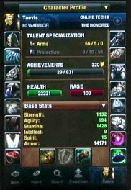

Features
- Primary features:
  - Character information display
  - Item browser
  - Update browser
- Secondary features:
  - Something funny if we have enough time

Implementation Plan and Goals
- HTTP Request/response system
- XML reader
- Icon-based GUI

Design
The first thing the user will see is the begin button which starts the program. Next user will have to give character name and realm name. If either of these is wrong the program will start again and ask character name and realm name again. After the program has found the given character in the given realm it will go to the character screen which will show character stat in the middle and all the items the character is using in buttons with icons on the sides. There is also a quit button for stopping the program. In the character screen user can press a item button which will open a popup with the item stats. There is also a ok button that when pressed will bring back the character screen.

Screen shots
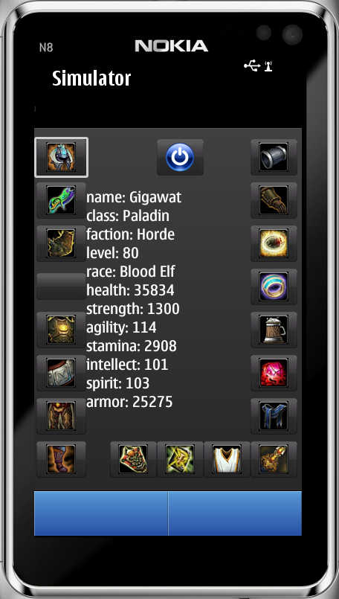

Project Artefacts

Presentation slides
wowmobilearmoryidea.pptx
qt_codecamp_presentation_grp5.pdf

Report document
wowmobilearmorybrochyre.pdf
codecamp_report_grp5.pdf

Source Package
grp5.zip

How to run software
Open project file(*.pro) in QT Creator and run project in simulator

Conclusion
Because of the strict deadline the program wasn't completely finished. Some features were left out and some didn't work properly. One of the features that were left out was find a upgrade feature. With this feature the user would have been able to find out what items would be better than the item he or she is currently using and where to find them. Another feature that was dropped was the item browser. With this feature the user would have been able to find all the items his or her character could use or just browse all items.
All the features we did for the program worked pretty well considering the time we had except the item stats but that wasn't completely our fault. The xml file that contained the data for the items did contain a lot more waste than the xml file we got our character stats from and we didn't have the time to clean up the printing of the data. There was also another bug which was our fault. The program would print only the first items stats to the screen and if the user chooses another item after that the program would still print the first items stats to the screen.
Another bug which wasn't our fault was the order of the items buttons. This was the result of blizzards weird logic in numbering their items. In the xml file we got from the Internet every item was given a number but on blizzards website the items weren't in any kind of numerical order. So when we put them in a numerical order the items were in different places than in the website. This bug didn't stop the user from using the program. It was just something that would take some time to get used to.
All and all we were quite happy at the results of our work. We got all the main features implemented in to the program and most of them worked properly. The only thing that we wished we could have got to work was the item stats but because of the tight schedule we didn't have the time.

