LOVE CALCULATOR
- Param Jyothi Marilla
- Sidhartha Yalavarthi
- Jalamadugu Ravitheja

Idea
Everyone knows that a name can tell lot about the person and their behavior. Names are not randomly chosen they all have a meaning.With love calculator you can calculate the probability of a successful relationship between two people,it is an effective way to get an impression of what the chances are on a relationship.

Solution
» To get an impression of what the chances are on a relationship. «

Features
Take two persons names.
Calculates the percentage of love.
Displays the message according to result.

Implementation Plan and Goals
Basically we followed the iteration process for the implementation.

Design
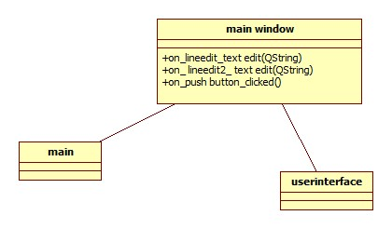

Screen shots
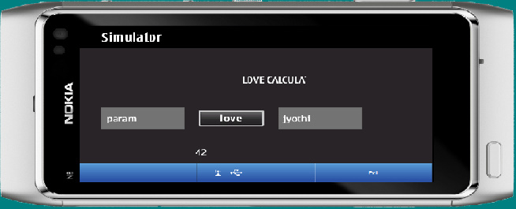

Project Artefacts

Presentation slides
grp_6.pptx

Report document

Source Package
lovecalculator.zip

How to run software
- open QTSDK sofware.
- open QT creator.
- open simulator.
- Run the application
Install lovecalc.sis to your Symbian touch device. It requires QtMobility 1.0 and Qt 4.6.2 libraries to be installed.

Conclusion
QT is relatively easy in some aspects like libraries and has many functions like signals ,slots which are very useful we faced some difficulties in the beginning,but some how we got support from many forums and links in internet. overall experience was good .

