(Alcohol Meter) grp07
1.
MD. Facihul Azam
2.
P.Rajaraviteja
3.
Srikanth Korrapati

Idea
The basic idea of Alcohol Meter is to check the alcohol content in the blood of a drunk human and inform the user body condition whether he/she can drive or not. The main concept of this Alcohol meter is to take input of the user gender,weight,type of drinks the user has consumed, with this information, Alcohol meter calculates the content of alcohol in user blood and displays a message whether he could drive or not.

Features
Takes some input variables.
Calculates the percent of alcohol in human blood.
Displays messages according to result.
- ..

Implementation Plan and Goals
Our basic idea was to implemented with few functionality.
At first we tried to implement for one drink.
When it was implementing successfully, we increased drinks and display functionality.

Design
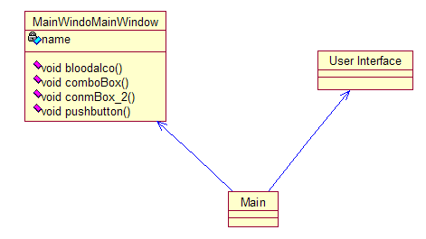

Screen shots
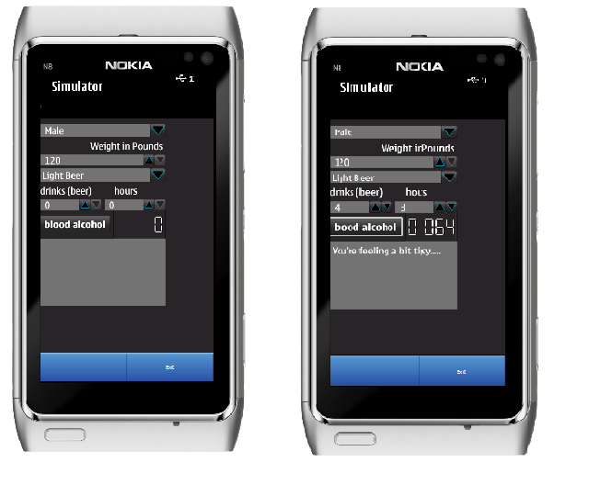

Project Artefacts

Presentation slides
code_camp_group_7.ppt

Report document
codecamp_ppt.pdf

Source Package
group7.zip

How to run software
-Extract ZIP file.
-Open NokiaQtSDK software.
-Open QT creator.exe
-Open simulator.
-Open source code from group 7 folder and run untitled.pro

Conclusion

