iManager
- Sanaz Ahmadi
- Teemu Kinnunen
- Jukka Lankinen

Idea
Organize images using only visual information, so that the user can find particular type of images easily. The system will organize images on the 2D map in the way that similar images are close to each other. Advantage of visual information is that user does not need to label all of his/her images to make searches.

Features
User can
- get a list of similar images from the server using visual information and visualize it
- browse image collection (Image map/gallery)
- sync the image collection with server with many devices
Optional features
- Share images with other users directly using mobile devices
- Image tagging and automatic learning of labels (image categories)

Implementation Plan and Goals
Server
- Image categorization using bag-of-words model (DONE)
- Syncing with clients (wip)
- Set up the server in the Internet
Client
- Syncing with server (wip)
- User interface design ([mostly] DONE)
- Settings page
  - Image folder
  - User information (user id, password)
  - Server settings (host address)

Design
THe framework
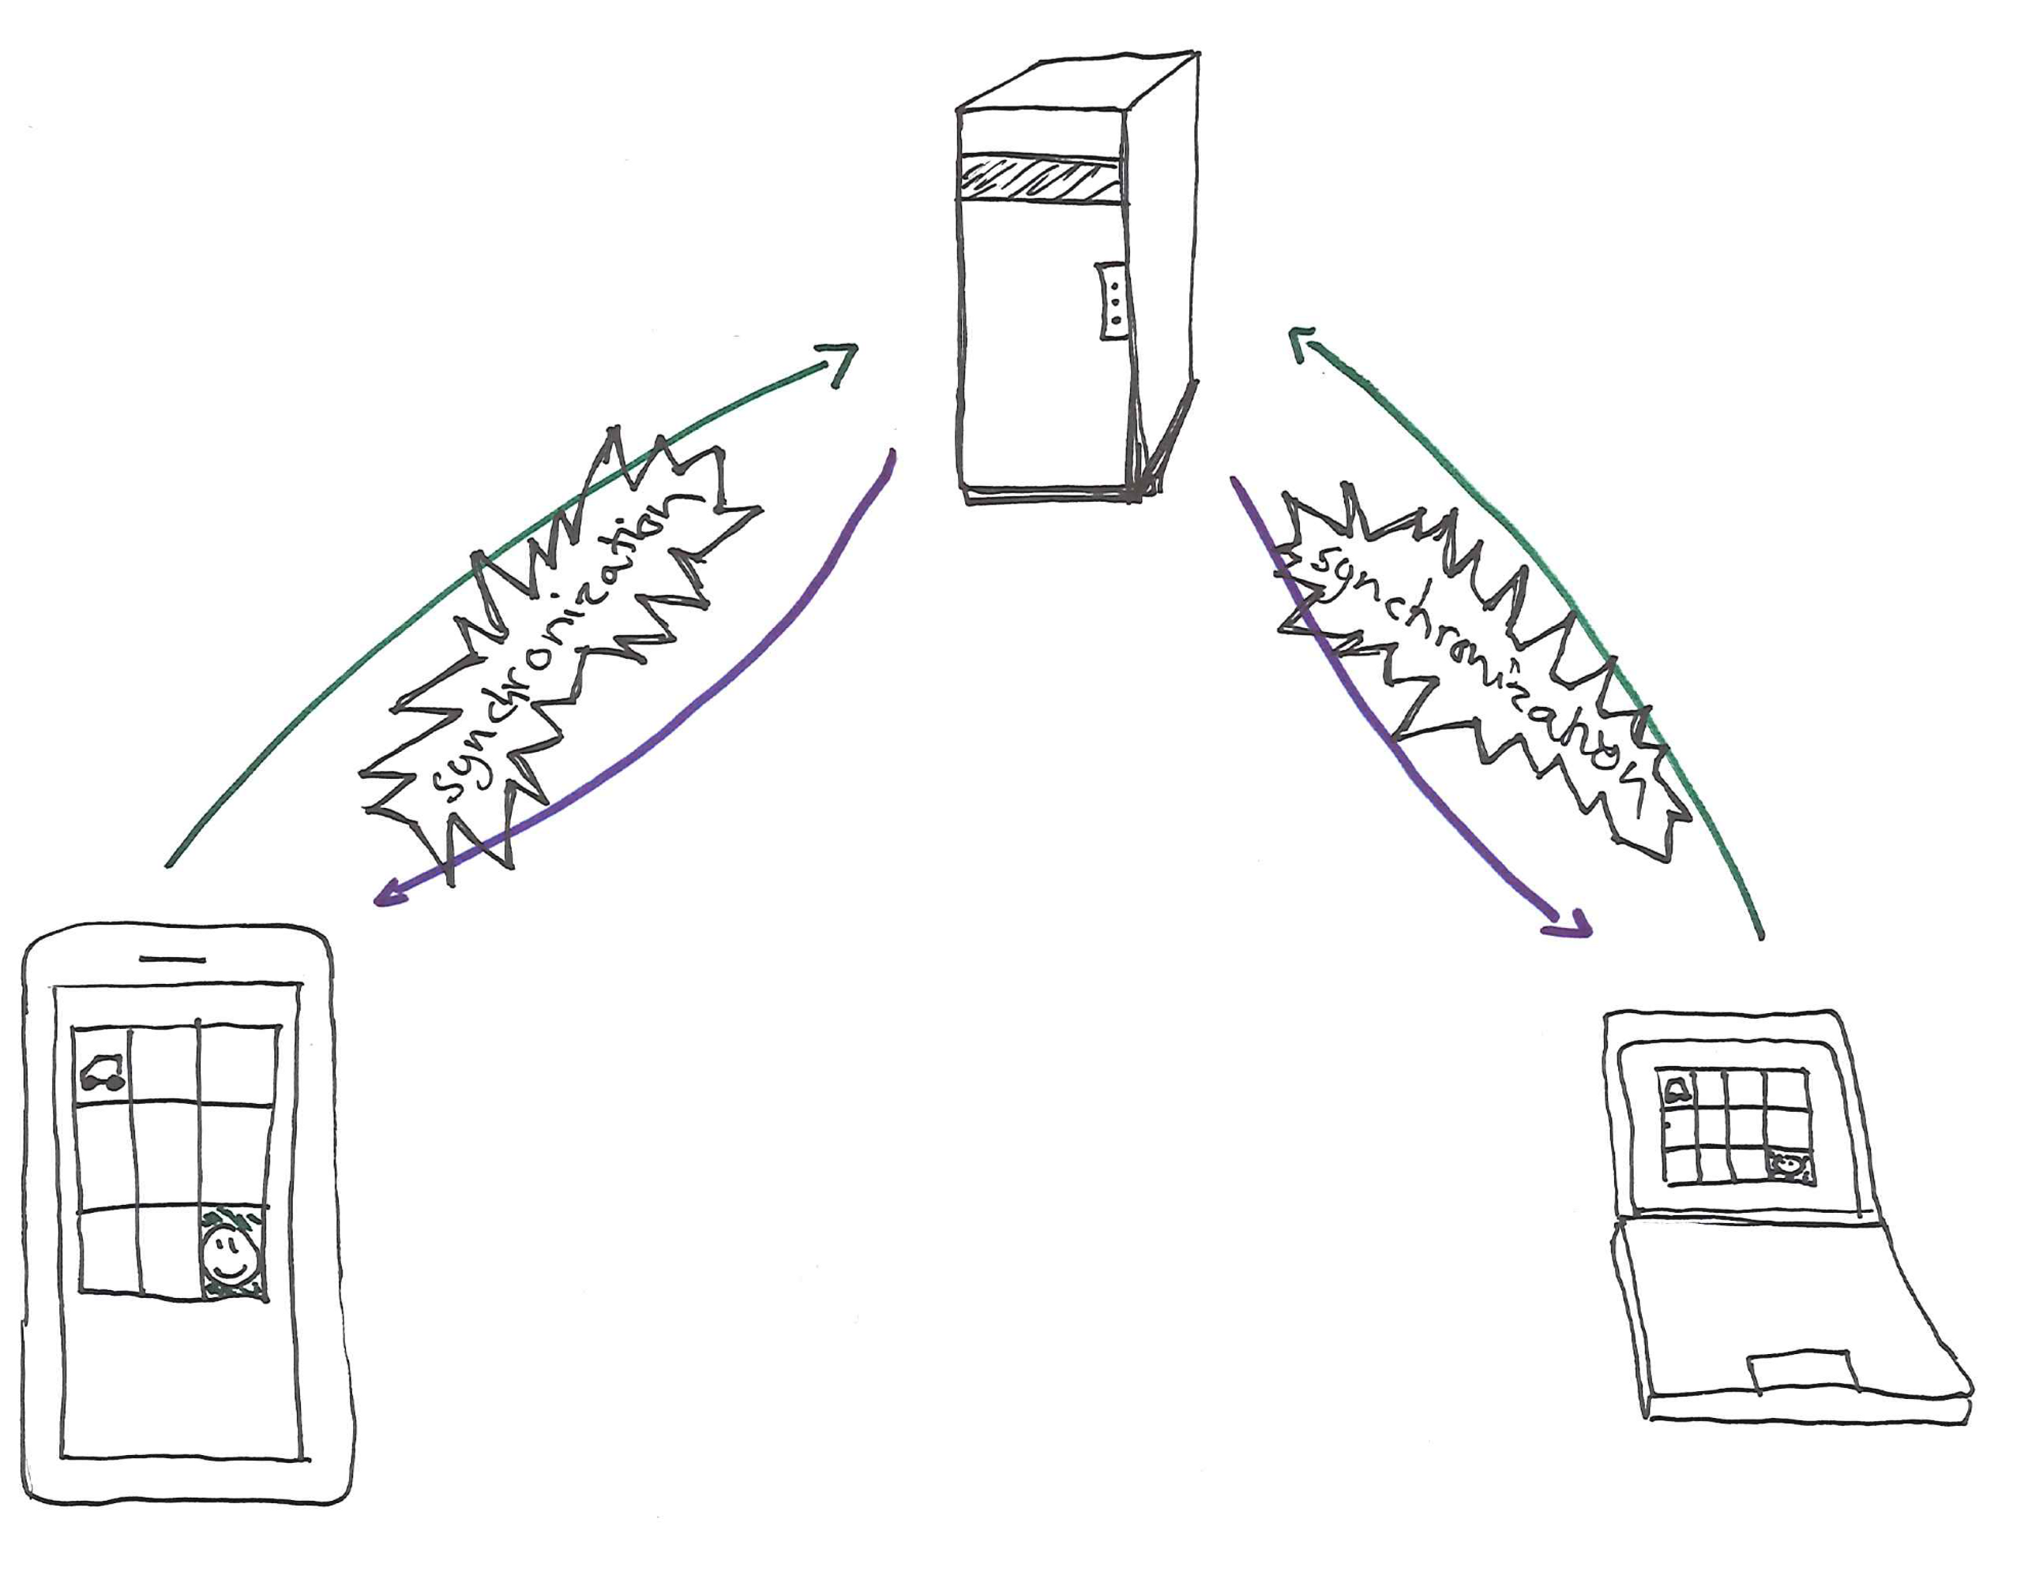The overview
The protocol
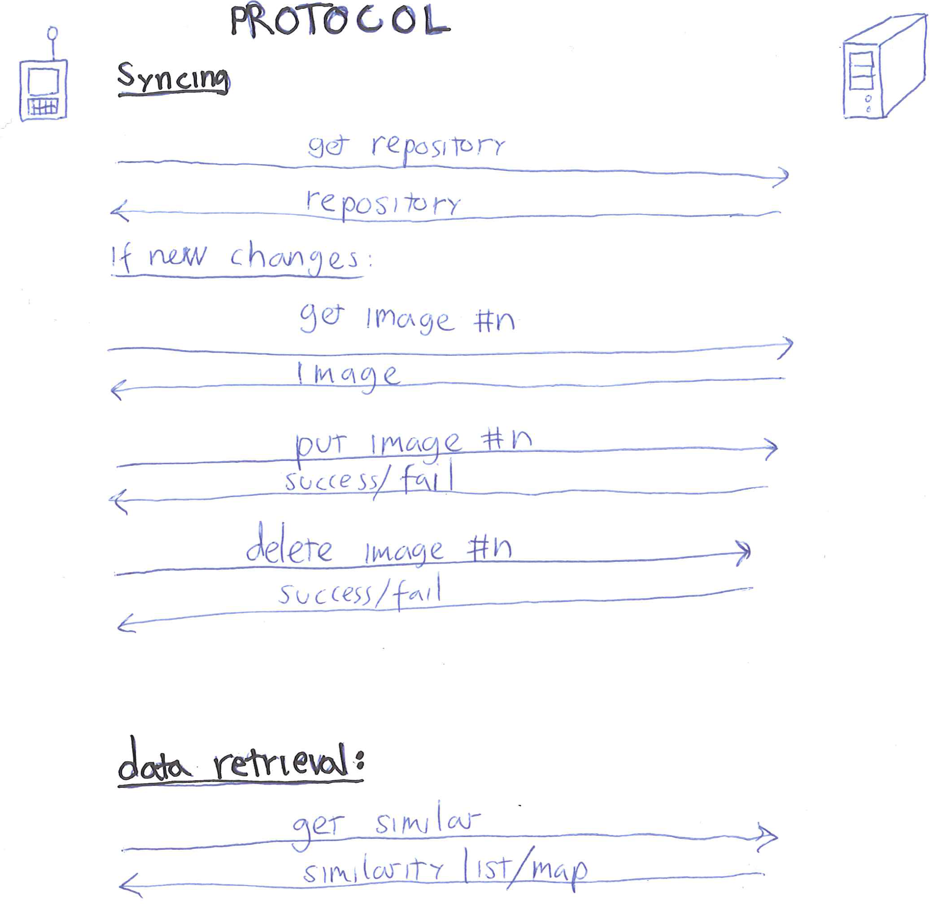The protocol

Screen shots

Project Artefacts

Presentation slides

Report document

Source Package

How to run software

Conclusion

