Qt Code Camp
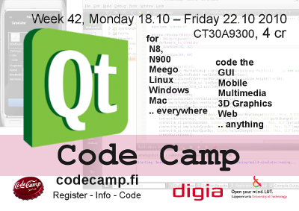
Week 42, Monday 18.10 - Friday 22.10 2010, Room 6428
CT30A9300 Code Camp on Communications Engineering (4 cr)

Coding
Goto Qt Coding Pages

Questions & Answers
If you have a questions, you can post it here. Feel free to add answers too. Go to the Q&A page..

Code Camp Week program
Location is computer classroom 6428
Monday
- 09:00 Opening
- Introduction and Topics
  - codecamp_start.pdf
- Topics .. ~16:00
- Task: Creating a idea
- 18:00 Social Event & Sauna
  - Telling about your group idea to others
Tuesday
- 09:15 Topics
- Task: copy structure grp page template to your grpNN page and describe name, idea and plan parts
- ~13:00 Short Idea Presentation (~5 min per group)
- Coding
Wednesday
- Start 10:00 (personnel at classroom)
- Coding
Thursday
- Start 10:00
- Coding
- Dead line coding
Friday
- Start 10:00, Code Complete
- Presentation preparation
- 12:00 - 15:30 Demonstrations
- 15:45 Winners & Closing

Groups
- 3 person groups
Group | Application | Name 1 | Name 2 | Name 3
grp1 | QuTe Translation | Oskar Sonninen | Rostislav Malevich | Petri Ryhänen
grp2 | Travel Cam | Naseer Ahmad | Fawad Ahmad | Zahir ul Din Babur
grp3 | Sound Controlled Alarm System | Mihai Iusan | Camilo Cifuentes | Bhupesh Mudari
grp4 | 8-puzzle game | Jarkko Pulli | Lauri Kyttälä | Petteri Pekonen
grp5 | WoWMobileArmory | Riku Pulliainen | Otto Luttinen | Antti Hannuksela
grp6 | Guess Your Number | Ravitheja Jalamadugu | sidhartha yalavarthi | param jyothi marilla
grp7 | Alcohol Meter | MD. Facihul Azam | P.Rajaraviteja | Srikanth Korrapati
grp8 | iManager | Sanaz Ahmadi | Jukka Lankinen | Teemu Kinnunen
grp9 | Q Air Hockey | Were | Bishal | Tommi
grp11 | Qt Fish | Jukka Stranden | Marko Suhonen | Antti Jäppinen
grp12 | Horoscope RSS Application | Abrar Sohail | Hilmi Abdullah | Open
- grp page template

What is Qt
Qt is a cross-platform application and UI framework. Using Qt, you can write web-enabled applications once and deploy them across desktop, mobile and embedded operating systems without rewriting the source code. – http://qt.nokia.com/products/

What is Code Camp ?
Code Camp is a learning and hacking experience. The code camp approach can be defined as a collaborative learning setting that aims to promote profession-oriented skills. In code camp, the term camp refers to a situation where students assemble and stay a while together. The term code refers to coding, i.e. writing computer programs.

Registration
Register to course via webropol:
- http://www.webropol.com/P.aspx?id=476063&cid=126126267
- Registration available till 2010-10-17 .

Recommended skills for Code Camp
- Programming experience on object oriented systems
- Basic knowledge from C++ programming language
- Basic understanding of common development areas: user interfaces, networking, event based systems, ..

Recommended actions before code camp
- From group ready with other students, group size is 3 (three).
- Start to think idea to do in code camp.
  - Target platform for code camp is mobile; N8, N900, Meego, Maemo + Qt, Symbian^3, Symbian touch
  - Qt Code Camp theme goes along Calling All Innovators developers contest; http://www.callingallinnovators.com/10m/about_the_contest.aspx
- Introduce yourself to Qt development
  - Install development environment to your computer (your laptop is a very good aid during code camp)
  - Code some tutorials
  - Introduce to the competition Calling All Innovators

