Project Bank
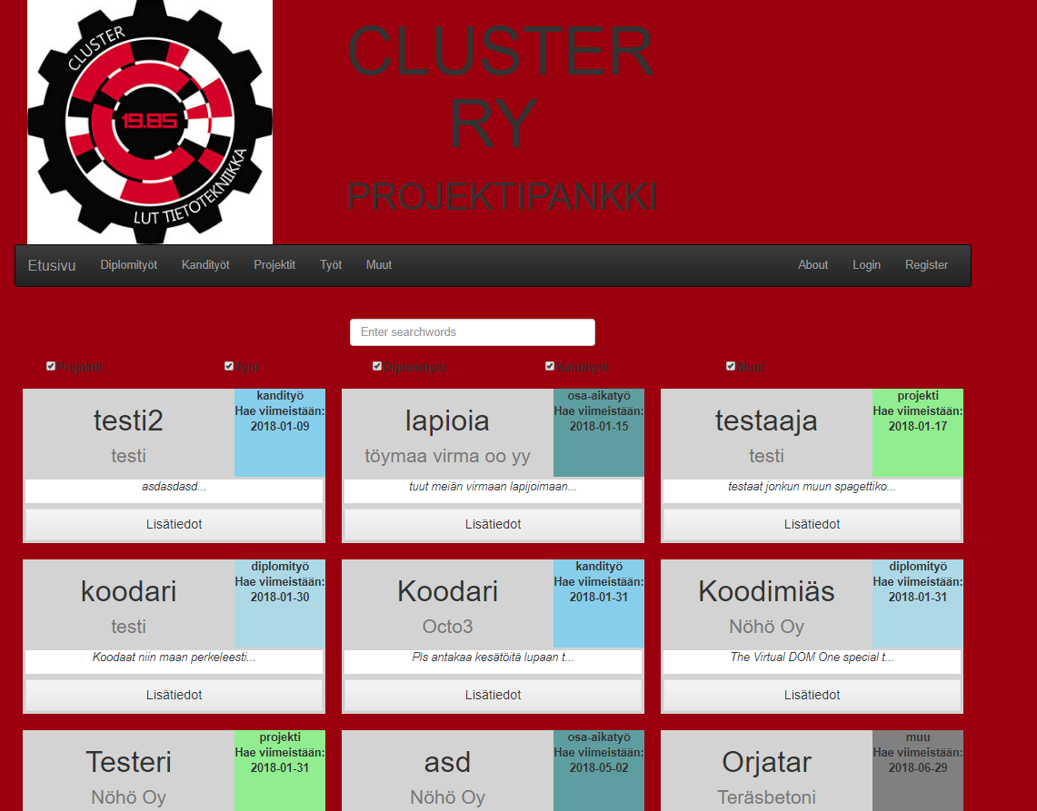
Platform for listing work and project opportunities. Targeted towards students of a specific field.

Attributes
- Streamlined with only the necessary features.
- Secure and robust.
- Customizable for different fields of study.

Value
- STUDENTS: Real life work and project opportunities
- COMPANIES: Recruitment targeting
- NGO’S & FIRMS: Proficient and enthusiastic developers for small projects

Features
- Retrieve all “cards” from database via php (card = unique item, which can be job, project or thesis opportunity).
- Show the cards in visually informational manner.
- Filter cards by their type or search.
- Click certain type from the navbar to show only that type of items.
- Show about page for the user.
- Links to login and register. Not implemented with react, these links take user to PHP-sites.

Tools & Technologies
We used certain set of tools and technologies during the implementation.
- Technologies
  - Create-react-app
  - react-bootstrap
  - flexbox-react
  - whatwg-fetch
- Tools
  - C9
  - Discord

Improvements after codecamp
Suggestions:
- About page - CHECK
- Improving visuals - CHECK (we did improve them, althought they're still not perfect)
- Direct filter links - CHECK
- Arranging items based on deadlines - CHECK (it's automatic, user has no possibility to change it)

Future development
- Improving the visuals
- Implementing control-panels (login, registration, adding cards) with react.
- Improving the filtering and arranging possibilities.
- Adding possibility to follow updates of the database. Email / social media plugin / something.
- Creating another service in relation to the current one: Personal CV database for software-students. Works like an open application for employees wishing to hire students.

Material
Project introduction presentation (Wednesday): project_presentation.pptx
Final presentation (Friday): project_presentation_kousa_kuisma.pdf
Final production build (Doesn't include PHP == no data): build.zip
Final source code: src.zip
Joblist JSON for testing purposes: https://pastebin.com/HD4Ut3sJ
DEMO VIDEO: https://drive.google.com/file/d/1PXpc1ZptTyBxRvp7CHdbxorWyD2q24Ol/view (background filling fixed after video)
It's also possible to get access to the C9 ide. Contact us for more information!

Team
Olli Kousa | React / UI
Kuisma Närhi | React / Back-end

