Group 3. Project Name here
- Alexey Denissov
- Fawad Ahmed
- Stewart Sabuka

Idea
We are going to create virtual keyboard which will allow user to use the keyboard to play different musical instruments and the user can also record the music he/she have composed and listen to it.

Result
The screenshot below shows the main page of our application when the user run it, it first display the instructions for the user. 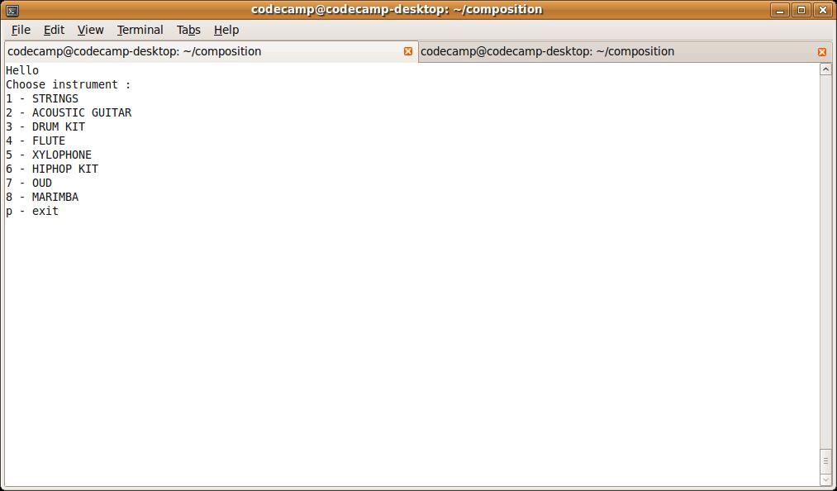
We are successfully able to allow playback of multiple instruments at the same on the desktop but on the device the playback is sequential. Our system is text based and we did not implement graphical user interface but the text instruction provided in the program are enough for a user to understand the program and use it easy. The idea is to help the user experiment with the sounds and let them compare the differences in the instruments and e.g. Guitars, Flute, Xylophone, and Oud etc.
comp2.c.tar.gz

