Group 5. Muzee
- Deepak Man Shrestha
- Kamal Panthi
- Santosh Kumar Kalwar

Muzee
Muzee is the combination of two words (Music + Quiz) especially focused for children between the age group of 3-12 years old. The main objective is to help children in the process of learning with Muzee application. This looks like simple Quiz game normally played in everyday life. But Muzee is little different than normal games simply because of Music focused in ubiquitous environment.

[Pseudo Algorithm for Muzee]
- Initiation (First Application will begin)
- Random image will appear with options
- Children selects options
- if the selected option is correct
- then music for that image will be played with description
- else help for making correct selection through music will be played
- end

Result
The application was successfully implemented with limited features. Here is the screenshot for the application- soundtrack.tar.gz
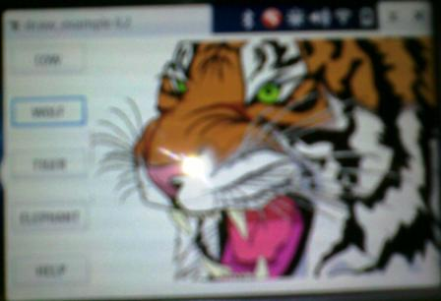
On the left hand sides are the options box such as Cow→Tiger→Wolf→Elephant and Help button On the middle is the picture for the animals.
- Case 1: User identifies the picture and clicks on the right button.
- Case 2: User could not identify the picture and clicks on the help button.
- Case 3: Help button produces the sound for the image. (e.g. if the image is of wolf, the sound for the wolf is produced)
- Case 4: User identifies the picture and clicks on the wrong button.
- Case 5: User after successful identification of picture and the right button moves to the next question.
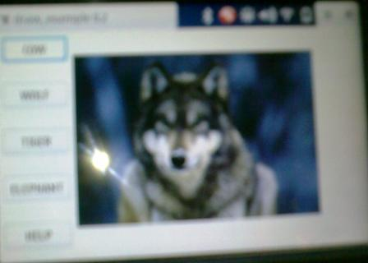
Enjoy the Game !

