Master of the Juniverse!!11 - Road Rage
- Japskua

Idea
Once you get old and lose your driver's license there is an empty spot in your life. However, now it's possible to crash your car endlessly without ANY PAYMENTS!
The Presentation Slides

Screenshots
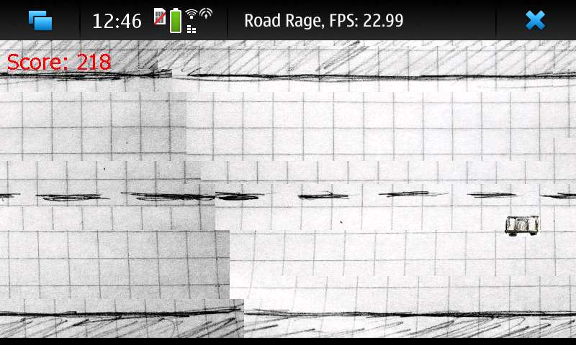Driving (bad screenshot)
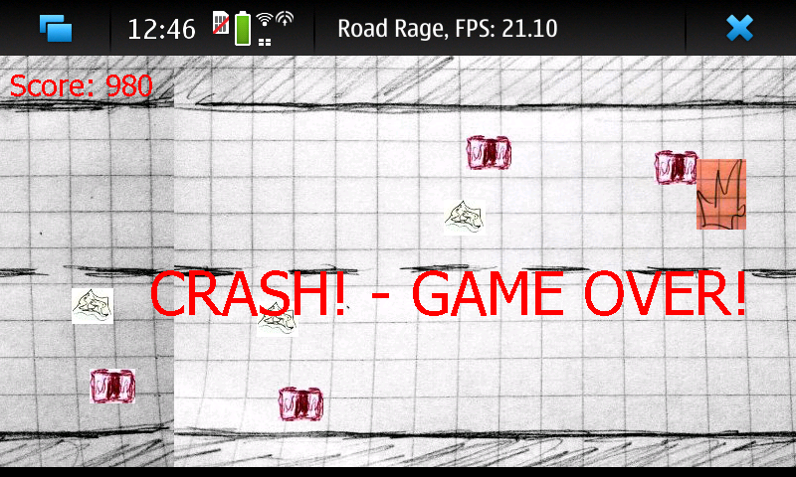Game Over, you crashed - again...

Code
The Game Source

Conclusion
Maemo Environment is a funny thing. I love Python!

