Dev4Fun - LifeCompanion
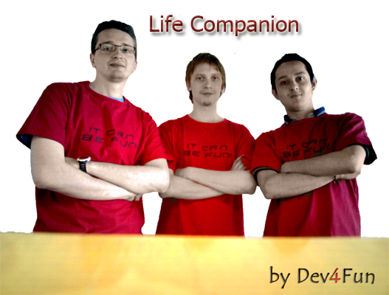
- Mihai Iusan
- Alexander Ovcharenko
- Camilo Cifuentes


Idea
Application is implemented for old people who has problems with coordination. When person falls down the accelerometer catches this event and makes special sound. If person doesn't respond in a one minute that all is fine, application will send an SMS message and call to predefined numbers.
Features
- Application works in the background
- Current actions and pages of the application are duplicated by voice records for easier communication with old person
- Application make a call on emergency event
- Interface is adapted for elder people who might have problems with user interface

Screenshots
Application starts with intro screen of the application.

Intro screen.
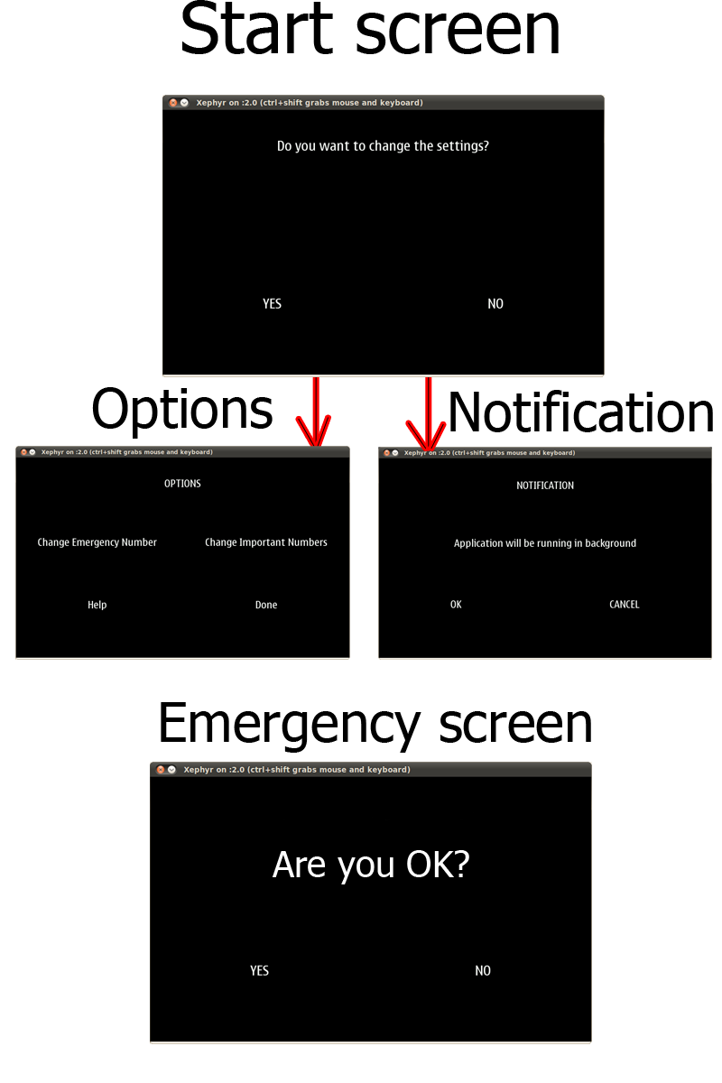
There are four main screens in the program:
Start screen - appeared on start up, asks user about changing the settings.
Options screen - On that page user can edit emergency number and important phone numbers.
Help screen - User can read a help on that page and information about the authors.
Notification screen - informs user that application will work in background.
Emergency screen - shows when phone falls down and asks person about his

Material
Code: lifecompanion.zip
Presentation: lifecompanion.pdf

Links
http://www.pygtk.org/docs/pygtk/

Conclusion
Due to low time and low experience in python language and maemo framework it was a really interesting challenge to make an useful application. The good atmosphere and help from other team opponents help us to design an stable program.
About the app, we can say that it could be very useful for old people and their relatives as the application can alert accidents about the user.

Future work
1) send a prerecorded voice messages.
2) voice control
3) finding GPS coordinates on emergency event and sending it via SMS.

