grp4 - MeHear
- Esa-Petri Tirkkonen
- Hilmi Abdullah

Idea
Using phone as hearing aid for old people (and not so old). Using phone's microphone and ear plugs. Basic idea is to amplify sound to make it audible for people with hearing proplems. Program will have volume control and some basic compressor and equaliser in it.

Result
We managed to do application which uses Gstreamer to stream straight from mic to ear plugs. It has also a compressor to make audio audible. Problem is just that volume or compressor is not controllable. Whole code would be needed to be rearranged to get buttons and knobs to do some thing. Propaply using gstreamers commandline version but that's other story

Screenshots
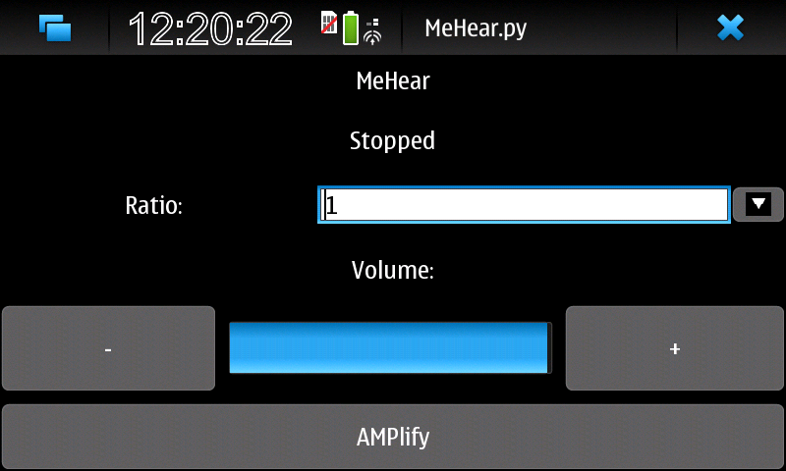

Code
#!/usr/bin/env python2.5
#
# Copyright (c) 2011
# This program is free software: you can redistribute it and/or modify
# it under the terms of the GNU Lesser General Public License as published by
# the Free Software Foundation, either version 3 of the License, or
# (at your option) any later version.
#
# This program is distributed in the hope that it will be useful,
# but WITHOUT ANY WARRANTY; without even the implied warranty of
# MERCHANTABILITY or FITNESS FOR A PARTICULAR PURPOSE. See the
# GNU Lesser General Public License for more details.
#
# You should have received a copy of the GNU Lesser General Public License
# along with this program. If not, see <http://www.gnu.org/licenses/>.
#
# ============================================================================
# Name : MeHear.py
# Author : Esa-Petri and Hilmi
# Version : 0.1
# Description : MeHear Maemo hearing aid program
# ============================================================================
from optparse import OptionParser
from time import sleep
import sys, os, time
import pygtk, gtk, gobject
import hildon
import dbus, gst, pygst
Volume=100
Cratio=10
class Record():
mic = None
def __init__(self, sink):
"""
@summary: The Constructor class, that searches for the microphone on initialization
"""
bus = dbus.SystemBus()
hal_manager = bus.get_object("org.freedesktop.Hal",
"/org/freedesktop/Hal/Manager")
hal_manager = dbus.Interface(hal_manager, "org.freedesktop.Hal.Manager")
print hal_manager
devices = hal_manager.FindDeviceStringMatch("alsa.type", "capture")
identifiers = []
for dev in devices:
device = bus.get_object("org.freedesktop.Hal", dev)
card = device.GetAllProperties(dbus_interface="org.freedesktop.Hal.Device")
if card["alsa.card"] not in identifiers:
print "%d. %s" % (card["alsa.card"], card["alsa.card_id"])
identifiers.append(card["alsa.card"])
self.mic = identifiers[0]
"""
@attention: this is important it initializes softfare playtrought (audioconvert is not nesesity)
@summary: takes stream from mic to autosink
"""
self.pipeline = gst.parse_launch("""alsasrc device=hw:%d ! volume %d !audiodynamic ratio=%d ! autoaudiosink location=%s""" % (self.mic, Volume, Cratio, sink))
def rec(self):
"""
@summary: sets recording on
"""
self.pipeline.set_state(gst.STATE_PLAYING)
print ""
print "recording started"
def stoprec(self):
"""
@summary: sets recording off
"""
self.pipeline.set_state(gst.STATE_NULL)
print ""
print "recording, stoped"
class player():
def __init__(self):
"""
@summary: player part
"""
self.player = gst.element_factory_make("playbin2", "player")
fakesink = gst.element_factory_make("fakesink", "fakesink")
self.player.set_property("video-sink", fakesink)
self.audiosink = gst.element_factory_make("autoaudiosink", "audio-output")
self.recorder=Record(self.audiosink)
"""
@attention: next links raw data from mic to player mekanism of gstreamer
"""
self.player.set_property("audio-sink",self.audiosink)
self.playmode = True
bus = self.player.get_bus()
bus.add_signal_watch()
bus.connect("message", self.on_message)
def on_message(self, bus, message):
t = message.type
if t == gst.MESSAGE_EOS:
self.player.set_state(gst.STATE_NULL)
self.playmode = False
elif t == gst.MESSAGE_ERROR:
self.player.set_state(gst.STATE_NULL)
err, debug = message.parse_error()
print "Error: %s" % err, debug
self.playmode = False
def play(self):
self.recorder.rec()
self.player.set_state(gst.STATE_PLAYING)
print "playing"
def stop(self):
#self.playmode = False
self.player.set_state(gst.STATE_NULL)
self.recorder.stoprec()
print "stoped"
class MeHear(hildon.Program):
def __init__(self):
self.pl= player()
# def record_button_clicked(self,button, label):
# buttontext = button.get_label()
# text = buttontext
# if text == "Record" :
# label.set_text(text+"ing...")
# button.set_label("Stop")
# print "Record button pressed"
#
# if text == "Stop" :
# button.set_label("Record")
# print "Stop button pressed"
def addvol_button_clicked(self, button, label, sm):
a=self.adjus.get_value()
self.adjus.set_value(a+10)
volume=a+10
print "volume %d"%(a+10)
def decvol_button_clicked(self, button, label, sm):
a=self.adjus.get_value()
self.adjus.set_value(a-10)
volume=a-10
print "volume %d"%(a-10)
def amplify_button_clicked(self, button, label):
buttontext = button.get_label()
text = buttontext
if text == "AMPlify" :
label.set_text("")
button.set_label("Stop")
self.pl.play()
print "play button pressed"
if text == "Stop" :
label.set_text("Stopped")
button.set_label("AMPlify")
self.pl.stop()
print "stop button pressed"
def main(self):
# place where fin info about pygtk http://www.pygtk.org/pygtk2tutorial/
win = hildon.StackableWindow()
# Create and pack labels
vbox = gtk.VBox(False, 10)
hbox3 = gtk.HBox(False, 10)
hbox2 = gtk.HBox(False, 10)
hbox = gtk.HBox(False, 10)
#interface.. buttons, labels ,... etc
labelHeader = gtk.Label("MeHear")
labelSubHeader = gtk.Label("voice amplifier")
self.adjus = gtk.Adjustment(value=60, lower=0, upper=100, step_incr=1, page_incr=0, page_size=0)
# Create the ProgressBar
self.pbar = gtk.ProgressBar(adjustment=self.adjus)
self. pbar.set_fraction(0.99)
self.addvol = gtk.Button("+")
self.addvol.connect("clicked", self.addvol_button_clicked, labelSubHeader,0.20)
self.decvol = gtk.Button("-")
self.decvol.connect("clicked", self.decvol_button_clicked, labelSubHeader,0.11)
buttonGTK = gtk.ToggleButton("AMPlify")
buttonGTK.connect("clicked", self.amplify_button_clicked, labelSubHeader)
#this changes the value of progres bar
#adjus.set_value(30)
#a= gtk.CheckButton("check button 1")
#hbox.pack_start(a, True, True, 0)
#b= gtk.ToggleButton("check button 1")
#hbox.pack_start(b, True, True, 0)
#c = gtk.RadioButton(None, "radio button1")
#hbox.pack_start(c, True, True, 0)
#adjus = gtk.Adjustment(value=60, lower=0, upper=100, step_incr=1, page_incr=0, page_size=0)
#d = gtk.SpinButton(adjustment= adjus, climb_rate=0.1, digits=5)
#hbox.pack_start(d, True, True, 0)
#hscrollbar = gtk.HSscrollbar(adjustment)
self.ratiotext= gtk.Label("Ratio:")
#http://www.pygtk.org/pygtk2tutorial/sec-ComboWidget.html
combo = gtk.Combo()
combo.entry.set_text("Compresion")
slist = [ "1", "3", "5", "10","15","20" ]
combo.set_popdown_strings(slist)
hbox.pack_start(buttonGTK, True, True, 0)
vbox.pack_start(labelHeader, True, True, 0)
vbox.pack_start(labelSubHeader, True, True, 0)
self.volumetext= gtk.Label("Volume:")
# Create a centering alignment object
#align = gtk.Alignment(0.5 ,0.5, 0, 0)
#vbox.pack_start(align, False, False, 5)
#align.show()
#align.add(self.pbar)
#self.pbar.show()
hbox3.pack_start(self.ratiotext, True, True, 0)
hbox3.pack_start(combo, True, True, 0)
hbox2.pack_start(self.decvol, True, True, 0)
hbox2.pack_start(self.pbar, True, True, 0)
hbox2.pack_start(self.addvol, True, True, 0)
vbox.pack_start(hbox3, True, True, 0)
vbox.pack_start(self.volumetext,True,False,0)
vbox.pack_start(hbox2, True, True, 0)
vbox.pack_start(hbox, True, True, 0)
# Add label's box to window
win.add(vbox)
win.connect("delete_event", gtk.main_quit)
win.show_all()
gtk.main()
if __name__ == "__main__":
app = MeHear()
app.main()
Upload and attach your project source code package here.
- Clean up compiled binary files before making package
- Use .zip format

Conclusion
Hilmi:Developing in Maemo environment was challenging, we faced some problems during the night but at the end it works. Moreover CodeCamp is a nice environment for learning.
Esa-Petri: Coding to maemo was nightmare as libraries aren't well ported like Gstreamer Pygtk and so on. Also software restrictions make coding awful. But learning to use gstreamer and Pygtk was good experience. I just would not want to have maemo ever. Trip to Riuttasaari was a really good experience and should be made as tradition. Overall good experience

