grp5 - Critical Assistant for (old) Person (CAP)
- Rostislav Malevich
- Sidhartha Yalavarthi(0377192)

Idea
CAP is last hope for old and physically limited person in cases when they falls down. CAP provides 5 levels of warnings and emergency signals. CAP is a stand-alone assistant with no user interaction. CAP targeted to old people, persons with physical limitations.

CAP Levels

LEVEL 1
- Idle mode. Looking for sights of falling.

LEVEL 2
- Falling were detected. User asked to confirm he is ok.

LEVEL 3
- Sound warning to call help from close area. (GPS unit powered up to receive coordinates.)

LEVEL 4
- CAP sends sms messages and call to predefined phone number. (FM transmitter powered up to transmit emergency messages.)

LEVEL 5
- CAP calls to emergency center (providing GPS coordinates and individual information by synthesizing text to speech.)
Each CAP level has time delay. If no user interaction detected in limited time, CAP rises emergence level. User interaction terminates current alarm. One more circle of emergency calls is started to guarantee stable condition of person. Emergency button to rise CAP level with no time delays.

Future Implementations
- CAP LEVEL 3. Power up GPS unit and receive current coordinates.
- CAP LEVEL 4. FM transmitter with frequency swapping
- CAP LEVEL 5. Speech synthesizer of GPS coordinates.

Screenshots
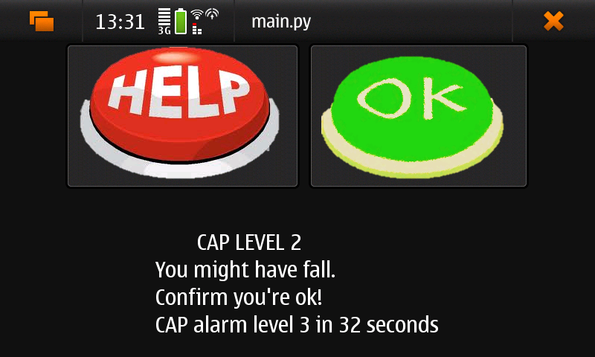

Code
Source code cap.zip

Presentation Slides
cap.ppt

Document
Final version final_cap.pdf

Conclusion
While making implementation of our idea, some vital features were left from application due to lack of tutorials.

