grp7 - Object Locator
- Bhupesh Mudari
- Chandrashekar Gattu
- Srikanth Korrapati
object_locator_--_final_report.pdf
object_locator_final.pdf
finalgrp7slide.pdf

Idea
Older people have a tendency to forget about their things. Objective of App:
- Take a picture of the object.
- Write/Store a note of where the object has been kept.
- When required in urgency, press the Identification button related to the image.
- Application Displays the object and its location.
- Object recognition can be done either manually(already stored image) or dynamically (using a camera)

Screenshots
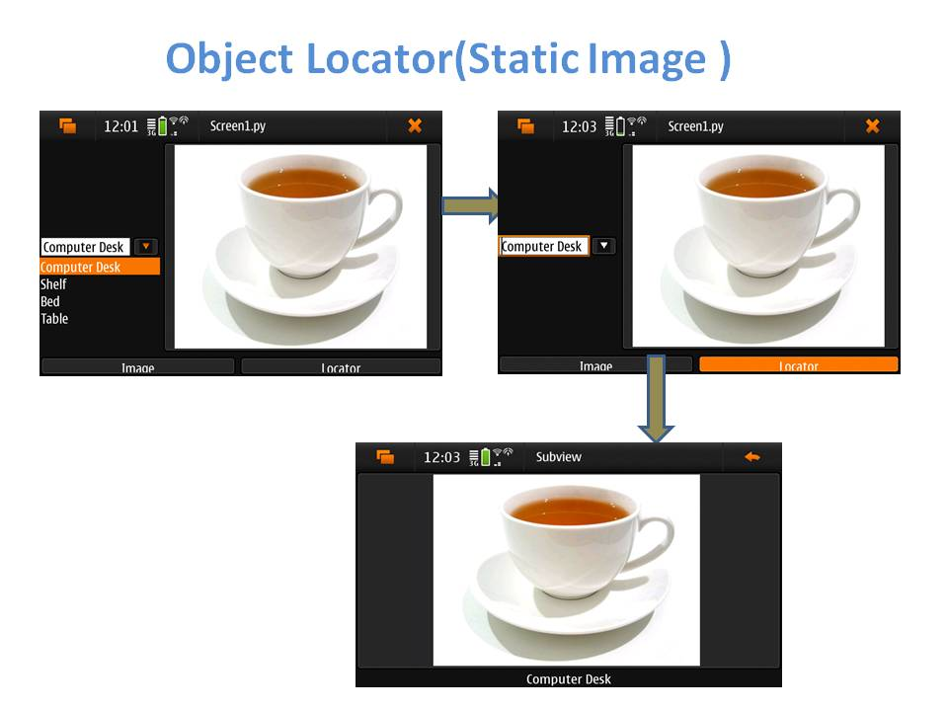
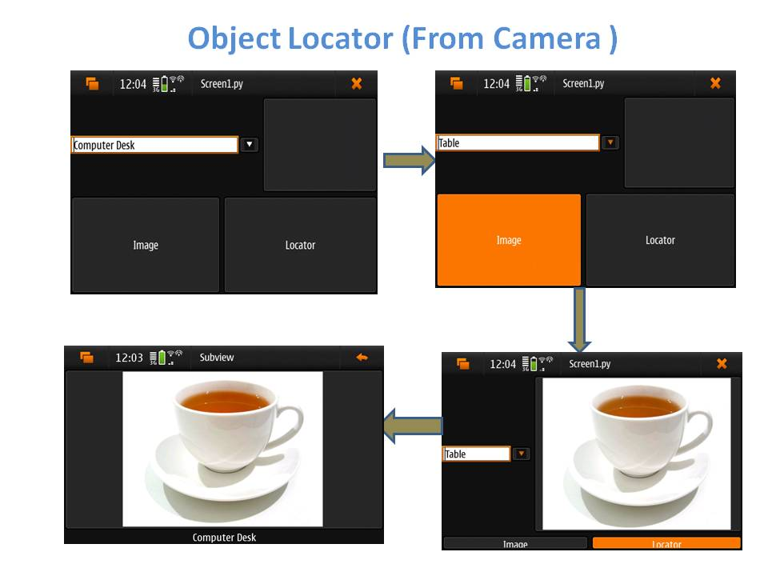

Code
Upload and attach your project source code package here.
- grp7oi_version1.zip
- grp7oi_finalversion1.zip

Conclusion
- Application is simple and easy to use.
- Elderly and Old people can track/locate their forgotten objects easily.
- Application supports both static and dynamic images.
- By extending the sample code, objects can be located using the GPS system.

