EASE - Energy-saving-Automated Sauna Experience

Group members
- Joonas Salminen
- Toni Martikainen
- Jayden Khakurel
- Edson

Idea and motivation
Motivation:
Social and Economic problem:
Many people die in Sauna (Over staying, Hyperthermia, drunk and being unconsciousness, etc) - 30-40 deaths in Finland 1)
Electric prices going up every year Global economy in poor condition Needs Saving than Spending.
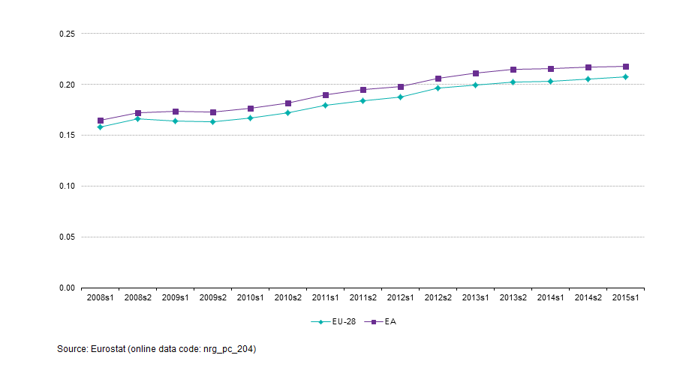 Evolution of EU-28 and EA electricity prices for household consumers 2)
Our scenario is a person trying to save energy/money when using the sauna in a single-person apartment. Our motivation for this comes from the fact that electric sauna stove is one of the biggest electricity consumers at home, about 6-10 kWh/session, with over half of the stove's energy consumption coming from pre-heating and the rest from keeping the warm up during the sauna session. Energy companies usually give some general instructions that you can follow to make the use of sauna more energy-efficient:
- Go to sauna immediately when it's ready
- Energy-efficient temperature for sauna is 70-80 °C
- Avoid breaks between people going to sauna
- Avoid keeping the sauna door open
- Keep the stove on only during the sauna session
Our idea is to automate some of these to make the person's life easier when trying to save some energy/money. In this case we're going to address points 1 and 2. We're also going to see the how much energy/money a person can save by using motion detection based lights in his sauna.

Features
Basically there are 3 parts in our system:
- Alarm system to inform the user when the sauna is ready (due to circumstances the alarm is a switch light turning on when sauna is warm which can then be turned off manually).
- Stove heating control which turns the heating on/off as needed to keep the temperature at certain level.
- Motion detection based lighting so that lights go on when there is movement and off if there is no movement for certain amount of time.

Technology
Automation server: FHEM
Server platform: TuxRadio (Debian/Linux, embedded)
Device protocol: HomeMatic
Used devices:
- Temperature sensor
- Light bulb
- Motion detector
- Switches

Energy and cost savings
Calculations are based on the scenario where person uses the sauna 7 times a week for 1.5 h (1 h for warming the sauna to 80 °C and 0.5 h for the sauna session itself) every week during the year.
We assume that the energy costs 0.12 €/kWh which is the average price of household electricity in Finland 3). We also assume that the power of the stove is 6 kW and we know that the lamp's power is 0.053 kW.
Stove
Normal situation: Let's assume that without alarm the person would go to sauna 10 minutes later than with alarm and thus waste energy.
6 kW * (1.5 h + 10/60 h waiting time) * 0.12 €/kWh * 52 weeks * 7 = 436.8 € in a year
Our situation:
6 kW * 1.5 h * 0.12 €/kWh * 52 weeks * 7 = 393.12 € in a year
So the saving is about 44 €/year.
Lighting
Normal situation: We assume that the light is on during the heating phase and sauna session itself.
0.053 kW * (1.5 h + 10/60 h waiting time) * 0.12 €/kWh * 52 weeks * 7 = 3.86 € in a year
Our situation: We assume that the motion detecting light is on for 22 minutes (two 4 minute cooldown breaks) during the whole session
0.053 kW * 22/60 h * 0.12 €/kWh * 52 weeks * 7 = 0.84 € in a year
So the saving is about 3 €/year with one lamp.
Total
Thus with our system the total savings are about 47 € (~392 kWh) in a year.
Cost for the equipment:
HomeMatic 131776 Wireless motion detector Indoors: 65 €
HomeMatic 130248 Wireless switch 1-channel Adapter 3680 W: 3 x 54 €
HomeMatic 132095 Wireless temperature and humidity sensor HM-WDS40-TH-I-2 Indoors: 54 €
Total: 281 €
One time investment. Return of Investment (ROI) : 281/47= 6 years.

Documentation
- Project presentation: group2_project_ease.pdf
- Protocol presentation: group2_p_enocean.pdf
- Project report: [download link]
- Project poster: group2_poster.pdf

Sources
- [zip link here]

1)
2)
3)

