Group 6: (Name)
Torino WebOS start
Group Information:
Seyed Mahmoud Mortazavi
Alireza Kahaei
Bandana Karki

Idea
This is simple web operating system.The operating system consists of a core which provides services to the higher layers(Applications).This OS has some of already installed software like a calculator and a notepad.The OS also has a process explorer that displays the current running applications.

Service
(List of application functionalities)
Every Operating System provides two main kinds of services. First are the services that it provides to the users of that and the second is the type of services that it provides to the application developers ie. APIs. Torino WebOS also provides these services at both levels and most important of all is that all the functionalities are provided through the Web interface. So there is no need to install any application on the client but only a browser, and have all the benefits that an Operating System can provide.
Here Comes the services that Torino provides to the user:
User Services (Applications)
Desktop Environment | the first application runs after the OS starts
Calculator | provides mathematical functions
Notepad | it is an editor which allows user to edit and save it on hard drive
Chess | provides user to play chess
Calender | it provides current date
Commander | it is command line utility that allows user to run file system specific commands like ls, cd and mkdir.
Process Explorer | it provides a visual picture of the running applications on OS
File Uploader | by using this utility user can send personal files to OS
Here Comes the services that Torino provides to the developer:
Applications Developer Services(API)
Create an application | by calling this API the developer can start another application process
Destroy an application | by calling this API the developer can destroy existing application process
Create an application | by calling this API the developer can start another application
File System Services
Create Directory | by calling this API the developer can make a new directory in the path specified
List Files | by calling this API the developer can read the list of the files an directories in the specified path

Software
(files and instructions to run software) Software Package (in zip)
This is a software package including the eclipse project and theme files.
torinowebos.zip
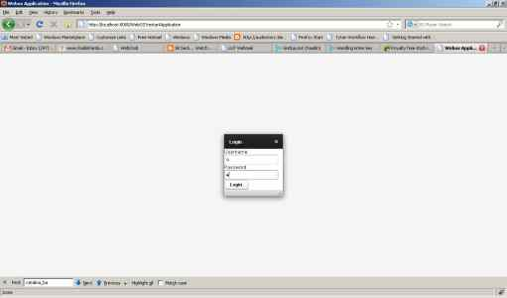
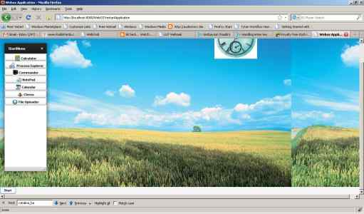
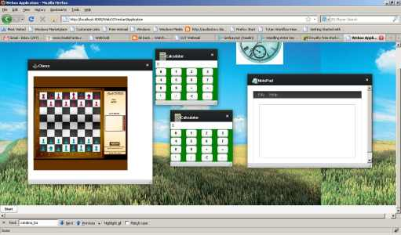
Vaadin review
Component summary
- vertical layout
- Table
- window
- button
- embedded
- textfield
- notification
- upload

Problem We encountered:
adding a background image to a panel via themes does not work
solution is to use Layouts not Panels
Acknowledgements
We want to thank group 2 for their help on solving our problem of Upload Component.

