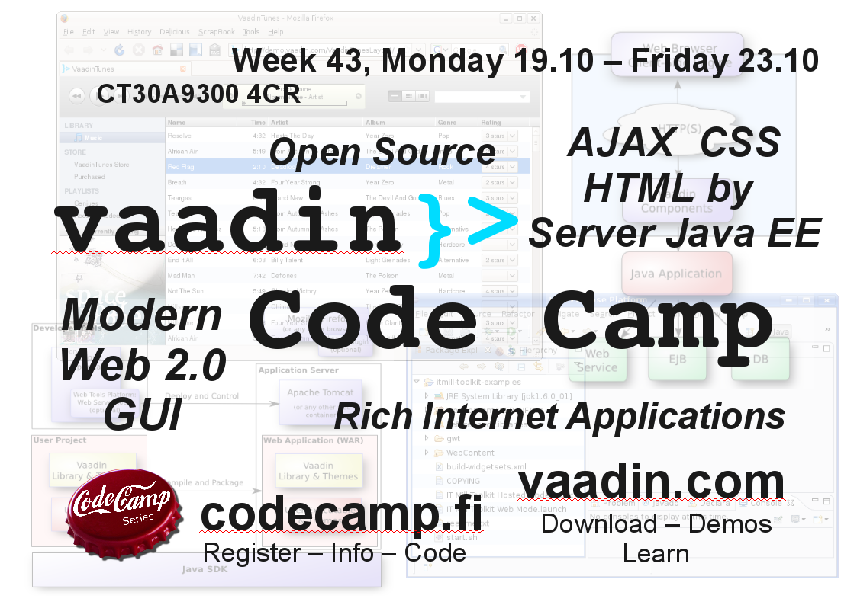

Vaadin Code Camp 2009
Week 43 Monday 19.10 - Friday 23.10 2009, 6428
CT30A9300 Code Camp on Communications Engineering (4 cr)
http://vaadin.com| vaadin Coding Pages

What is vaadin ?
Vaadin is a Java framework for building modern web applications that look great, perform well ans make you and your users happy. Demos, Downloads, API's, Book and more ⇒ http://vaadin.com. vaadin coding.

What is Code Camp ?
Code Camp is a learning and hacking experience. The code camp approach can be defined as a collaborative learning setting that aims to promote profession-oriented skills. In code camp, the term camp refers to a situation where students assemble and stay a while together. The term code refers to coding, i.e. writing computer programs.

Registration
Enroll to course CT30A9300 Code Camp on Communications Engineering in WebOodi .

Code Camp Week
Location 6428 Windows Classroom
- Start time on Monday 10:15
 | Monday | Tuesday | Wednesday | Thursday | Friday
10:15 | Intro | Idea complete & Design | Coding | Coding | Code complete
12:00 | Lunch | Lunch | Lunch | Lunch | Demo
13:00 | Intro | Coding | Coding | Coding | Demo
16:00 | Idea Brainstorming | Coding | Coding | Coding | Closing
18:00 | Idea Brainstorming | Coding | Coding | Coding
02:00 |  | Coding | Coding | Deadline style Coding
Presentations
- Code Camp Start (seems not to work with firefox in 6428)

Groups
Group | Application | Name 1 | Name 2 | Name 3
grp1 | Avis | Kokko Joona-Pekka | Myllys Wille | Jurkkola Ville
grp2 | TwiToday | Parkkila Janne | Malevich Rostislav | Maglyas Andrey
grp3 |  | Azad Md. A K | Azam MD. F | Sheuly Sumsunnahar
grp4 | Remote Jukebox | Pyy Mikko | Bhetuwal Pashupati | Babur Zahir U D
grp5 | OurEasyMovies | Santosh Kalwar | Deepak Man Shrestha | Manish Thapa | Kamal Panthi
grp6 | Torino WebOS | Kahaei Alireza | Seyed Mahmoud Mortazavi | Karki Bandana
grp7 |  | Sohail Abrar S | Were Oyomno | Karki Bishal Raj
grp8 |  | Ahmadi Zeleti Fatemeh S | Adomako T Joshua | Sabuka Stewart R

Discuss
Discuss coding etc. problems
- IRC
  - Read http://vaadin.com/chat
  - Get some irc client eg. http://www.mirc.com/ or use web client eg. http://webchat.xs4all.nl/
    - mirc can be installed into your home profile (My Documents)
  - set your nick name (and other information).
  - set server to irc.freenode.net
  - join to #vaadin channel
- Forums ⇒ http://vaadin.com/forum
- Skype

FAQ

What are recommended skills for code camp ?
Programming experience.
vaadin is Java framework, so basic Java knowledge and experience is recommended for coding. If you have solid practice on other object oriented languages, it is quite feasible to learn java during course as well.
Basic on Graphical User Interface programming is recommended as well basics on Web programming.

Can I prepare to Code Camp ?
Yes. During code camp week we will brainstorm a software idea, design it and code it. Getting good ideas might sometimes be hard and thinking about different ideas before code camp makes it faster to get into coding part.
Also introduce to vaadin framework ⇒ http://vaadin.com .

I have a exam in Code Camp week ?
You are free to go exam, but code camp in intensive course and idea is to focus coding during the well, so it is recommended you prepare to exam before the code camp week.

Grading ?
Grading 1-5 from
- Idea and presentation of the Idea in wiki: 25%
- Coding of the implementation: 40%
- Demonstration: 15%
- Code Camp Spirit: 20%

More ?
If you have questions about code camp send email to petri dot heinila at lut dot fi.

Links
Vaadin
- Forum: http://vaadin.com/forum
- Twitter: http://twitter.com/vaadin
- API: http://vaadin.com/api/
Data storage
- For simple “key=value” case use Java Properties file
- db4o is is also simple solution without annotations
- If you are targeting Google App Engine use JDO or JPA and read: http://code.google.com/appengine/docs/java/datastore/
- For Java-based SQL storage Apache Derby
Personal Pages
- Sami: http://vaadin.com/sami
- Jonatan: http://vaadin.com/jonatan
Other
- GoodNews Sample Code and two jar's are neeeded as well to put them into MyProject/WebContent/WEB-INF/lib folder:
  - https://rome.dev.java.net/ rome-1.0.jar
  - http://www.jdom.org/dist/binary/ and jdom-1.1.1.zip. Open zip and take jdom.jar from jdom/build folder.
  - OR on eclipse
    - Create vaadin project GoodNews
    - File→Import, General→Archive File, select goodnews.zip and finish ⇒ GoodNews/GoodNews/ folder is created
    - Move files from GoodNews/GoodNews/WebContent/WEB-INF/lib/ to GoodNews/WebContent/WEB-INF/lib
    - Move files from GoodNews/GoodNews/src/com/example/goodnews to com.example.goodnews
    - GoodNews/GoodNews can be deleted
- Contributed components/widgets: http://dev.vaadin.com/svn/contrib/ and http://dev.vaadin.com/svn/incubator/
- Uilder code search: http://uilder.virtuallypreinstalled.com/search

