Educational Technologies Centre

Dept. of Innovation & Software
Innovation and Software research group at LUT has ongoing research in collaborative learning and the gamification of learning. Please see the publications below for information about the research.

Research in Data Analysis
Antti Knutas, Arash Hajikhani, Juho Salminen, Jouni Ikonen, and Jari Porras. 2015. Cloud-Based Bibliometric Analysis Service for Systematic Mapping Studies.
In Proceedings of the 16th International Conference on Computer Systems and Technologies (CompSysTech '15).
(Download Preprint)

Research in Collaborative Learning and the Gamification of Learning
Antti Knutas, Jouni Ikonen, and Jari Porras. 2015. COMPUTER-SUPPORTED COLLABORATIVE LEARNING IN SOFTWARE ENGINEERING EDUCATION: A SYSTEMATIC MAPPING STUDY.
International Journal on Information Technologies & Security, 7(4).
(Download Preprint from Researchgate; Download Preprint PDF)
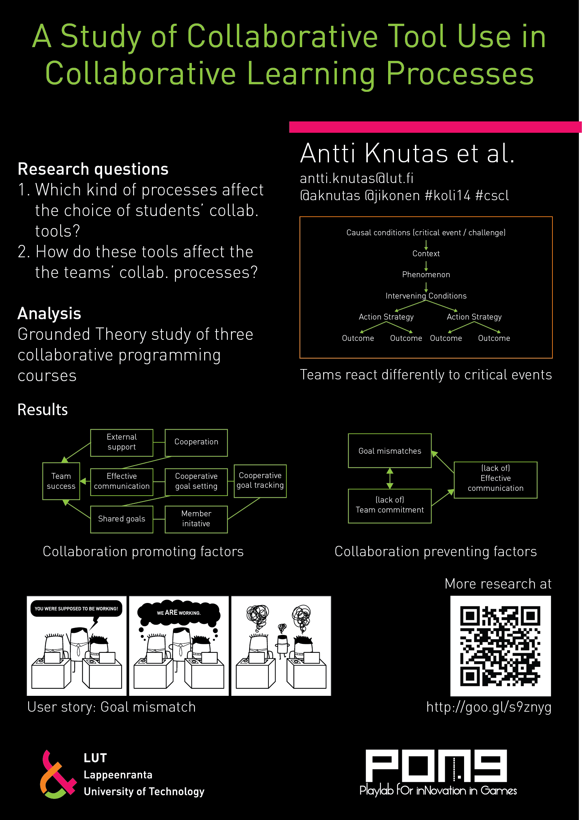
Antti Knutas, Jouni Ikonen, Laura Ripamonti, Dario Maggiorini, and Jari Porras. 2014. A study of collaborative tool use in collaborative learning processes.
In Proceedings of the 14th Koli Calling International Conference on Computing Education Research (Koli Calling '14). ACM, New York, NY, USA, 175-176. DOI=10.1145/2674683.2674706 ACM DL link: http://doi.acm.org/10.1145/2674683.2674706
(Download preprint; see the full size poster)
Antti Knutas, Jouni Ikonen, Dario Maggiorini, Laura Ripamonti, and Jari Porras. 2014. Creating software engineering student interaction profiles for discovering gamification approaches to improve collaboration.
In Proceedings of the 15th International Conference on Computer Systems and Technologies (CompSysTech '14), Boris Rachev and Angel Smrikarov (Eds.). ACM, New York, NY, USA, 378-385. DOI=10.1145/2659532.2659612 - ACM DL link: http://doi.acm.org/10.1145/2659532.2659612
(Download preprint; see the notification about errata; see the slides)
Antti Knutas, Jouni Ikonen, Uolevi Nikula, and Jari Porras. 2014. Increasing collaborative communications in a programming course with gamification: a case study.
In Proceedings of the 15th International Conference on Computer Systems and Technologies (CompSysTech '14), Boris Rachev and Angel Smrikarov (Eds.). ACM, New York, NY, USA, 370-377. DOI=10.1145/2659532.2659620 - ACM DL link: http://doi.acm.org/10.1145/2659532.2659620
(Download preprint)
Antti Knutas, Jouni Ikonen, and Jari Porras. 2013. Communication patterns in collaborative software engineering courses: a case for computer-supported collaboration.
In Proceedings of the 13th Koli Calling International Conference on Computing Education Research (Koli Calling '13). ACM, New York, NY, USA, 169-177. DOI=10.1145/2526968.2526987 - ACM DL link: http://doi.acm.org/10.1145/2526968.2526987
(Download preprint)
Antti Knutas, Harri Hämäläinen, Jouni Ikonen, and Jari Porras. 2013. Implementation of an embedded mobile device based feedback system for real-time audience feedback.
Computer Applications in Engineering Education 21, E31–E40. doi:10.1002/cae.20570 - Wiley link: http://onlinelibrary.wiley.com/doi/10.1002/cae.20570
(Download preprint)

Wearable Technology in Education
Jouni Ikonen and Antti Knutas. 2014. Exploring Wearable Cameras for Educational Purposes.
International Conference on e-Learning ’14.
(Download preprint)

Center for Innovative Educational Technologies
Communications software laboratory of Lappeenranta University of Technology is part of Virtual Network of Innovative Educational Technologies Centres (VNIETC) in the field of Computing
The laboratory has been actively seeking different ways to improve teaching. Some of the approaches are:

Code camp teaching method
- Kari Heikkinen, Jouni Ikonen and Jari Porras, Integrating Code Camp Concept into CSE Curricula, Proceedings of the international conference on e-learning and the knowledge society (e-Learning’10), Riga, Latvia, August 26-27, 2010. pp. 215- 220. ISBN 978-9984-30-181-5.
**Keywords: Code Camp, Teaching Method and Curricula design**
**Main contribution:** Applying Code Camp practices and activities to the whole curricula design and to a single traditional course plan.
- Heikkinen, Kari & Porras, Jari & Ikonen, Jouni & Hämäläinen, Harri: Emphasizing Group Work In Code Camp Process, Journal of Education, Informatics and Cybernetics, 2009, vol. Vol.1, nro. 2, p. 25-31, ISSN 1943-7978. published article BibTeX Local copy: emphasizing_group_work_in_code_camp_process_2008_citation.pdf
**Keywords: Code Camp, Group work and Skill Analysis **
**Main contribution:** Development of Code Camp method and practices in a process. The basis of development are group work activities and skills obtained through group work.
- Kari Heikkinen, Jari Porras, Jouni Ikonen: Introducing Code Camp Process, The 2nd International Multi-Conference on Society, Cybernetics and Informatics (The 6th International Conference on Education and Information Systems, Technologies and Applications), June 29th – July 2nd 2008. Vol. 2., pp.175-180. ISBN 1-934272-47-7
**Keywords: Code Camp, Process and Skill Analysis **
**Main contribution:** Introducing Code Camp method and practices as a process. Analysis of that process through skill development.
- Jari Porras, Kari Heikkinen, Jouni Ikonen: Teaching .NET Programming with Code Camp Approach. The 2nd International Multi-Conference on Society, Cybernetics and Informatics. (The 6th International Conference on Education and Information Systems, Technologies and Applications), June 29th – July 2nd 2008. Vol. 3., pp. 34-39. ISBN 1-934272-48-5.
- Jari Porras, Kari Heikkinen, Jouni Ikonen: Code camp – a Setting for Collaborative learning of Programming. Advanced Technology for Learning (ATL) International Journal, Special Issue on Technology for Collaborative Learning. Vol 4, No. 1, 2007, ACTA press. pp. 43-52. ISSN 1710-2251. preprint BibTeX
- Jari Porras, Jouni Ikonen, Kari Heikkinen, Kimmo Koskinen, Leena Ikonen: Better programming skills through Code Camp approach, 16th EAEEIE Annual Conference on Innovation in Education for Electrical and Information Engineering (EAEEIE'05), 6th -8th June, 2005, Lappeenranta, Finland.
- Use of Peer Review in programming courses. There are also related publications:
- Harri Hämäläinen, Ville Hyyrynen, Jouni Ikonen and Jari Porras, Applying Peer-Review Software for Programming Assignments. International Journal on Information Technologies & Security, No 1, 2011, pp. 3-17, ISSN 1313-8251. preprint .
The main contribution is the presented peer-assessment software for software courses,
which has been released as open source and the evaluation of the software.
- Ville Hyyrynen, Harri Hämäläinen, Jouni Ikonen and Jari Porras, Experiments on Applying Peer-Review Software for Programming Assignments, Proceedings of the international conference on e-learning and the knowledge society (e-Learning’10), Riga, Latvia, August 26-27, 2010. pp. 197-202. ISBN 978-9984-30-181-5. preprint
The main contribution is the evaluation of peer-review trials on programming courses.
- Ville Hyyrynen, Harri Hämäläinen, Jouni Ikonen and Jari Porras. MyPeerReview: An Online Peer-Reviewing System for Programming Courses, 10th Koli Calling International Conference on Computing Education Research, Koli National Park, Finland, 28-31.10.2010, pp. 94-99. ISBN 978-1-4503-0520-4. preprint BibTeX
- Harri Hämäläinen, Jukka Tarkkonen, Kari Heikkinen, Jouni Ikonen and Jari Porras: Use of Peer-Review System for Enhancing Learning of Programming. The 9th IEEE International Conference on Advanced Learning Technologies, Riga, Latvia, July 14-18, 2009. pp.658-660, ISBN 978-0-7695-3711-5 preprint BibTeX

E-portfolio in learning
- Harri Hämäläinen, Jari Porras and Jouni Ikonen, Integration of learning support applications in the development of e-Portfolios, The IEEE Multidisciplinary Engineering Education Magazine, Vol 4, No 3, pp. 76-82, 2009. ISSN 1558-7908
- Harri Hämäläinen, Jouni Ikonen and Jari Porras: Using Wiki for Collaborative Studying and Maintaining Personal Learning Diary in a Computer Science Course. The 9th IEEE International Conference on Advanced Learning Technologies, Riga, Latvia, July 14-18, 2009. pp.679-680, ISBN 978-0-7695-3711-5
- Harri Hämäläinen, Jouni Ikonen and Jari Porras: Developing Technical e-Portfolio Construction Process. The 9th IEEE International Conference on Advanced Learning Technologies, Riga, Latvia, July 14-18, 2009. pp.711-712, ISBN 978-0-7695-3711-5
- Harri Hämäläinen, Jouni Ikonen and Ilkka Nokelainen. The Status of Interoperability in E-Portfolios: Case Mahara. 7th E-learning Conference, e-Learning'11 (E-Learning and the Knowledge Society), Bucharest, Romania, August 25-26th, 2011, pp. 64-69, ISBN 978-606-505-459-2. Preprint Presentation
The main contribution of the paper is the recognition of current status of the interoperability work concerning e-Portfolios.
The needs for well-designed specifications and their implementations are obvious and topical since the users (students) will be
transferring their portfolios from a platform to another in near future.

Technology in the loop
- Harri Hämäläinen, Jouni Ikonen and Jari Porras: Applying wireless technology to teaching environment, Proceedings of 1st Workshop on Applications of Wireless Communications (WAWC'03), Lappeenranta, Finland, August 7th, 2003, pp. 29-36. ISBN 951-764-784-0.
- Harri Hämäläinen, Jouni Ikonen and Jari Porras: Increasing student participation through online virtual environment, Proceedins of the Second Annual Finnish / Baltic Sea Conference on Computer Science Education, Report A-2002-7, University of Joensuu, Department of Computer Science, October 18-20, Koli, Finland, pp. 28-31, ISBN 952-458-197-3. Presentation
- Antti Knutas, Harri Hämäläinen, Jouni Ikonen and Jari Porras: Implementation of an Embedded Mobile Device Based Feedback System for Real-Time Audience Feedback, Journal of Computer Applications in Engineering Education, DOI: 10.1002/cae.20570, Abstract
- Harri Hämäläinen, Jouni Ikonen and Jari Porras: A Tool for Visualizing Skill Requirements in ICT Job Advertisements. 7th E-learning Conference, e-Learning'11 (E-Learning and the Knowledge Society), Bucharest, Romania, August 25-26th, 2011, pp. 254-259, ISBN 978-606-505-459-2. Preprint Presentation

Other educational aspects
- Jouni Ikonen, Ari Happonen and Jari Porras: Game programming for learning - Experiments in teaching protocols with game programming18th EAEEIE Annual Conference in Praha , Czech Republic (July 2-4, 2007), pp. 9, ISBN 978-80-01-03745-4.
- Jari Porras, Satu Alaoutinen, Kari Heikkinen and Jouni Ikonen: Parallel Goals? – analyzing goals to the required workload, 18th EAEEIE Annual Conference in Praha , Czech Republic (July 2-4, 2007) , pp. 7, ISBN 978-80-01-03745-4.
- Jouni Ikonen, Harri Hämäläinen, Satu Alaoutinen, Kari Heikkinen and Jari Porras: From Tacit to Acknowledged Knowledge, 20th EAEEIE conference, Valencia, Spain, 22-24.6 2009. preprint BibTeX
- Harri Hämäläinen, Tomi Ruuska, Ari Happonen. Mobile Feedback System for Supporting Interactive Learning , 3rd International Conference on Web Information Systems and Technologies, 3-6th March, 2007, Barcelona, Spain, pp. 446-451, ISBN 978-972-8865-79-5. Preprint Presentation
- Harri Hämäläinen, Jari Porras, Kimmo Koskinen. WebTUTOR – A Web-based Personal Study Plan Tool , 2005, p. 6, 16th EAEEIE Annual Conference on Innovation in Education for Electrical and Information Engineering (EIE), Lappeenranta, Finland, 6th-8th June 2005, ISBN 952-214-052-X. Publication

Research projects
Lappeenranta University of Technology is part of Future Education and Training in Computing: How to support learning at anytime anywhere EU consortium
Related conference:
- International Conference on Computer Systems and Technologies ( CompSysTech)
- International Conference on e-Learning ( e-Learning )

