

Contact Directory

Team
- Hilmi Abdullah

Goal
Create public sector directory service application.

Idea
The Idea is to Create an application which can use the Open Data available of the public sector.

Features
The user can search for any public sector information depending on a specific criteria.

Screenshots
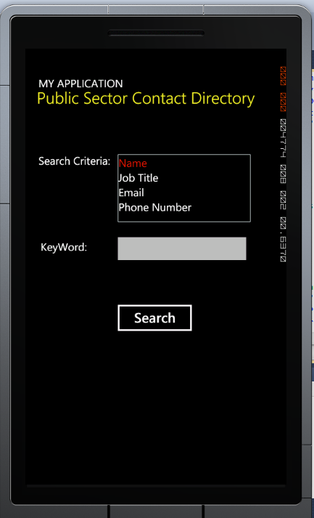

Technologies
- The application is based on .NET Framework platform
- Microsoft Silverlight for outstanding user interface

Implementation process
Although I was planning to implement a fully working application, but due to some problmes that I faced, I couldn't acheive the goals. Firstly, I was planning to implement with LDAP interface, which I just got it yesterday(Thursday). Unfortunatly, it was harder than what I expected. Later, I tried to do with HtmlDocument and parsing, but again I faced a problem which when accessing the website, the main page adds some random numbers and letters to the URL. So it didn't work again. As a result, due to my limited time, I just added a webBrowser to the application which the user can search for the information throw the website directly!

Code Camp Experience
Although I didnt meet the goals of implementation, but it was a good experience, since it was my first time with Windows Phone Programming.

Links
http://www.julha.fi

Project artifacts

Presentation Slides
pdpresent.pdf

Project Source code
publicsectorcontactdirectory.zip

Report

Brochure

