

Librarian

Team
- Camilo Cifuentes
- Mihai Iusan
- Valtteri Kekki

Idea
- Helping people to find books that they need.
- Make a simple centralized application for searching multiple libraries
- Show the book position on the map

Motivation
- Sometimes to find the book that you want can give you a big headache
- The book that you found can be far from location and another copy to be near your location
- Finding the book can be a heavy search over multiple websites over the internet

Solution
This helps you to:
- Create an application which will search multiple libraries simultaneously
- Use Open Data readily available
- Show the book status
- Book position on the map

Features
- Search books by Title, Author or ISBN
- Get the location on the map

Screenshots
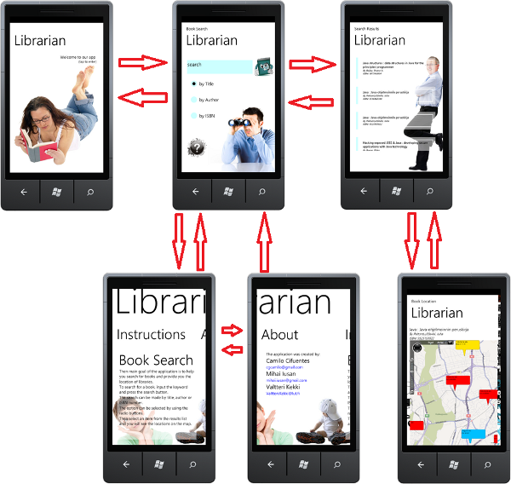

Technologies
- The application is based on .NET Framework platform
- Bing Maps for geolocation
- Microsoft Silverlight for outstanding user interface

Implementation process

List of increments

Improvements

Links

Project artifacts

Presentation Slides

Project Source code

Report

Brochure

