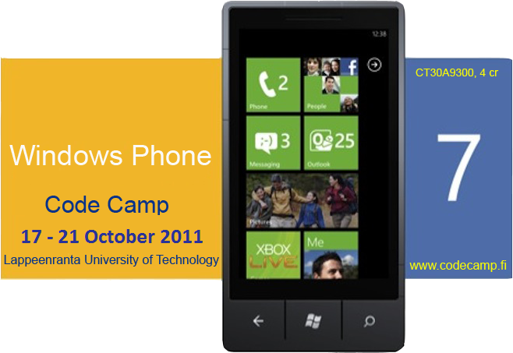


WP7(Windows Phone 7 Code Camp 2011
Code Camp Week: Monday 17.10 - Friday 21.10.2011 Room no: Basement 6218
CT30A9300 Code Camp on Communications Engineering (4 cr)
This week's theme is utilizing open APIs available in Finland. ( see: http://apps4finland.fi/fi/en and http://apps4finland.fi/fi/datakatalogi ) Also, as a new theme the target is to get your app published all the way to the marketplace.

News & Notes
- The Code camp starts at 10:00 with short introduction to the course and will be continued with the basics of WP7 programming.
- Social evening starts at 18:00 at (location will be mentioned later).
- Please contact Bishal Raj Karki (bishal.karki@lut.fi) for any questions or queries.
The classroom 6218 is in use by other IT course from 14:15 to 17:15. Otherwise it is free for us to use. So it is not available during that time. The official secondary location for us is the classroom 6325.
A short demo about marketplace publishing will be given at 13:00 on Wednesday.

Code Camp Week
Location 62xx Basement Lab
- Start time on Monday 17.10.2011 at 10:00
 | Monday | Tuesday | Wednesday | Thursday | Friday
08:15 | - | Coding | Coding | Coding | Code Finalizing
10:00 | Introduction to Code Camp & WP7 Basics | Coding | Coding | Coding | Code complete
12:00 | Lunch | Coding | Coding | Coding | Demo
13:00 | Group Formation | Coding | WP7 Marketplace How-To Presentation | Coding | Demo
14:15 | Idea Development | Lunch / Dinner (classroom not available) | Lunch / Dinner (classroom not available) | Lunch / Dinner (classroom not available) | Closing
18:00 | Social event and sauna(Idea Presentation) at LUT 66xx sauna | Coding | Coding | Coding
02:00 |  | Coding | Coding | Deadline style Coding | Feedback
Presentations
- Some Short Words About Cloud Hosting by Antti Knutas

Feedback times
- To be updated after the code camp.

Groups
Group | Application | Name 1 | Name 2 | Name 3
LUT1 | TEAM NAME | Student 1 | Student 2 | Student 3
LUT2 | TEAM NAME | Student 1 | Student 2 | Student 3
LUT3 | TEAM NAME | Student 1 | Student 2 | Student 3
LUT4 | TEAM NAME | Student 1 | Student 2 | Student 3
LUT5 | TEAM NAME | Student 1 | Student 2 | Student 3

WP7 CodeCamp Minimal Requirements
- More requirements coming up later
- XAP Application must be created in
  - either Silverlight
    - Application must have either Panorama control or pivot control(for UI)
    - Application must include multiple screens and transitions between screens.
    - Application must preserve state so that input data on the screen does not get lost after call/camera interruptions (Tombstoning).
  - or XNA Game Studio
    - Game must use accelerometer, touch control, GPS etc
    - Game must preserve state when call or other interruption(camera, home key pressed) occurs, so that game wont restart from the very beginning after the call(Tombstoning).
    - Game must have multiple play levels.
    - Game should store user credentials(nick, game points/scores, current game level etc) and must provide the list of top scorers.

Discuss
Discuss coding etc. problems
- IRC : irc.freenode.net
  - #lut-codecamp
- Forums ⇒ will be there soon!!
- Skype

FAQ

What are recommended skills/requirements for code camp ?
- Participation in any of previous code camps on .NET
- Programming experience(I hope you all have some…if not..then you'll have one during this code camp) and of course learning INTEREST is the most.

Can I prepare to Code Camp ?
Yes. During code camp week we will brainstorm a software idea, design it and code it. Getting good ideas might sometimes be hard and thinking about different ideas before code camp makes it faster to get into coding part.

I have an exam in Code Camp week ?
You are free to go exam, but code camp is intensive course and idea is to focus on coding during the week, so it is recommended you prepare to exam before the code camp week.

Grading ?
Grading 1-5 from
- Idea and presentation of the Idea in wiki: 15%
- Coding of the implementation: 40%
- Presentation: 10%
- Code Camp Spirit: 20%
- Code camp report 15%

More ?
If you have questions about code camp send email to bishal.karki@lut.fi.

Links
Some basic Tutorials links: . C#.net:
- Link1: Visual C# .NET Programming
- Link2: C# Language Syntax
- Link3: Data types in C#
- Link4: Property in C# class
- Link5: C# sample for basic file operations
- Link6: C# sample for retrieving html content from any websites
- Link7: C# Guided Tour
ASP.net:
- Link1: ASP.NET tutorials
- Link2: ASP.NET tutorials for beginners
- Link3: ASP.NET Tutorial This is quite good but the backend script language used is VB. still you can get idea for c# as well..not much difference.
- Link4: ASP.NET tutorials for beginners
- Link5: Free ASP.NET MVC eBook Tutorial
- Link6: ScottGu's Blog
Ajax:
- Link1: Ajax tutorials
- Link2: 2010Microsoft official AJAX web site
- Link3: Microsoft AJAX learning videos
- Link4: Microsoft AJAX Control Toolkit Samples
Windows Phone 7 Programming:
- Absolute phone 7 getting started
- Phone 7 videos
- Silverlight for Windows phone7
- XNA Framework for Phone 7
- Phone 7 App hub
- More will appear here soon
XML:
- Link1: Xml tutorials for beginners
- Link2: A Beginners Guide to Creating and Displaying Your First XML Document.
- Link3: XML Tutorial
- Link4: XML Basics
CSS:
- Link1: CSS Quick Tutorial
- Link2: CSS Structure and Rules
- Link3: CSS Properties
- Link4: Linking Style Sheets to HTML
- Link5: Displaying XML with CSS
Silverlight4:
- Silverlight 4 getting started
- Link2:
- Link3:
- Link4:
- Link5:
Expression Blend:
- Link1:
- Link2:
- Link3:
- Link4:
- Link5:
Database:
- Link1:
- Link2:
- Link3:
- Link4:
- Link5:
- MS SQL:
  - Link1:
  - Link2:
  - Link3:
  - Link4:
  - Link5:
- LINQ:
  - Link1:
  - Link2:
  - Link3:
  - Link4:
  - Link5:
http://www.avlade.com/WindowsPhone/

What is Code Camp ?
Code Camp is a learning and hacking experience. The code camp approach can be defined as a collaborative learning setting that aims to promote profession-oriented skills. In code camp, the term camp refers to a situation where students assemble and stay a while together. The term code refers to coding, i.e. writing computer programs.

Registration
Enroll to course CT30A9300 Code Camp on Communications Engineering in Webropol

