Wild Train
- Petri Ryhänen 0334856
- Rostislav Malevich 0312328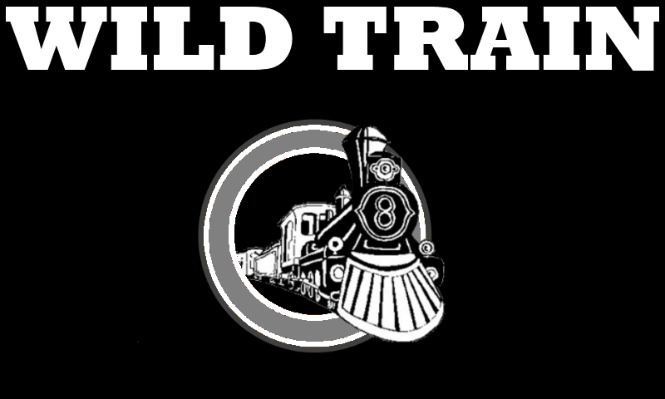

IDEA and GAME LOGIC
Player controls stream train by maintaining ideal temperature of engine. If engine temperature is optimal, train accelerates, if temperature is not perfect, speed is decreasing. Player can add water to decrease temperature or add wood/coal for more heat. By time, engine is cooling down so keeping engine in optimal condition is vital. Player receives money from keeping train moving. More speed = more money.
In WILD TRAIN there are enemies that try to stop train by blocking it's way. Nasty cowboys can easily notice fast moving train, but slow one does not attract them. More speed = more enemies. Enemies can be killed by bomb.
Player's goal is to ride train to station with maximum amount of money left. Game is lost, if train is stopped or destroyed.
There are 4 items in game, each of them require money to buy. Price is changing according to game level.
- WATER cools train engine
- COAL increases heat of engine
- BOMB kills enemy
- TOOLS repair possible damage made by enemies

RULES
- Keep optimal temperature of engine
- Keep train moving
- Avoid cowboys
- Repair damage
- Remember! More speed = More more = More cowboys.

Project arficats
Early game scretch | 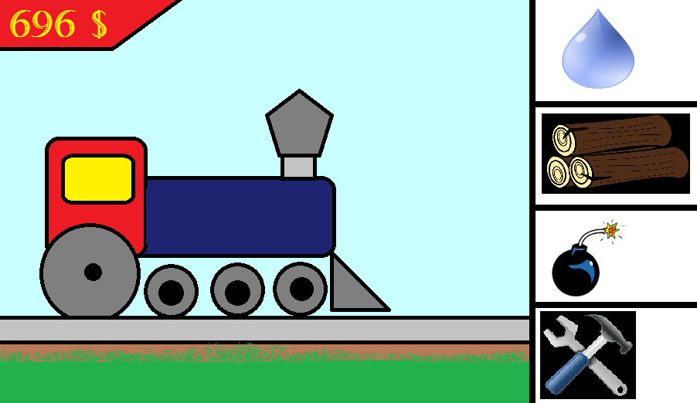
In game screenshot

Project milestones
Feature | Description | Status | Priority
XNA framework | XNA framework for WP7 emulator | OK | 1
State machine prototype | State machine for game with needed states (intro, menu, game, paused, etc) | OK | 2
Train engine control | Decrease/Increase temperature of engine | OK | 2
Game level | First game level | OK | 2
Enemies | Enemies, their effect and killing them | OK | 3
Scrolling background | Scrolling background | OK | 3
Graphics | Graphics for game object | OK | 3
Sounds | Game sounds | OK | 4
Menu | Content of menus | OK | 2
Particles | Smoke and dust particles | OK | 4
Repair Delay | Repair takes some time | R OK | 4
Memory | Writing and reading data |  | 3
Sandbox | Extra endless level | OK | 5
Tombstoning | Tombstoning | OK* | 3

WP7 code camp requirements
Task | Status
Game must use accelerometer, touch control, GPS etc | OK
Game must preserve state when call or other interruption(camera, home key pressed) occurs, so that game wont restart from the very beginning after the call(Tombstoning) | OK*
Game must have multiple play levels | OK*
Game should store user credentials(nick, game points/scores, current game level etc) and must provide the list of top scorers

SOURCE
wildtrain_18.05_17-00.zip wildtrain_19.05_19-30.zip wildtrain_19.05_23-00.rar wildtrain_0_4_pr.rar

Presentaion
presentation1.pptx

