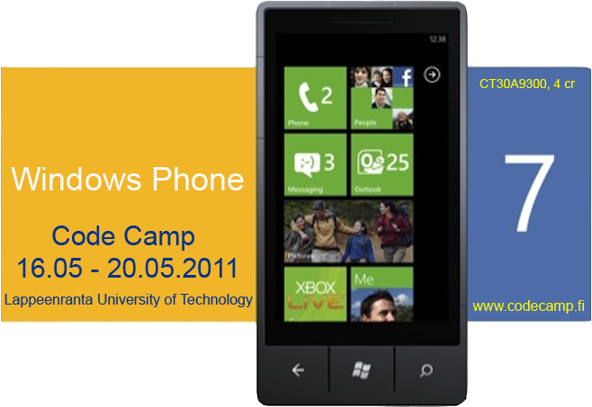

''EPIC WATCH''

Team 5 Mainio
- Mohamed Nuh
- Sidhartha Yalavarthi
- Udhyan Timilsina

Problem
- Many people die due to the fact that they are not aware of a situation like Epidemic is in their area. This is due to the fact that there are no record so that some of these epidemic can be analysis

Goal
- Have a WP7 application that takes the information of the victim,
- allows to store the information in the database and notifies to the rescue worker through mail,
- if there are similar cases in the same area
- that are will be declared as epidemic and high alert will be notified.

Idea
- Create a WP7 app that can take the information of the patient,compare it with records and if it is above the threshold then the message is send to authorities.
- Authorities can also view the area through bing maps for exact location of the country.

Use case diagram
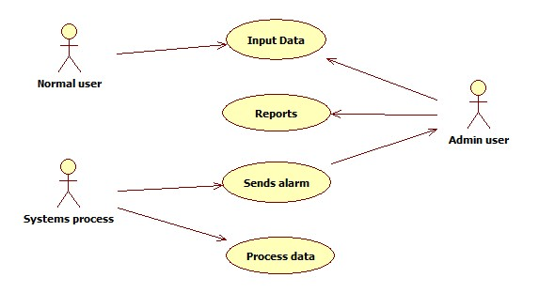

Architecture
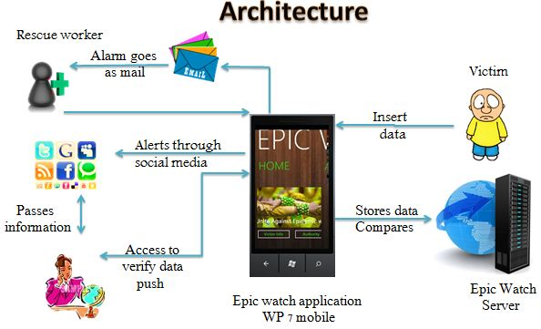

Screen shots
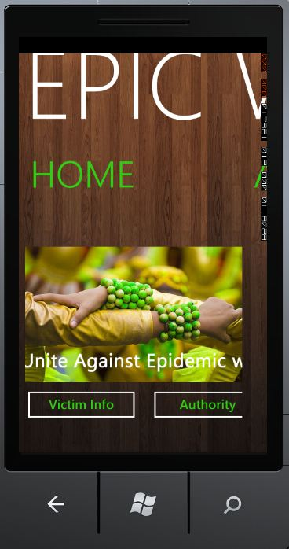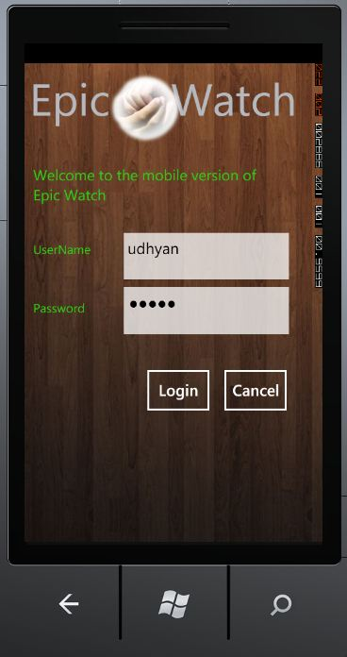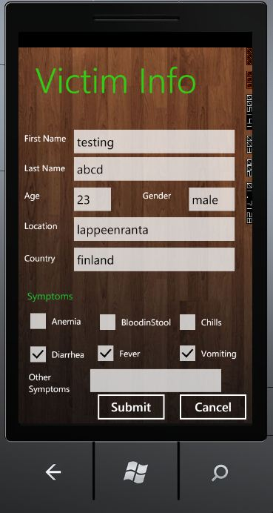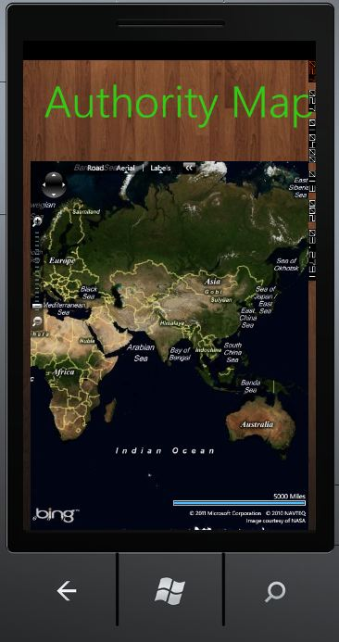

Tools and Technologies
- Microsoft Visual Studio 2010
- Microsoft Silver light
- Microsoft SQL Server
- Microsoft Expression Blend 4
- Bing maps


Project Artifacts
Source code udu.rar

Demo Presentation
epic_watch.ppt

Final Presentation
final_presentation.pptx

Report

