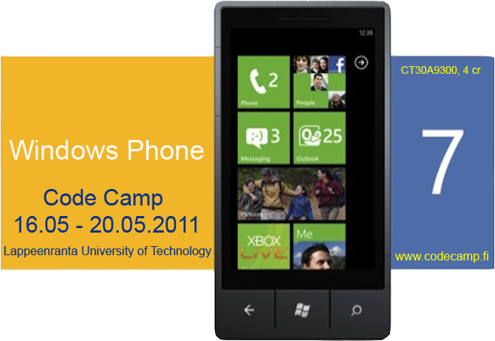


WP7(Windows Phone 7 Code Camp 2011
Code Camp Week: Week 21 Monday 16.5 - Friday 20.5.2011 Room no: ML 6428
CT30A9300 Code Camp on Communications Engineering (4 cr)

News & Notes
- The Code camp starts at 9:00 with short introduction to the course and will be continued by the video lectures from University of Helsinki.
- Social evening starts at 18:00 at department sauna at 7th floor in 6th building. Sauna will be heated from 19:00 till 22:00.
- Please contact Bishal Raj Karki (bishal.karki@lut.fi) for any questions or queries.
- Use the following link to register to the course events.
  - Webropol
- Code complete and demo instructions.

Code Camp Week
Location 6428 Windows Classroom
- Start time on Monday 16.5.2011 at 9:00
 | Monday | Tuesday | Wednesday | Thursday | Friday
08:15 | Starts at 9(Introduction and then Video Lecture from University of Helsinki ) | Coding | Coding | Coding | Code Finalizing
10:00 | Video Lecture from University of Helsinki | Coding | Coding | Coding | Code complete
12:00 | Lunch | Lunch | Lunch | Lunch | Demo
13:00 | Video Lecture from University of Helsinki | Coding | Coding | Coding | Demo
14:15 | Video Lecture from University of Helsinki | Coding | Coding | Coding | Closing
18:00 | Social event and sauna(6th building 7th floor) | Coding | Coding | Coding
02:00 |  | Coding | Coding | Deadline style Coding | Feedback
Presentations

Feedback times
- To be updated after the code camp.

Groups
Group | Application | Name 1 | Name 2 | Name 3
LUT1 | Wild Train | Petri Ryhänen | Rostislav Malevich
LUT2 | TEAM NAME | Student 1 | Student 2 | Student 3
LUT3 | GameCreations | Mihai Iusan | Camilo Cifuentes | Alex Ovcharenko
LUT4 | MobileProperty | Arttu Hanska | Saeedeh Mehrouzi | Nana Assyne
LUT5 | Epic Mobile | Nuh Mohammed | Sidhartha Yalavarthi | Udhyan timilsina

WP7 CodeCamp Minimal Requirements
- XAP Application must be created in
  - either Silverlight
    - Application must have either Panorama control or pivot control(for UI)
    - Application must include multiple screens and transitions between screens.
    - Application must preserve state so that input data on the screen does not get lost after call/camera interruptions (Tombstoning).
  - or XNA Game Studio
    - Game must use accelerometer, touch control, GPS etc
    - Game must preserve state when call or other interruption(camera, home key pressed) occurs, so that game wont restart from the very beginning after the call(Tombstoning).
    - Game must have multiple play levels.
    - Game should store user credentials(nick, game points/scores, current game level etc) and must provide the list of top scorers.

Discuss
Discuss coding etc. problems
- IRC : irc.freenode.net
  - #lut-codecamp
- Forums ⇒ will be there soon!!
- Skype

FAQ

What are recommended skills/requirements for code camp ?
- Participation in any of previous code camps on .NET
- Programming experience(I hope you all have some…if not..then you'll have one during this code camp) and of course learning INTEREST is the most.

Can I prepare to Code Camp ?
Yes. During code camp week we will brainstorm a software idea, design it and code it. Getting good ideas might sometimes be hard and thinking about different ideas before code camp makes it faster to get into coding part.

I have an exam in Code Camp week ?
You are free to go exam, but code camp is intensive course and idea is to focus on coding during the week, so it is recommended you prepare to exam before the code camp week.

Grading ?
Grading 1-5 from
- Idea and presentation of the Idea in wiki: 15%
- Coding of the implementation: 40%
- Presentation: 10%
- Code Camp Spirit: 20%
- Code camp report 15%

More ?
If you have questions about code camp send email to bishal.karki@lut.fi.

Links
Some basic Tutorials links: . C#.net:
- Link1: Visual C# .NET Programming
- Link2: C# Language Syntax
- Link3: Data types in C#
- Link4: Property in C# class
- Link5: C# sample for basic file operations
- Link6: C# sample for retrieving html content from any websites
- Link7: C# Guided Tour
ASP.net:
- Link1: ASP.NET tutorials
- Link2: ASP.NET tutorials for beginners
- Link3: ASP.NET Tutorial This is quite good but the backend script language used is VB. still you can get idea for c# as well..not much difference.
- Link4: ASP.NET tutorials for beginners
- Link5: Free ASP.NET MVC eBook Tutorial
- Link6: ScottGu's Blog
Ajax:
- Link1: Ajax tutorials
- Link2: 2010Microsoft official AJAX web site
- Link3: Microsoft AJAX learning videos
- Link4: Microsoft AJAX Control Toolkit Samples
Windows Phone 7 Programming:
- Absolute phone 7 getting started
- Phone 7 videos
- Silverlight for Windows phone7
- XNA Framework for Phone 7
- Phone 7 App hub
- More will appear here soon
XML:
- Link1: Xml tutorials for beginners
- Link2: A Beginners Guide to Creating and Displaying Your First XML Document.
- Link3: XML Tutorial
- Link4: XML Basics
CSS:
- Link1: CSS Quick Tutorial
- Link2: CSS Structure and Rules
- Link3: CSS Properties
- Link4: Linking Style Sheets to HTML
- Link5: Displaying XML with CSS
Silverlight4:
- Silverlight 4 getting started
- Link2:
- Link3:
- Link4:
- Link5:
Expression Blend:
- Link1:
- Link2:
- Link3:
- Link4:
- Link5:
Database:
- Link1:
- Link2:
- Link3:
- Link4:
- Link5:
- MS SQL:
  - Link1:
  - Link2:
  - Link3:
  - Link4:
  - Link5:
- LINQ:
  - Link1:
  - Link2:
  - Link3:
  - Link4:
  - Link5:
http://www.avlade.com/WindowsPhone/

What is Code Camp ?
Code Camp is a learning and hacking experience. The code camp approach can be defined as a collaborative learning setting that aims to promote profession-oriented skills. In code camp, the term camp refers to a situation where students assemble and stay a while together. The term code refers to coding, i.e. writing computer programs.

Registration
Enroll to course CT30A9300 Code Camp on Communications Engineering in Webropol

