Match Pairs
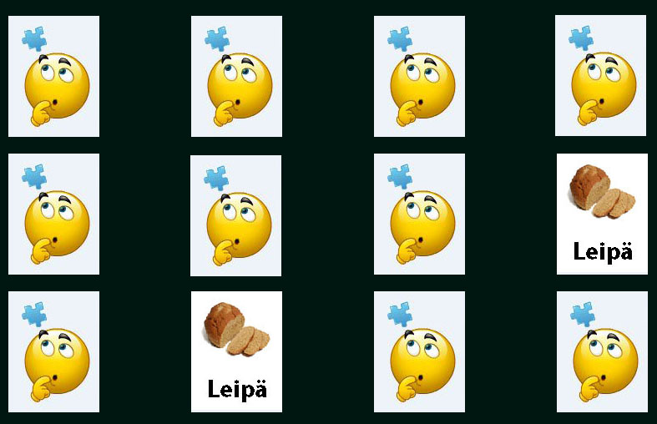
Group 1
- Poorang Vosough 0392601
- Alireza Adli 0406160

Motivation
Idea
- Finding a fun way to teach some key Finnish words for other nations children.
- Also it can be used as a part of a language learning application for any language
Motivation
- Team motivation was to review CSS skills and find out some differences between HTML5 and old HTML versions
- Moreover, to get familiar with Javascript in practice.
- Coding in Visual Studio on Windows 8 platform

What is Match Pairs
- Match Pairs is a card match application. User opens the Match Pairs, after clicking on play button s/he will find out whole set of 12 cards. S/he should find the similar card of the one s/he opened by clicking on different options. It will finish after finding all the similar cards.
- Cards are set of Finnish words for some fruits, food and public transportation with their picture, so it will be a language training for children.

Features
- Starting page
- Game page
- Deck of 12 cards
- Fruits with Finnish meanings (cards backside)
- Food with Finnish meaning (Card backside)
- Bus with Finnish meaning (Card backside)
- Drink with Finnish meaning (Card backside)

Technologies
- HTML5
- CSS
- JavaScript
- Visual Studio
- Windows 8

Presentation
Presentation Report Poster

Source code
matchpair.zip

