GROUP MEMBERS
Rasmus Halsas 0358373
Arttu Urpalainen 0358700

IDEA
Our idea was do a platformer similar to bit-triprunner. It's a sidescroller where you control rainbow-colored ball trough hazardous environments.

MOTIVATION
We generally like games and had few good ideas for a good and colorful JS game. Additionally I had ImpactJS -license so game was obvious option. Having fun and tight schedule were the biggest motivators. We had to scrap some features, but we managed to tackle most of the wanted stuff on the product.

FEATURES
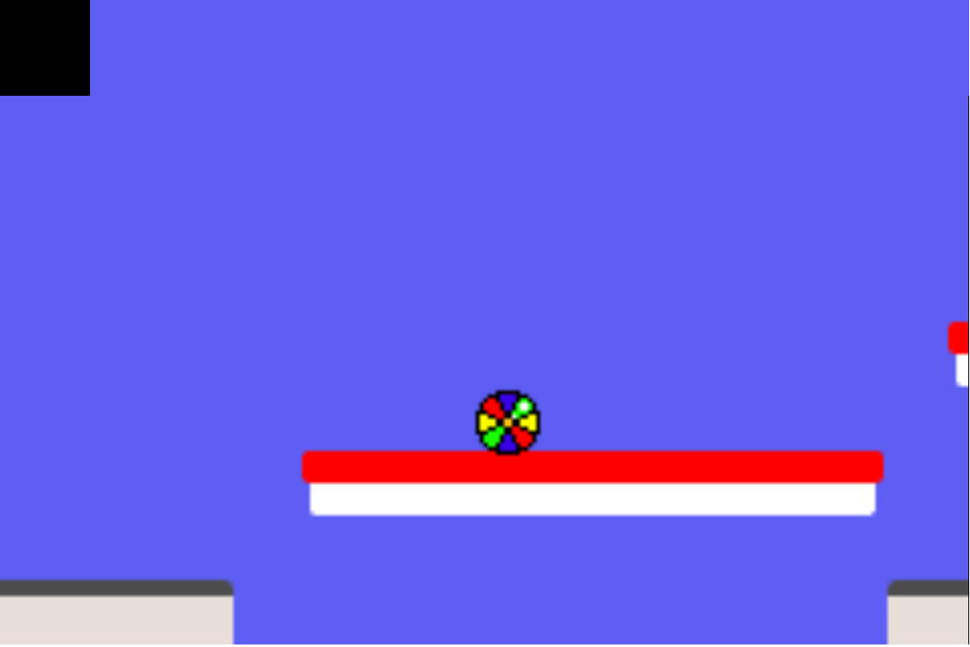
- Control a colorful ball trough different areas.
- There are four different powerups which add spice to the gameplay,
there was plans for more, but the time constraints cut the most of the ideas. - Powerups affect; speed, navigation and gravitational properties.
- Product needs to have keyboard nearby in the current version, but doing touch controls is 1 hour job or less, if we are not as tired as now!
- Three increasingly difficult levels

