Pool
TEAM
- Janne Tallqvist
- Sami Tarkiainen

GOAL
- To create a pool game.

Idea
- Pool.
- Nice physics.
- Maybe a twist. You play bar pool and get drunker after each round, so the gameplay will get harder eventually.

Problems
- The box2D web physics engine and a lack of api documentation.
- Microsoft and internet explorer.
- Touch events in mobile devices, 'cause box2d.

Pool
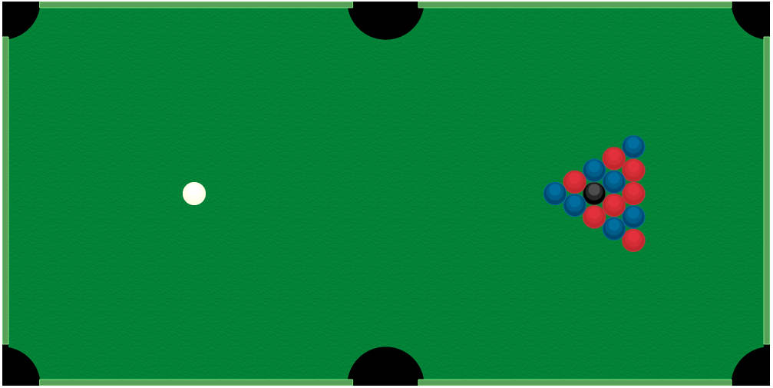

FEATURES
- Pool table and some balls.
- Physics works sort of.
- You can hit onlly the white ball.

Technologies
- Javascript and HTML5, obviously
- box2d web physics engine

Flies
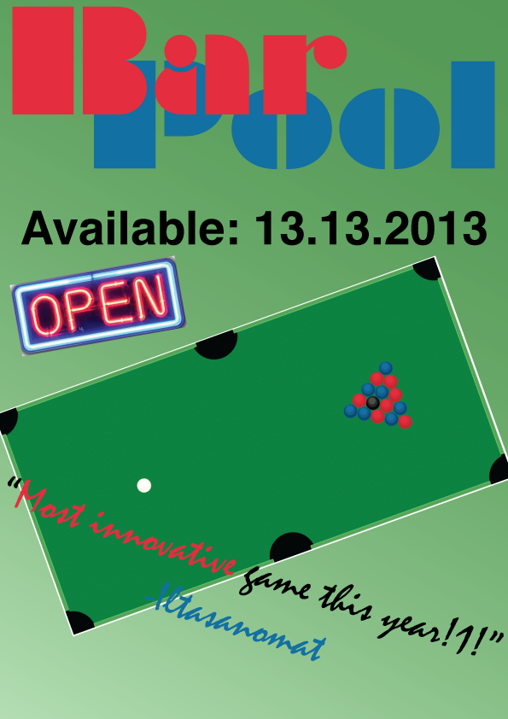 codeari_report.pdf

