GALAXY SHOOTER
Shooting arcade game for XBox 360, inspired from 80's popular game “Chicken Invaders”

Project Members
- Joonas Äijälä (0312438, aki-joonas.aijala@lut.fi)
- Yabor
- Bishal Raj Karki(b0331930, bishal.karki@lut.fi)

Idea
- This game was initial introduced a Shooting game version set up for 2 persons and three persons
- The idea was to enable people to fight against the machine and hopefully against friends.
- The current implementation focused 2D over 3D given the time constraints and learning curve involved in OpenGL
- Wireless communication
  - WLAN - this was considered the defacto standard particularly using TCP
  - Blue tooth (Emulator dependent) - this has not been clearly tested due to the lacking component in the Emulator
- Players
  - Single / Multi - Single player is fully supported, however at time of writing the multi-player endeavors were hampered by wireless LAN connectivity

Features, Implementations & Achievements
Feature | Priority | Task | Comments
Interactive Menu screen | 3 | DONE | ……
Game Music | 3 | DONE | …..
Switching between Multiple Screen | 3 | DONE | …….
Game Graphics | 1 | DONE | ……
Multiplayer Death Match | 1 | DONE | ….
Multiplayer Co-op Match | 1 | DONE | ……
Player Ships | 1 | DONE | ……
Weapons | 1 | DONE | ……
Sound Effects | 2 | DONE | different sound effects for different game components
Alien Ships | 2 | DONE | ……
Game Obstacles | 1 | DONE | ……
Bonuses | 2 | DONE | ……
Game Logic | 1 | DONE | ……
Game Over determination | 1 | DONE | ……
Physics | 2 | DONE | ……
Artificial Intelligence | 2 | DONE | ……
Game Options | 2 | DONE | ……
Counter Displays | 1 | DONE | Hitcounts and lifes dynamically updated and shown to the users

WEAPONS | TYPE | TASK | COMMENTS
Machine Gun | Single, double and triple | DONE | ……
Laser Gun | Single, double and triple | DONE | ……
Shot Gun | Single, auto and round | DONE | ……
Missile Launcher | Single, multi and nuke | DONE | Heat sensitive missiles
Gatling Gun | Single and double | DONE | ……

OBSTACLES | TASK | COMMENTS
Asteroids | DONE | ……
Black Hole | DONE | pulls the player ships towards the black hole

PHYSICS | TASK | COMMENTS
Collision | DONE | ……
Ship Movement | DONE | ……
Asteroid movement and collision | DONE | ……
Bouncing back after collision | DONE | ……
Black Hole | DONE | pulls the player ships towards the black hole

ARTIFICIAL INTELLIGENCE | TASK | COMMENTS
Enemies | DONE | ……
Missiles | DONE | ……

USER SET GAME OPTIONS | TASK | COMMENTS
Hitcounts | DONE | ……
Lives | DONE | ……
Asteroids frequency | DONE | ……
Black hole frequency | DONE | ……
Keep Weapons from last round | DONE | ……
Game controller settings | DONE | ……

Features
- Co-operative multiplayer match
- Multiplayer Deaath match
- Abundant weapons
  - MachineGun
  - Laser
  - Heat Sensitive Missiles
  - Nuke…
- Obstacles
  - Black holes
  - Asteroids
  - Alien UFOs
- Physics involved
- AI
- A lot of great fun!

ScreenShots
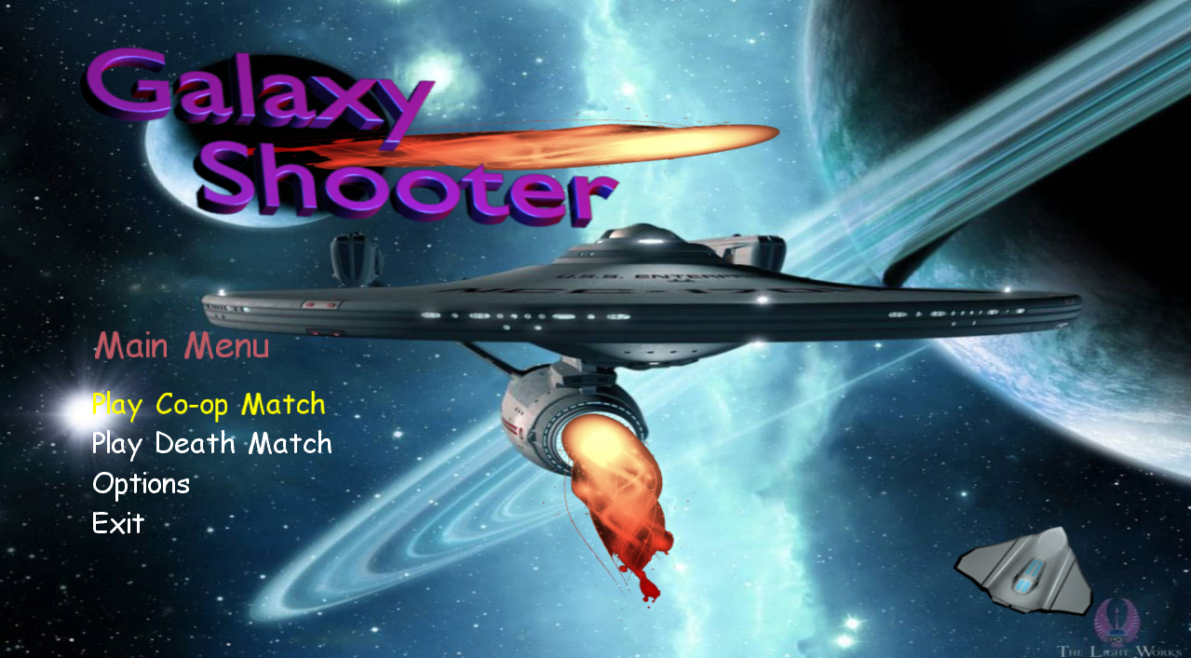Main Menu
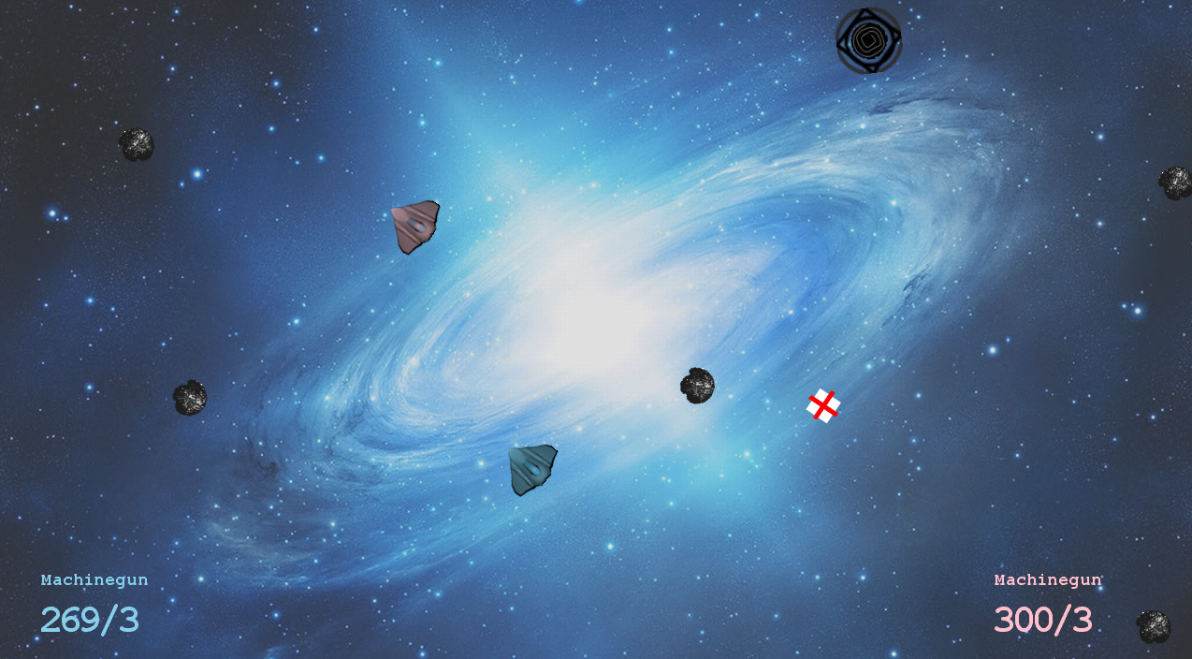Multiplayer Death Match
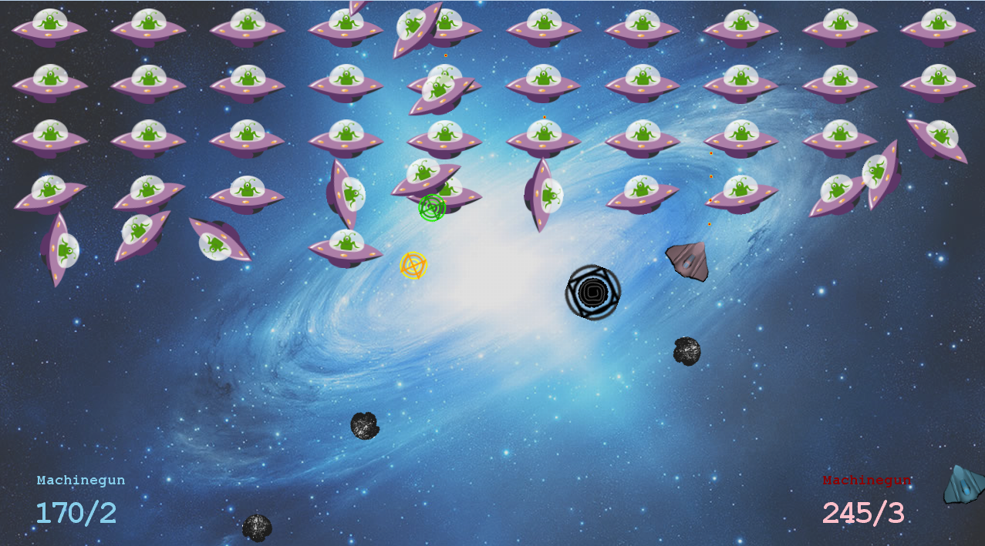Multiplayer Co-op match

