Mad Boxing
 Mad Boxing

Ascension Team
Janne Parkkila - 0303159
Rostislav Malevich -
Tuomas Kaittola

The Idea
This idea is influence by an old 8-bit Nintendo game Punch Out. Check out a short clip from youtube about the Punch Out game: http://www.youtube.com/watch?v=hu69QEHhvNo
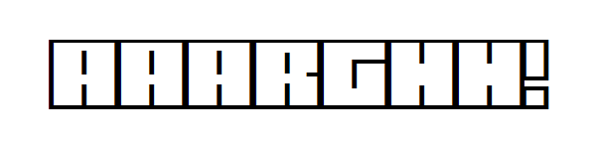 AAAAAAAAAAAAAARGH!!!!!!

Features
3D Graphics
- Player Model
- Enemy Model
Different Punches
- Upper Left & Right
- Lower Left & Right
- Straight to face
- Block
- Dodge?
Winning the Game by
- Knock out
- Time out
Player and the enemy have their own health bars, which are drained with hits.

Tools
The tools used in the project so far are:
- XNA Game Studio 3.1
- Blender for graphics
- GXSCC for sounds
- XNA Input (http://xnainput.codeplex.com/)

Project Status
Feature | Description | Status
Player Model | 3D Model of the player's own fists | Completed
Enemy Model | 3D Model of the enemy | Completed
Controls | Controls for windows and Xbox versions | Completed
Options Menu | Options menu for starting a new game etc. | Completed
Arcade Style Hits | Graphics for receiving/dealing damage | Completed
Music | 8-bit music for the game | Music created, not added to project
Game Logic | The actual game logic | 85 % Done
Animations | The punching/hitting/dying/etc animations | Completed

Last Night Duty
Feature | Description
Screen Flash | Screen flashes when player receives a hit
Sound Effects | Hits, Blocks
Music | Background music
Boxing Ring | The Boxing Ring where the fighters actually are
Counting | 3, 2, 1, Fight! at the game start
HUD | Show time ?fatigue?
COMPLETED FEATURES
Feature | Description | Time
Impact Check | Check if enemy hits / player hits | 20.10
Hit Effect | Hit Texture effect when dealing / receiving damage | 20.20
HUD | (Heads Up Display) to show health | 20.45
Game Modes | Arcade / Simulation | 22.00
Options | Options screen to main menu | 22.30

Screenshots
Models made by Blender
- Fist
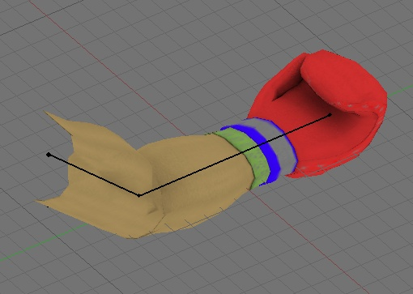Fist model
- Enemy Model
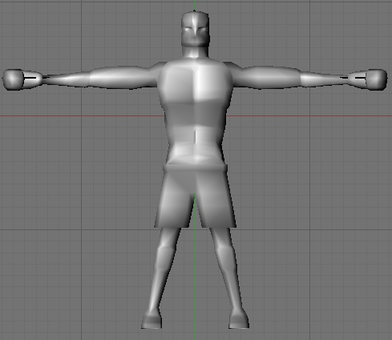Enemy model

