Mad Boxing
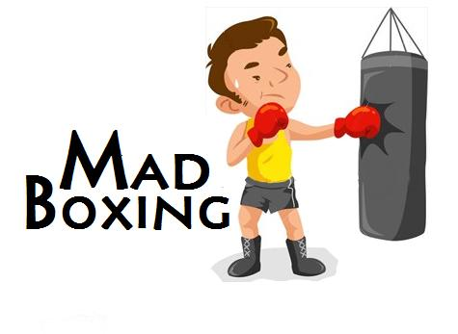 Mad Boxing

Ascension Team
Janne Parkkila - 0303159
Rostislav Malevich - 0312328
Tuomas Kaittola

The Idea
This idea is influence by an old 8-bit Nintendo game Punch Out. Check out a short clip from youtube about the Punch Out game: http://www.youtube.com/watch?v=hu69QEHhvNo
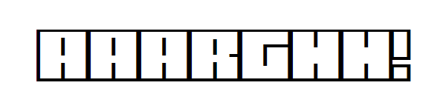 AAAAAAAAAAAAAARGH!!!!!!

Features
3D Graphics
- Player Model
- Enemy Model
Different Punches
- Upper Left & Right
- Lower Left & Right
- Straight to face
- Block (Yes!)
- Dodge (Nope!)
Winning the Game by
- Knock out
- Time out
Player and the enemy have their own health bars, which are drained with hits.

Tools
The tools used in the project so far are:
- XNA Game Studio 3.1
- Blender for graphics
- GXSCC for sounds [This was scrapped]
- XNA Input (http://xnainput.codeplex.com/)

Project Status
Feature | Description | Status
Player Model | 3D Model of the player's own fists | Completed
Enemy Model | 3D Model of the enemy | Completed
Controls | Controls for windows and Xbox versions | Completed
Options Menu | Options menu for starting a new game etc. | Completed
Arcade Style Hits | Graphics for receiving/dealing damage | Completed
Music | Music for the game | Completed
Game Logic | The actual game logic | Completed
Animations | The punching/hitting/dying/etc animations | Completed
Scrapped Ideas
- 8-bit music for the game [was not so good idea]
- Cheerleaders (NOOOOOO! NOT ENOUGH TIME )

Last Night Duty
Feature | Description
Counting | 3, 2, 1, Fight! at the game start
COMPLETED FEATURES
Feature | Description | Time
Impact Check | Check if enemy hits / player hits | 20.10
Hit Effect | Hit Texture effect when dealing / receiving damage | 20.20
HUD | (Heads Up Display) to show health | 20.45
Game Modes | Arcade / Simulation | 22.00
Options | Options screen to main menu | 22.30
Sound Effects | Hits, Blocks | 23.00
Music | Background music | 23.10
HUD | Show time | 23.50
Boxing Ring | The Boxing Ring where the fighters actually are | 01.00
High Score List | Created the highscore list | 01.00
Screen Flash | Screen flashes when player receives a hit | 02.20
Changed Game Logic | Successful block now gives 2 HP and hit takes 5 HP | 03.10
Better AI | Changed the AI to defend when health is less than 30 % | 03.20
Fixed Controls | The XBOX Pad now actually works | 03.40
Finalized Controls | NOW IT REALLY WORKS! | 04.05
GOING HOME FOR THE DAY | FINALLY | 04.10
Return to work | Came back to business | 09.50

Screenshots
Models made by Blender
- Fist
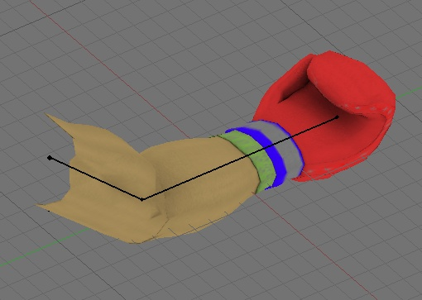Fist model
- Enemy Model
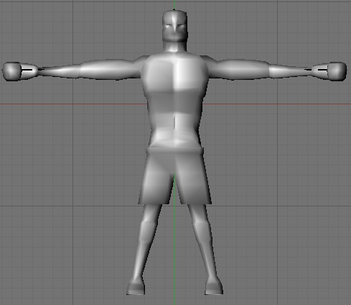Enemy model

