Photos from the XNA Code Camp
Groupshot from the sauna evening.
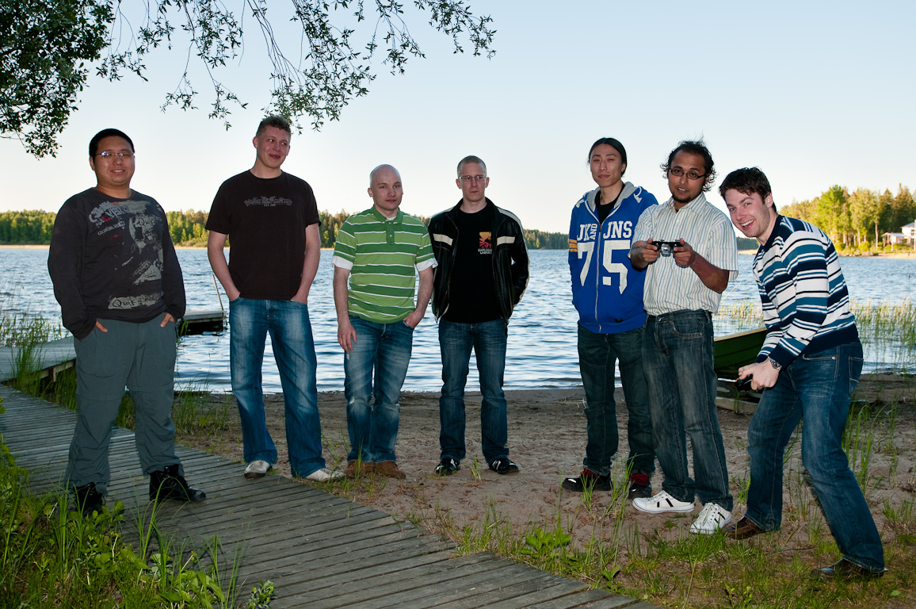Groupshot from the sauna evening
The visiting game design lecturer from Tampere.
The visiting game design lecturer from Tampere
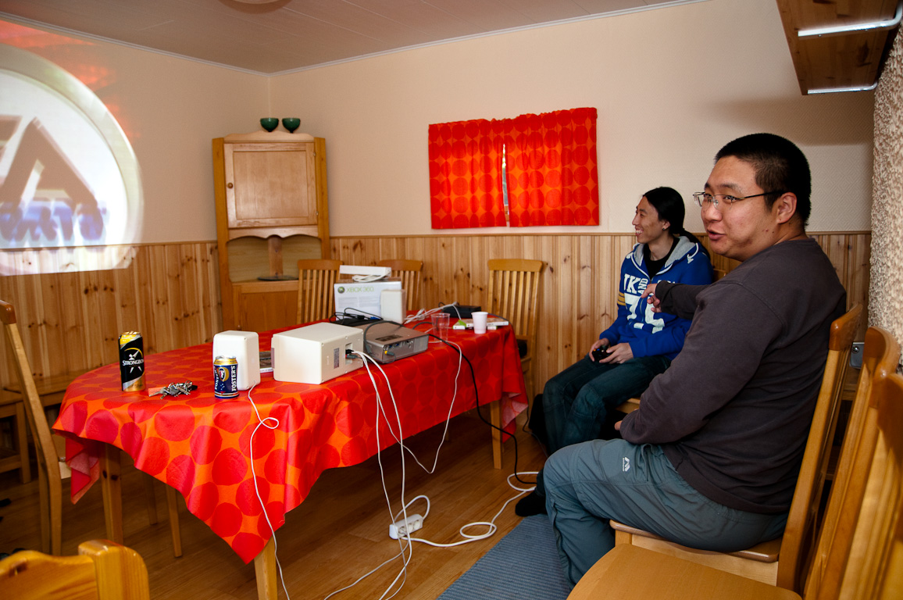
Students getting familiar with the platform.
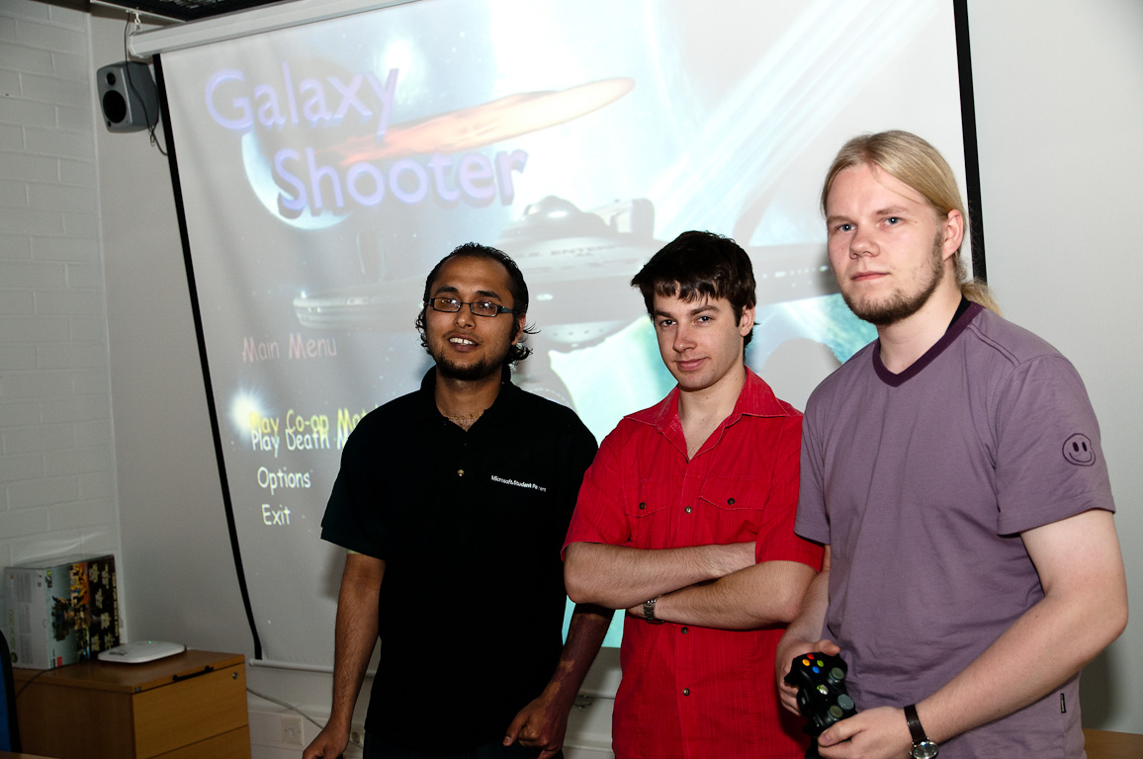
Galaxy Shooter team
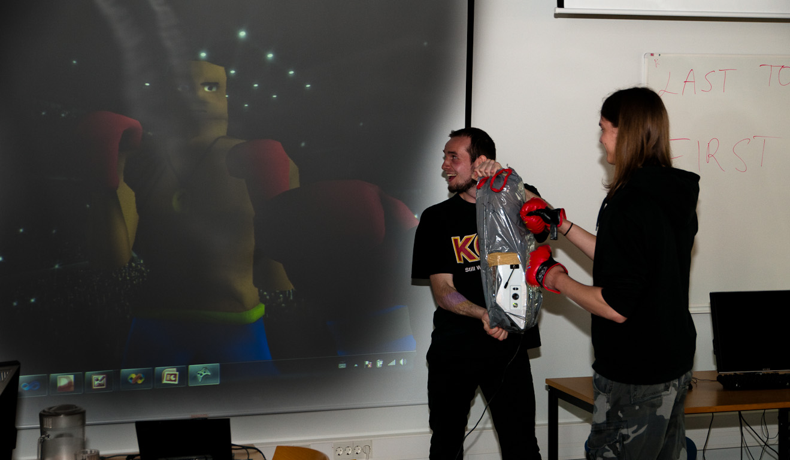
MadBoxing team demonstrating their motion-sensitive punching bag controller. (Photograph is both composite and heavily processed in order to show the projector image clearly.)
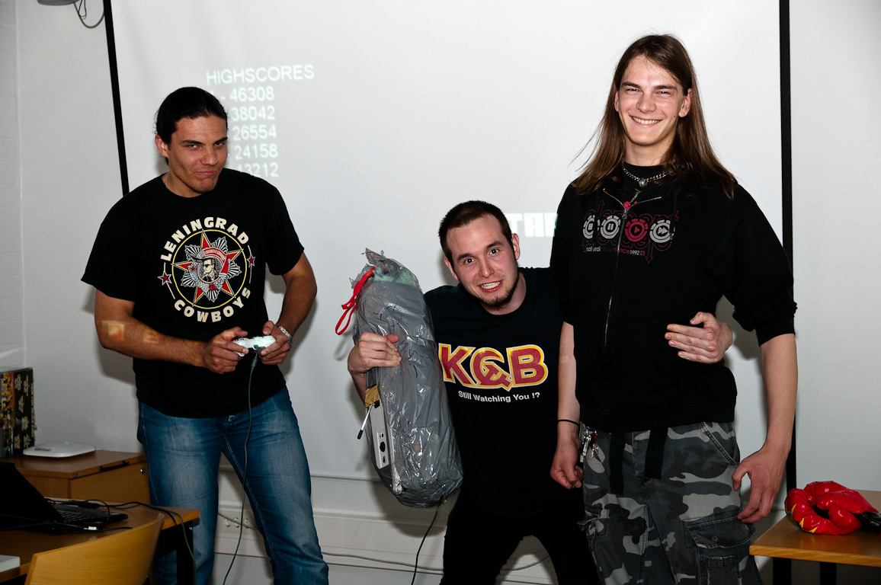
MadBoxing team
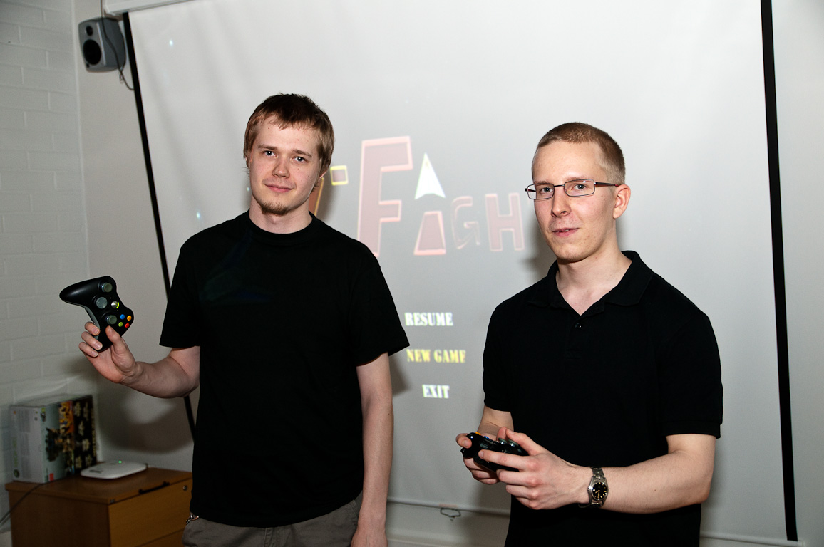
S-Fight team
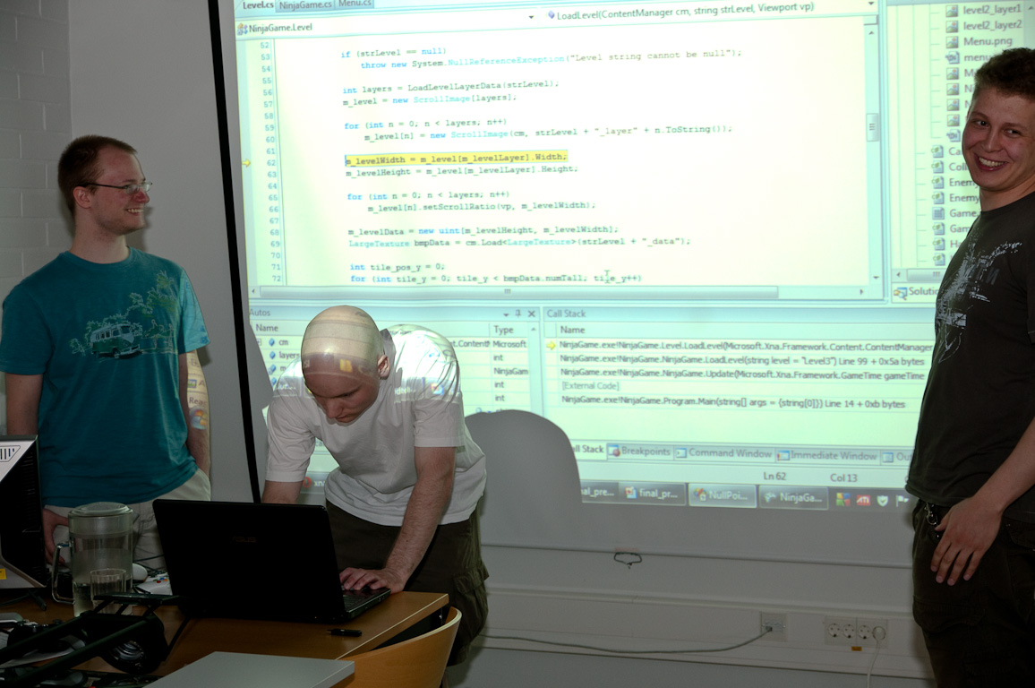
Ninja Game team doing some last minute debugging
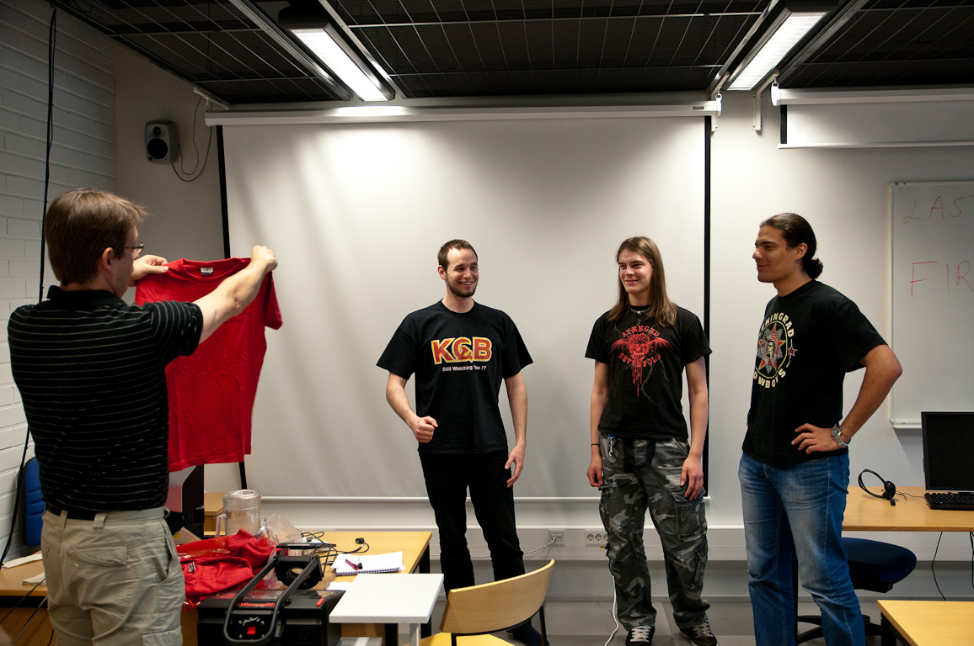
Prof. Porras presenting the winning team their prize t-shirts

