XNACode Camp 2010
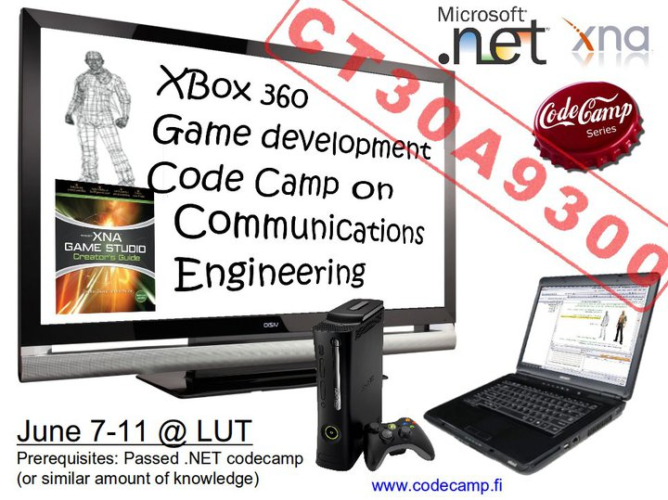 Monday 7.6 – Friday 11.6 2010, Summer period
CT30A9300 Code Camp on Communications Engineering (4 cr)

News
2010-06-04 These pages updated to include schedule information.

What is XNA?
XNA is a Microsoft oriented programming platform for …

What is Code Camp ?
Code Camp is a learning and hacking experience. The code camp approach can be defined as a collaborative learning setting that aims to promote profession-oriented skills. In code camp, the term camp refers to a situation where students assemble and stay a while together. The term code refers to coding, i.e. writing computer programs.

Code Camp Schedule
Code Camp Week @ Location 6428 Windows Classroom
 | Monday | Tuesday | Wednesday | Thursday | Friday
10:15 | Intro | Intro | 10:00 Coding | 10:00 Coding | 10:00 Finalizing the Code
12:00 | Lunch | Lunch | Lunch | Lunch | 10:30 Demo Preparation
13:00 | Intro | ~14:00 Idea Presentation | Coding | Coding | Demo's (15)
16:00 | Idea Brainstorming | Design | Coding | Coding | Closing
18:00 | Evening Program | Coding | Coding | Coding | Brain Reset
02:00 |  | Coding | Coding | Deadline style Coding
Monday
- Starting slide sets
- Evening Program, Starts 18:00
  - Location: University Sauna (same building)
  - Presentation and discussion about ideas
Tuesday
- …
Wednesday .. coding ..
Thursday .. coding ..
- at the end, preparation of ..
  - Coding, freeze the features and code them to demonstration state
  - Presentation
    - Presentation slides
Friday, presentation demonstrations
- 15min / group presentation time
- Presentation starts at 10:30
- Presentations ends around 15:30, then
- Honorable mentions
- Closing of Code Camp Week

After Code Camp
- 1 page Brochyre (advertisement) of your software.
- 5 page (not more) description (like white paper) of your application.
- Fill Course feedback
- Finalization of your group wiki pages
  - wiki page complete
  - presentation slides
  - source package
  - 1-page Brochyre as .pdf
  - 5-page description as .pdf
- Deadline for these is XX

Groups
- 3 Person groups
Group | Application | Name 1 | Name 2 | Name 3
grp1 | Galaxy Shooter | Yavor Ivelinov Ivanov | Joonas Aijala | Bishal Raj Karki
grp2 | Team null pointer exception | Niko Kurvinen | Oskar Sonninen | Mikko Kaistinen
grp3 | MadBoxing | Janne Parkkila | Rostislav Malevich | Tuomas Kaittola
grp4 | Awesome Jungle | Antti Knutas | Li Aoke | Jifeng Xing
grp5 | S-Fight | Matti Bragge | Anssi Salo

Problems and Solutions
Please put your questions/programming problems here in this sections. We will try to solve it collaboratively. Teemu will also be reviewing/answering these questions remotely once a day.
After you put the questions here please do email me once at bishal.karki@lut.fi
Qs 1:
Answer:

Grading ?
Grading 1-5 from
- Idea and presentation of the Idea in wiki: 25%
- Coding of the implementation: 40%
- Demonstration: 15%
- Code Camp Spirit: 20%

Feedback
Course feedback survey will be published here. All students are wished to answer to the questionnaire as it helps developing the course.
Students may check what kind of learners they are by answering the questions in the following questionnaire

What are recommended skills for code camp ?
Programming experience.
.NET basics from our previous code camp or otherwise

Can I prepare to Code Camp ?
Yes. During code camp week we will brainstorm a software idea, design it and code it. Getting good ideas might sometimes be hard and thinking about different ideas before code camp makes it faster to get into coding part.

I have a exam in Code Camp week ?
You are free to go exam, but code camp in intensive course and idea is to focus coding during the well, so it is recommended you prepare to exam before the code camp week.

More ?
If you have questions about code camp send email to the organizers. * bishal.karki@lut.fi

For staff
course arrangements

Tutorial links:
XNA programming guide, class libraries, etc. XNA related: http://msdn.microsoft.com/en-us/library/bb200104.aspx
Video tutorials from http://creators.xna.com/
Introduction: http://creators.xna.com/en-US/education/gettingstarted/bgintro/chapter1
2D Game Tutorial: http://creators.xna.com/en-US/education/gettingstarted/bg2d/chapter1
3D Game Tutorial (This is probably not the best kind of game to do during codecamp): http://creators.xna.com/en-US/education/gettingstarted/bg3d/chapter1
XNA 101: http://www.xnavideotutorial.com/modules/XNA_101/
Basic Tutorials:
Action RPG Tutorial: http://mindcemetery.com/Articles/default.html
Also, check out XNA forums: http://forums.xna.com/forums/
Check:
creators.xna.com - xna creators club
codeplex.com - lots of open source
blogs.msdn.com/shawnhar-in-depth stuff about XNA
www. charlespetzold.com/phone - free book about WP7

