

**You can find the application at:**

[**http://codecamp.fi/doku.php/dotnet2011/lut1/start**](http://codecamp.fi/doku.php/dotnet2011/lut1/start)

**Contact us:**

**firstname.lastname@lut.fi**

**Volunteering for Everyone**

Volunteering can be easy!

V4E supports the volunteer within you

Igor Botyan

Camilo Cifuentes

Mihai Iusan

**Team**

******[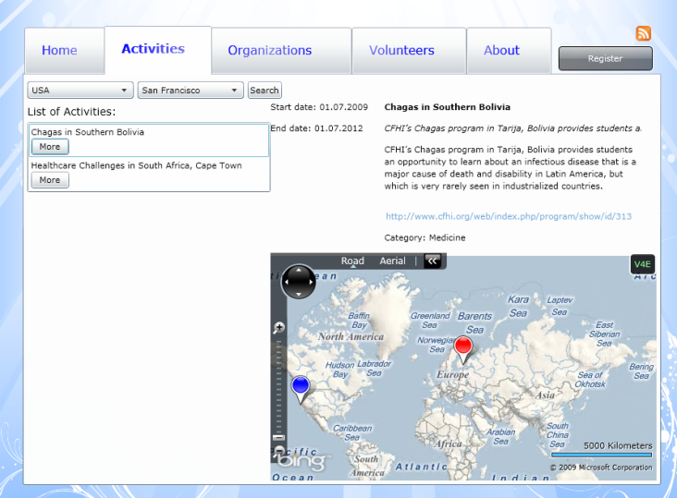](http://codecamp.fi/lib/exe/detail.php/dotnet2011/lut1/activities.png?id=dotnet2011:lut1:start)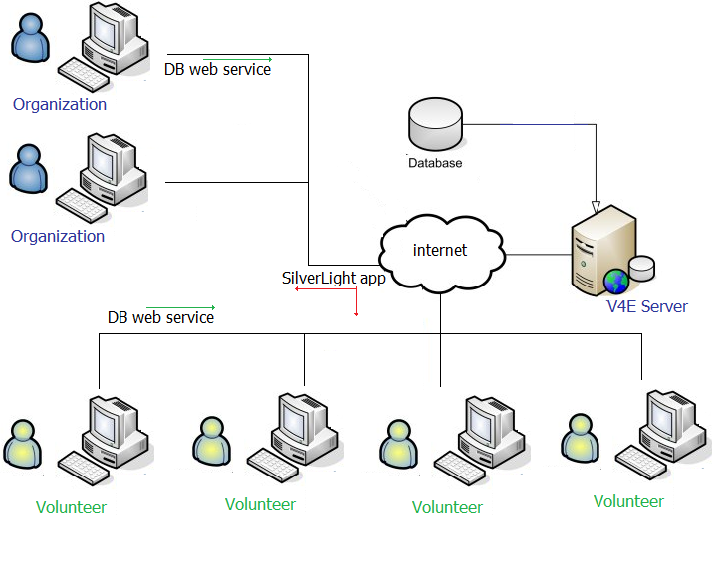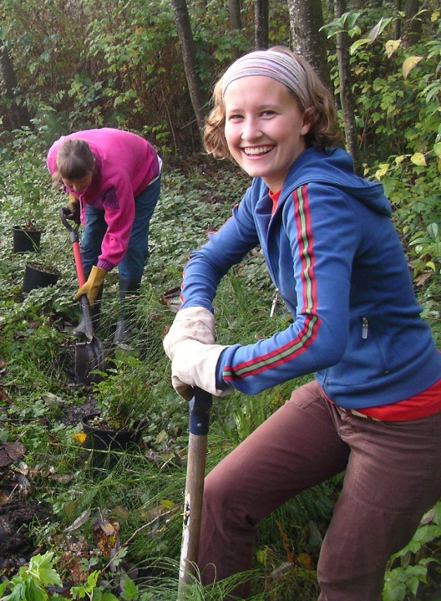

**V4E, Volunteering made easy!**

**User Interface**

**Architecture**

Why do people volunteer?

To learn new skills? To have fun? To make a difference?

People have different reasons to volunteer but for whatever reason not all of them have the information needed to give a helping hand.

How many volunteer organizations can we search over the internet?

“31 700 000 results” in Bing!

Which one to choose? Where to look?

*What if they want to volunteer in different fields or locations?*

What about organizations?

When a disaster appears there is not time to lose for searching people. Volunteers can be there waiting to be called.

Wouldn’t be nice to have some kind of *“yellow pages”* of volunteers?

About the Millennium Development Goals, V4E is trying to achieve *E:\LUT\imaginecup\images\1d.png*

The Develop a global partnership for development

V4E provides the following features:

* Web application for both sides
* Geolocation tool to show volunteering activities around the world
* Registration of volunteers for sharing information about them to the organizations
* Registration of organizations to share information about themselves and their activities

Maybe all this problems are actually already solved, but all of them separately, no single solution. Not all together.

***Volunteering for Everyone is that tool, that directory!***

**It centralizes organizations and volunteers into a single place.**