The Problem

How many organizations of volunteers can we search over the internet? Just by typing that in Bing we can see that there is about “31 700 000 results”, which one to chose? Where to look?
Volunteers are people who want to act now! They want to contribute in fields they know, they do not care about to which organization they are going to work for, they only want to help others.
Many people know about “Red Cross”, “International Amnesty”, “Human Rights Watch”, “Greenpeace”. But what about those organization that don’t have the funds to make themselves known but still they have the same devotion as the others?
Why not just give to the volunteers a proper tool to search for the places to act, the activities to chose, the organizations involved? Let’s avoid the long process of search and the difficult process of application.
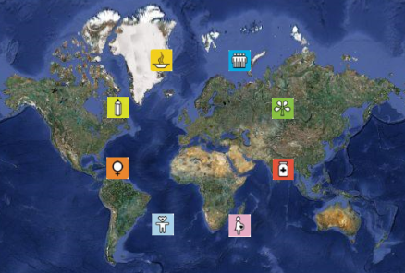
In the other hand, the organizations have the same problem when trying to get to people. Where can they find the volunteers? Even more important, where can they find the volunteers for the field required? When a disaster happened there is no time to lose searching for people by creating a new web site or by making more media publicity. Volunteers are already there waiting to be called.
Wouldn’t be nice to have some kind of “yellow pages” of volunteers? It could be a directory that simplifies the process of searching.
Maybe all this problems are actually already solved, but all of them separately, no single solution. Not all together.

The solution

V4E is that tool, that directory. It centralized organizations into a single place.
It is basically a friendly web application that can be access by all parties using internet and a browser.
It provides the following features:
- Web application that can be used on all sides of volunteering process
- Geolocation tools to show nearest volunteer activities or around the world
- Registration of volunteers to share information about them between organizations
- Registration of organization to share information about themselves and their activities

To resume, V4E provides a channel of communication between volunteers and organizations.

About the Millennium Development Goals, V4E is trying to achieve The Develop a global partnership for development. V4E knows that many people want to collaborate to make a better world.

But as we talk about any ONGs and volunteering we can understand that all the others are also involved here in this project.

The software

Functionalities
V4E provides the following use-cases:
- Organizations can register: this way they can be listen in V4E organization directory
- Organizations provide information about volunteer activities: they can create activities, describe them and located in the map for easy search.
- Volunteers can register: this is how organizations can then look for them.
- Volunteers can search for a volunteer activity: using different types of search like “by organization”, “by location”, “by category”.
- Volunteers can contact organizations: This is the main idea.
V4E also make use of web service geo location to show always the position of the current volunteer, this is mainly because user will see at first all activities that are near to his location.
V4E provides RSS service so volunteers can subscribe to it in order to get news about their favorite organizations or categories.
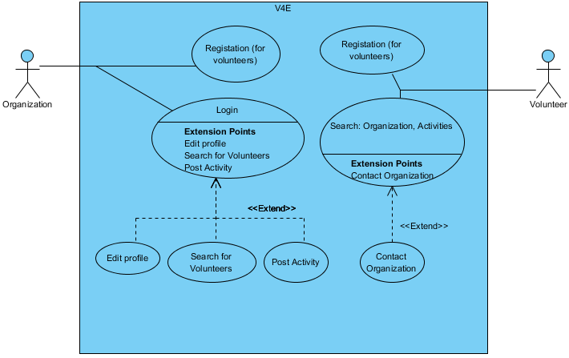

Interface

Clean, intuitive.
It is totally made in SilverLight, it uses Bing maps to display the location of organizations, offices, activities, etc.
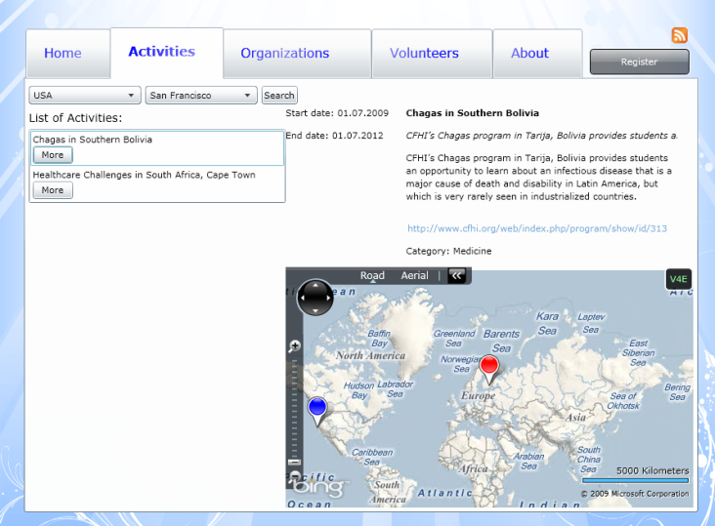
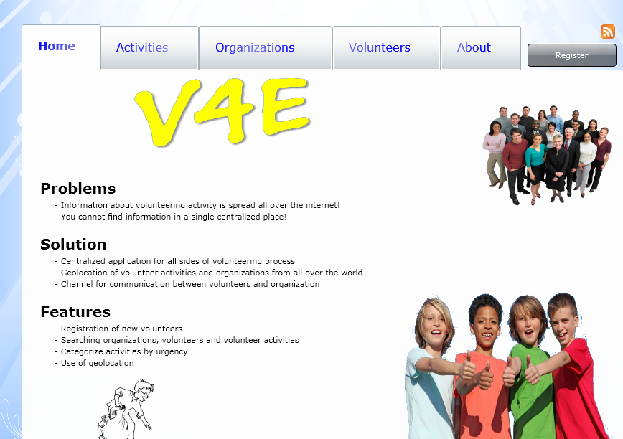

Technologies

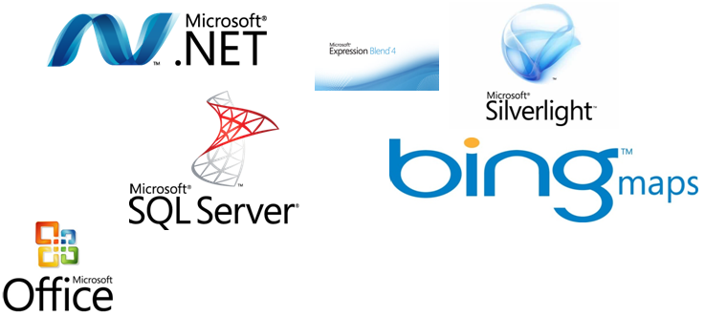

Architecture

Application is located in a windows server. Clients need only internet and a web browser.
Server sends the application totally based in Silverlight to the clients, the application make use of Bing maps API so it is able to operate with the map, basically to add locations dynamically, to search on the map and the call geo location service.
When clients make update/add/delete content from the page, a web service is called in order to update the database.

