HOME AUTOMATION 2017 CODE CAMP REPORT
TOPIC : « CYBERSPACE »

Made by : Anara Abdukalikova
Germain Déroche
Jonathan Berrios
Roman Zhohov

Contents
Introduction 3
1. Project: Cyberspace 4
1.1. Problem definition 4
1.2. Goals and outcomes 4
1.3. Sustainability 5
1.4. Implementation 5
1.4.1. The ideal scenario 6
1.4.2. Assumptions and limitations 6
1.5. Costs 7
2. Communication Protocols 8
2.1. Bluetooth Low Energy 8
2.1.1. Bluetooth Low Energy protocol stack 8
2.2. Insteon protocol 12
2.2.1. INSTEON Specifications 12
2.2.2. INSTEON Device Communication 13
2.2.3. INSTEON Message Repeating 15
Conclusion 15
References 16

Introduction
During our semester in LUT (Lappeenranta University of Technology), in the context of PERCCOM master, we had a code camp about home automation. Home automation has become a real growing business in some countries in the last 10 years, especially in Germany which has a huge market for that. Moreover, home automation can be a very good enabler for sustainability of the buildings, by managing energy consumption, needs of the people inside the building or by providing a global overview of the actual status of your house.
We were given a home automation project to realize by Pr. Olaf Droegehorn not only for acquiring knowledge in that domain, but also to link it a bit more with sustainability. To implement this project, he provides us some tools and features and asked us to think about a home automation scenario for LUT.
In this report, we will present our project and the different expected outcomes from it as well as 2 communication protocols which can be used in a context of home automation.

Project: Cyberspace
In this part, we will present our project. Firstly, we will define the problem that should be solved by our solution, then will define the different expected outcomes of our project and its sustainability impacts. Finally, we will provide a performance scenario as well as the architecture and the cost of our project.

Problem definition
Our project consists of the implementation of a relaxing room for the open space located in LUT. We decided to develop this scenario because the actual open space only provides some comfortable seats, chess game, guitar, coffee machine and TV, which are not restful enough. So, in order to increase the relaxation of the different users in the open space we decided to implement the improvements in the open space.

Goals and outcomes
Our project has 3 main goals:
- Create pleasant virtual environment with affecting human’s senses
- User-friendly design with enhanced control
- Satisfy workers’ needs in term of relaxation
Then if we satisfy these goals we assume to get some outcomes which are:
- Increase workers efficiency by allowing them to relax
- Increase social relation between workers, because the room become more attractive
- Provide efficient usage of energy
The picture below illustrates the ideal scenario of the project :
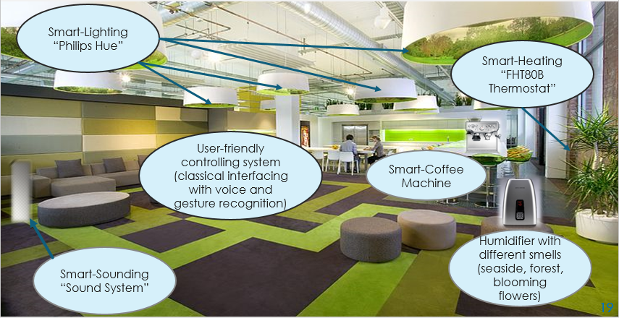
Figure 1. – Ideal scenario

Sustainability
Sustainability is mainly considered as a concept or an approach that is aimed at the creation of balance in the way of living and tightly connected with the sustainable development. As it was mentioned in the forum for future that sustainable development is a combination process of improving people quality of life on a par with enhancing the earth’s life support systems. Sustainability is based on the three pillars: economical, social and environmental. The changes and improvements can be done either in one of the pillars or in three of them simultaneously for achieving sustainability.
Our project is mostly addressed to sustainability in the social aspect, aiming at the improvements which will result in the human well-being and efficiency boost. Since the main goal of this project is to enhance the open space environment for people working and studying in the university, its implementation will lead to the improvement of workers’ efficiency and satisfaction. Creating comfortable environment enables having proper rest during working hours, therefore it contributes to the augmentation of efficient performance in general.
For measuring sustainability, there are different indicators and metrics depending on what kind of sustainability to assess. Thus, social indicators that could be used in future scenario of our project are:
- Rate of complaints and how they have been addressed
- Employees' satisfaction
This could be achieved by doing a survey and interviewing the workers about their feeling, complaints and feedbacks for the cyberspace project.

Implementation
The realization of the cyberspace project is based on the use of the home automation devices, such as Switch (FS20 ST-4), Temperature sensor (HMS100TF), Thermostat+control (FHT80B-3+FHT8V-3), HUE Go and Bridge (Philips), DHS-Computertechnik as a main server. The following pricture illustrates the architecture of the implemented system :
FHEM
Server
Thermostat
Humidifier
HUE Philips
Temperature &
Humidity sensor
Switch
Presence sensor
(Remote Control)
Music system
Smart lighting

Figure 2. – Project architecture

The ideal scenario
People occurrence in the open space is captured by the presence sensor and the signal from the sensor is forwarded to the FHEM server. All other devices are connected to the FHEM server and predefined to start working only after getting the signal of people presence in the room. As soon as there is anyone in the room the light, music and humidifier will be turned on. As for the thermostat, it can be tuned to automatic, manual or holiday/party modes. In this project we tuned it to the automatic mode, moreover we specified that it will be working in the comfortable temperature mode during the whole day, and will be switched to the lowering temperature mode after 8 pm and will be switched to the comfort mode again at 8 am. In addition, all users can check the availability of the coffee in coffee machine by simply visiting the web page of FHEM server, where it will be shown by the icons. The implementation of that will be held by the weight and temperature sensors reacting to the amount and temperature inside the machine and sending the information to FHEM server. In future scenario, the opportunity to control the system by the voice and gesture recognition is considered.

Assumptions and limitations
During the realization of the project the performance of some sensors were emulated and substituted in the process by the available devices. For instance, the performance of presence sensor was emulated by the remote control button, smart sound system was realized by playing the music from the laptop through the speakers. The activation of the humidifier, music and light was controlled by the remote buttons as well, which were programmed to turn on the switch (where the devices were connected). In addition, due the unavailability of the weight sensor coffee checking process was showed just by predefining condition on FHEM server webpage to change the icon.

Costs
Regarding the cost of our project the table below summarizes the possible cost of our prototype:
Hardware | Price(€)
Humidifier | 35
Audio System | 110
Temperature sensor(HMS100TF) | 30
Presence sensor | 60
Plug(FS20 ST-4) | 30
Thermostat+control(FHT80B) | 40
HUE Bridge | 50
HUE Go | 80
FHEM Server | 300
Weight Sensor | 15
Total | 750
Table 1. Cost of the prototype
The real cost of the prototype may vary in case of the real implementation, where the extra Phillips HUE lights may be included.

Communication Protocols
This section contains the information about two communication protocols which can be used for home automation.

Bluetooth Low Energy
Bluetooth low energy (BLE) was specially designed for the Internet of Things (IoT). It implements low energy functionality which makes it perfect for devices that utilize energy-harvesting or batteries. Major operating systems and hardware architectures support BLE which enables its deployment for broad range of devices, from home appliances to smart wearables and sensor.
BLE entered the stage while other low-power wireless technologies, such as ZigBee, 6LoWPAN or Z-Wave, have been steadily gaining power in application domains that require multihop networking [2,3]. However, BLE utilizes a single-hop networking scenario that applicable to a different use cases in areas such as healthcare, home automation, smart energy and security.
Bluetooth technology is already implemented in many devices (e.g., in mobile phones, laptops, automobiles, etc.) that may boost an adoption of BLE, since technical implementation of BLE reuse existing Bluetooth components. According to published forecasts [4], BLE will be used in billions of devices in the near future. Moreover, the IETF 6LoWPAN Working Group (WG) [5] has already argued the value of BLE for the Internet of Things.

Bluetooth Low Energy protocol stack
Similarly to classic Bluetooth, the BLE consists of two main parts: controller and host. The controller utilizes Physical and Link Layers. It can be implemented as a System-on-Chip with radio. The Host is designed to work with Logical Link Control, Adaptation Protocol (L2CAP), the Attribute Protocol (ATT), the Generic Attribute Profile (GATT), the Security Manager Protocol (SMP) and the Generic Access Profile (GAP). Communication between the Host and the Controller is enabled by using Host Controller Interface (HCI). Fig. 1 shows the protocol stack of BLE.
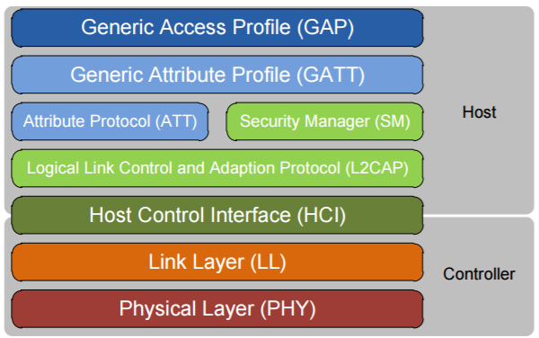
Figure 2. - BLE protocol stack.

Physical Layer
One of design requirements was to create robust physical layer to avoid interference with other devices that operate in the same band. In the same time, physical layer should have low power consumption. BLE utilizes ISM band – 2.4 GHz and defines 40 (3 advertising channels and 37 data channels) radio channels with 2 MHz spacing. Advertising channels are dedicated to device discovery, connection establishment and broadcast transmission, while data channels are used for bidirectional information exchange between connected devices.
An adaptive frequency hopping mechanism is utilized to mitigate interference and wireless propagation issues (fading and multipath). All physical channels use a Gaussian Frequency Shift Keying (GFSK) modulation, which is easy to implement. The modulation index (0.5) is selected to reduce peak power consumption. The physical layer data rate is 1 Mbps. The BLE specification requires the sensitivity to be better than or equal to −70 dBm.

Link Layer
In BLE, the broadcast transmission is done in advertising packets through the advertising channels. Broadcast devices – advertisers use all the advertising channels sequentially. Other devices that only receive data through advertising channels are called scanners.
Connection between two devices is required to start bidirectional data transmission. BLE utilizes asymmetrical procedure to establish connection. Typically, advertiser marks his status as a connectable device by using advertising channels while other devices (initiators) receives those advertisements and send a Connection Request message to the advertiser. Advertiser creates a point-to-point connection with the initiator. Packets for data channels can be identified by a random 32-bit access code. There are two roles at the Link Layer:
- Master (device that can have multiple simultaneous connections with different slave-devices);
- Slave (can have only one master);
Therefore, BLE utilizes the star topology (consists of master and its slaves).
As we said previously, low power consumption is one of the main goals for BLE. It is achieved by applying so-called sleep mode when devices “wake up” periodically to receive possible packets from the master. The master specifies the time slots and needed frequency channel for slaves which means Time Division Multiple Access (TDMA) utilization.
To ensure correct reception of the massages, all data units include a 24-bit Cyclic Redundancy Check (CRC) code.
BLE Link Layer connections utilizes a stop-and-wait flow control mechanism based on cumulative acknowledgments, which at the same time provides error recovery capabilities. [6] Each data channel frame header has two one-bit fields called the Sequence Number (SN) and the Next Expected Sequence Number (NESN). The SN bit defines the packet, whereas the NESN specifies which packet from the peer device should be received next.
In case of successful reception of data channel packet, the NESN of its next packet will be incremented, and that packet will work as an acknowledgement. Otherwise, if a device receives a packet with an invalid CRC check, the NESN of the received packet cannot be relied upon. This forces the receiving device to resend its last transmitted packet, which serves as a negative acknowledgement. [6]

Logical Link Control Adaptation Protocol (L2CAP)
BLE uses the simplified version of protocol which is based on classic Bluetooth L2CAP. This protocol is intended to multiplex the data from higher layers (ATT, SMP and Link Layer control signaling) and provides best-effort service (without retransmissions or flow control). Segmentation and reassembly functionalities are not needed due to the size of the data units coming from upper layers (max L2CAP payload is 23 bytes).

Attribute protocol (ATT)
The ATT specifies the communication between two devices while they have the server and client roles. In this case, the server contains a set of attributes. An attribute is a data structure in which the information from Generic Attribute protocol (GATT) is stored. Server-client roles are totally independent from master-slave scheme.

Generic Attribute protocol (GATT)
- GATT Client (The device that is ready to receive data. It initiates and requests from the GATT Server. It can receive responses, indicators and notification from the server) [5];
- GATT Server (This device that has data and receives incoming requests from clients and sends responses, indicators, notifications to a Client);
Important to notice that one device can play both roles simultaneously.

Security Manager protocol (SMP)
Security Manager protocol is responsible for authentication and data encryption between the devices. It has several procedures:
- Encryption and authentication;
- Pairing and bonding devices;
- Key generation and passing;
- Selection of pairing method;

Generic Access Profile (GAP)
The GAP defines the generic approach of discovery and link management of Bluetooth devices. Similarly, it includes data format requirements and user interface. The GAP defines following roles:
- Broadcaster role: this device can only broadcast data using advertising channels;
- Observer role: this device can receive the advertising events;
- Peripheral role: this device has single connection with the Central role device and referred as a Slave in terms of link layer;
- Central role: this device is in charge of the establishment of multiple physical connections. Central role device may operate as a master at the link layer.
Packet encapsulation on each layer is shown in Fig. 2.
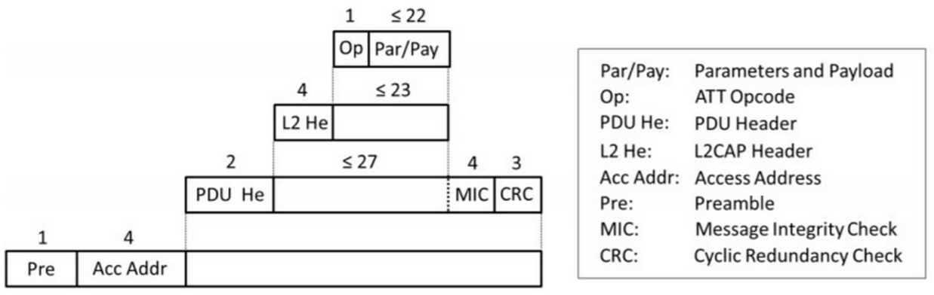
Figure 3. - Encapsulation of data. [5]

Insteon protocol
INSTEON is a proprietary technology. This technology boost low-cost devices to be networked together using the powerline, radio frequency (RF), or both. All INSTEON devices are peers, in this way any device can be a transmitter, receptor, or they can also repeat other messages, without requiring a master controller or complex routing software. Simplicity if the aim of this technology. By adding more devices makes an INSTEON network more reliable, by means of a simple protocol for communication for retransmissions and retries. Any INSTEON devices are compatible with legacy X10 devices, another technology which features transmission through the power line.

INSTEON Specifications
The most important property of INSTEON is its no-frills simplicity. The aim is to avoid unnecessary bit-load per message. INSTEON messages are fixed in length and synchronized to the AC powerline zero-crossings. No routing information more than source and destination address. INSTEON technology allows infrastructure/home devices like light switches and sensors to belong in the same network together in large numbers, at low cost. INSTEON technology can perform without any need of any other technology, but it can also bridge to other networks, such as WiFi LANs, the Internet, telephony, and entertainment distribution systems. Such bridging allows INSTEON technology flexibility to adapat and be integrated into home control environments.
The following Table 2 shows the most relevant features of INSTEON, such as bit rate TX, modulation, amongst others.
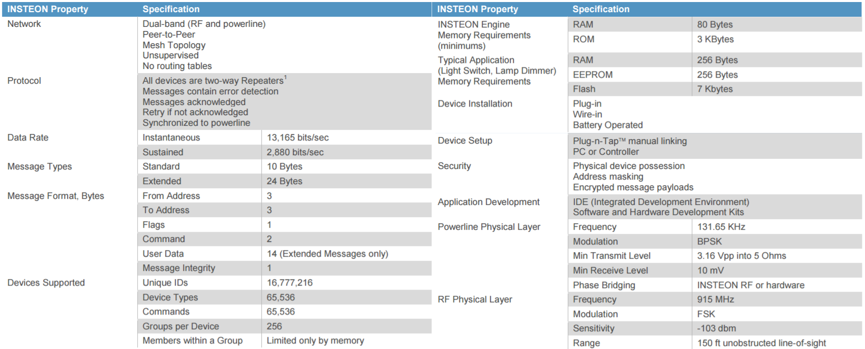
Table 2 - INSTEON Technology features

INSTEON Device Communication
Communication between devices occurs using the INSTEON protocol over the air via radio frequency (RF) and over the powerline (PL).
The Figure below gives an approach on how an INSTEON devices can be laid out on an infrastructure network.
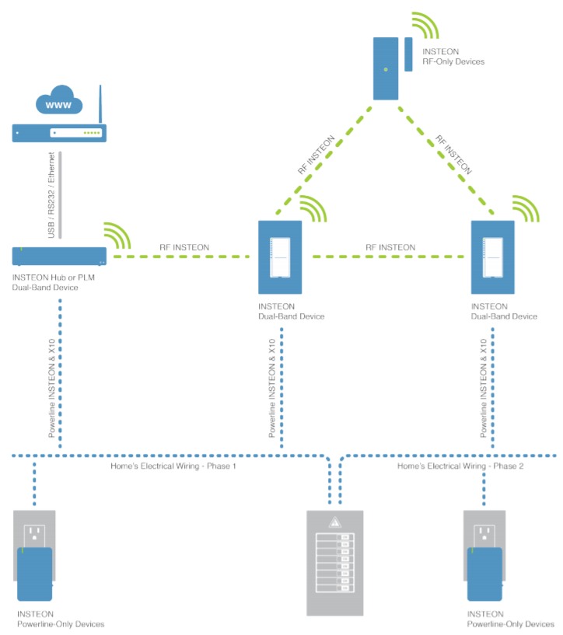
Figure 4. - INSTEON devices network layout [7]
INSTEON technology has been developed in North America. In that continent, electrical power is commonly distributed to homes as split-phase 220-volt alternating current (220 VAC). At the main electrical junction box to the home, the single three-wire 220 VAC powerline is split into a pair of two-wire 110 VAC powerlines, known as Phase 1 and Phase 2. Phase 1 wiring usually powers half the circuits in the home, and Phase 2 powers the other half.
INSTEON RF devices communicate with other INSTEON RF devices by using the INSTEON RF protocol. Similarly, INSTEON PL devices communicate with each other over the powerline by using the INSTEON Powerline protocol. INSTEON dual-band devices are those which use both the INSTEON Powerline protocol and the INSTEON RF protocol, solving significant problems by its flexibility and adaptability at scenarios where encountered with devices that can only communicate by one physical medium.
On regards of the powerline transmission. In a common scenario, the powerline signals originating on the opposite powerline phase from a powerline receiver are severely attenuated, because there is no direct circuit connection for them to travel over. A typical solution to this problem is to connect a signal coupling device between the powerline phases, either by hardwiring it in at a junction box or by plugging it into a 220 VAC outlet. INSTEON technology, automatically solves the powerline phase coupling problem by the use of INSTEON dual-band devices capable of both powerline and RF messaging. INSTEON RF messaging bridges the powerline phases when at least one INSTEON DUAL-BAND device is installed on each powerline phase.
In the case when suitably equipped with a dedicated serial interface, such as USB, RS232, or Ethernet, INSTEON devices can also interface with the Internet, smart phones, tablets, personal computers and other digital equipment. In the las Figure 1 above, an INSTEON device is shown communicating with a PC using a serial link.
Serial communications bridges networks of INSTEON devices to otherwise incompatible networks of devices in a home, to computers, to other nodes devices on a local-area network (LAN), or to the global Internet. Those connections to outside resources allow networks of INSTEON devices to exhibit complex, adaptive, and outmost customer-pleasing behaviors.

INSTEON Message Repeating
The Figure 2 below shows an example layout on how network reliability improves when additional INSTEON devices are added, reliability enhanced. This example distribution shows INSTEON devices communicating by powerline-only (PL), RF-only (RF), and both (DB). In order to make the example more illustrative, only two dual-band products are included.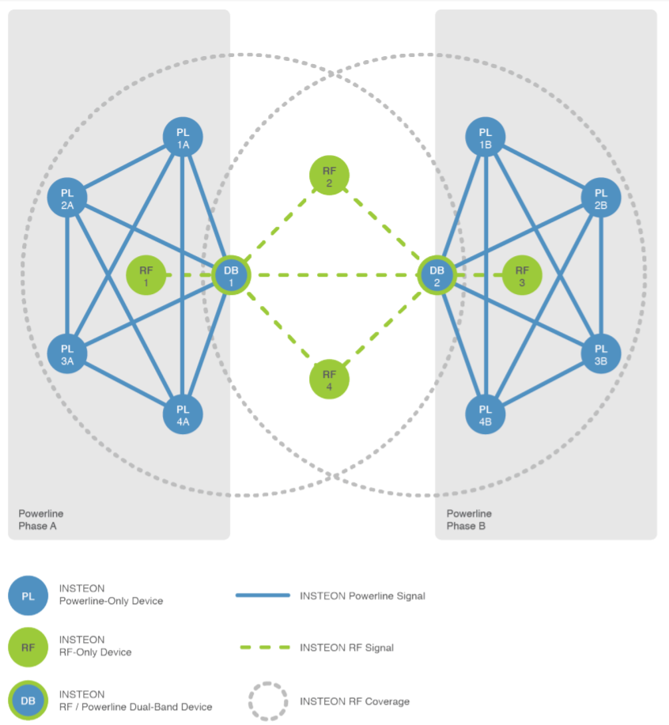
Figure 5. - Network reliability supported by INSTEON devices [7

Conclusion
With this project, we discovered a new technologic area which is home automation. More precisely, we got a very good overview about what is home automation and how can it be used in order to serve sustainable development.
It also helped us to discover the different features and appropriate tools to implement that kind of technology and also a general idea of which scenario can be used to enhance sustainability within this technology.
In conclusion, to keep pace with this technological area is really hard and therefore to be prosperous in this field requires new innovations different from what already exists.

References
1. Specification of the Bluetooth System, Covered Core Package, Version: 4.0. The Bluetooth Special Interest Group; Kirkland, WA, USA: 2010.
2. Gomez C., Paradells J. Wireless home automation networks: A survey of architectures and technologies. IEEE Commun. Mag. 2010; 48:92–101.
3. Ludovici A., Calveras A., Casademont J. Forwarding techniques for IP fragmented packets in a real 6LoWPAN network. Sensors. 2011; 11:992–1008.
4. West A. Smartphone, the key for Bluetooth low energy technology.
5. Bluetooth Low Energy, Cypress Semiconductor Corporation, 2015
6. Gomez C, Oller J, Paradells J. Overview and Evaluation of Bluetooth Low Energy: An Emerging Low-Power Wireless Technology. Sensors (Basel, Switzerland). 2012;12(9):11734-11753. doi:10.3390/s120911734.
7. Insteon documentation : http://cache.insteon.com/documentation/insteon_details.pdf
8. Insteon technology documentation : http://www.insteon.com/technology/#documentation

