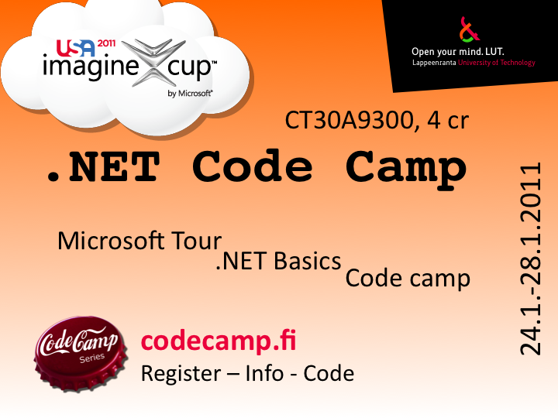


.NET Code Camp 2011
Code Camp Week: Week 4 Monday 24.1 - Friday 28.1 2011 Room no: ML 6428
.NET Basics: Thursday and Friday 20 - 21.1.2011 Room no: ML 6428
Microsoft Technology Tour: Friday 14.1.2011 Room no: 2310
CT30A9300 Code Camp on Communications Engineering (4 cr)

News & Notes
- Please contact Bishal Raj Karki (bishal.karki@lut.fi) for any questions or queries.
- Here is a sample report and brochure from last year: Sample Brochure and Report(CrySys)
- Imagine Cup Submission Deadline for software design (Finland Local Competetion) : 6 March 2011
- Please Add Prof. Jari Porras as your mentor while creating your Imagine Cup group and submitting your entry
- Please submit your entry through this link: TBA Hopefully every group submits their entry by the deadline
- Please submit your 1 page brochure and 5 page report in pdf file format
- Please check this link for more information on Finland local competetion Imagine Cup 2011-Software Design Category in Finland
- Deadline for Final report and poster submission: 18 February 2011
- Please return the final report and poster in pdf file format to email bishal.karki@lut.fi by 18 February 2011.
- Please check for the course wiki after Final submissions for further imagine cup guidelines.
- Please do not forget to upload your code files(zip) into the wiki under your group pages.
- Report Submission Deadline(LUT): 11th of February (recommended few days before)
- Feedback Day: 11th February 2011 - Please get your time(30 mins) reserved on the wiki for the feedback day
- Friday 11.2.2011, a 5 page Software description and 1 page brochure for code camp result and for feedback for the imagine cup . Put your documents into group wiki area, if you can put your documents into wiki at 10.2.2010 it would be better for us to study it prior and prepare the feedback for each group. Else bring it along with you during the feedback. Please send the email conformation at bishal.karki@lut.fi after putting your report on the wiki.
- Use the following link to register to the course events.
  - http://www.webropol.com/P.aspx?id=509770&cid=148923921
- Please, fill in the questionnaire concerning your learning styles as http://ct100020vir3.pc.lut.fi/learningstyles/
- Please DO NOT FORGET to register yourself to the microsoft tour through Microsofts web page.
  - For Idea Day i.e. Microsoft Technology Tour day (14.01.2011) you should register through http://msevents.microsoft.com/CUI/EventDetail.aspx?EventID=1032438114&Culture=fi-FI
- Code complete and demo instructions.

How to participate in local sefifinals
- if you have not already, please start by going to the Imagine Cup site and registering at http://imaginecup.com/register. From there you need to go to the Software Design page and select “Compete”. This will point you to a page to form a team.
- Submit your idea before end of the day of March 6, 2011 to ImagineCup site (after forming your team) and also by email to icfi2011@microsoft.com.
- Your entry should be described in maximum of five 5 pages document which describes the following:
  - Problem Definition
  - Solution
  - Technical Architecture

Idea Day/ Microsoft Technology Tour
Location 2310
- Start time on Friday 14.1.2011 at 9:00
Time | Event
09:00 | Educational resources, programs and tools available to educational institutions, teachers and students.
10:00 | Overview of the business operated tools and techniques to user interface design and application development. Overview of instruments, project types (WCF / Data / EDM dynamic datapages, Silverlight, XNA, Office, etc), Silverlight / HTM5/IE9 cloud and programming in general.
12:00 | Lunch Break
12:45 | Silverlight and Windows Phone Application
14:30 | Break
14:45 | Web Application Development 2, Windows Phone Development with Silverlight and the Azure cloud environment ...
16:15 | Event Endings
.

.NET Basics Day
Location : LUT ML6428
- Start time : (Thursday - Friday) (20 - 21).1.2011 at 8:15
Time | Activity
08:15 | Introduction
08:45 | .NET Tutorial starts from Expert Tuomo Ketomäki
10:00 | Break
10:15 | Tutorial Continues
12:00 | Lunch Break
12:45 | Tutorial Continues
14:00 | Tea Break
14:15 | Tutorial Continues
16:30 | The End

.

Tuomo Ketomäki's Content (22.01.2010)
Presentation | Material (pdf)
ASP.NET Basics | Basics(pdf)
AJAX | Ajax(pdf)
Master Pages and navigation | Master Pages and Navigation(pdf)
User Controls | User Controls(pdf)
Data binding and LINQ to SQL | Data binding and LINQ to SQL (pdf)
Web Services | Web Services(pdf)
Silverlight | Silverlight(pdf)
.
Demo Applications | Material (zip)
ASP.NET Demos | ASP.NET Demos (zip)
Silverlight Demos | Silverlight Demo (zip)

Code Camp Week
Location 6428 Windows Classroom
- Start time on Monday 24.1.2011 at 10:15
 | Monday | Tuesday | Wednesday | Thursday | Friday
08:15 | ------ | Coding | Coding | Coding | Code Finalizing
10:15 | Intro & Idea Brainstorming | Coding | Coding | Coding | Code complete
12:00 | Lunch | Lunch | Lunch | Lunch | Demo
13:00 | Idea Complete & Design (Wiki Ready) | Coding | Coding | Coding | Demo
14:15 | Short Idea Presentation & Feedback | Coding | Coding | Coding | Closing
17:00 | Social event and sauna | Coding | Coding | Coding
02:00 |  | Coding | Coding | Deadline style Coding | Feedback
Presentations

Feedback times
- Friday 11th of February: Tite library 6614
- 8.30-9.00 Add your group here to reserve the time
- 9.00-9.30 Group 5
- 9.30-10.00 Group 1
- 10.30-11.00 Group 4
- 12.00-12.30 Group 7
- 12.30-13.00 Group 6
- 13.00-13.30 Group 2
- 13.30-14.00

Wizard of UX
wizardofux.zip
Instructions
- All you need to do is to unzip this packet and double click WizardofUX.exe file. All .dll files must kept in the same directory with the exe file.
- Please remember to answer the small survey after you have used the Wizard of UX

Groups
Group | Application | Name 1 | Name 2 | Name 3 | Name 4
LUT1 | V4E | Igor Botyan | Camilo Cifuentes | Mihai Iusan
LUT2 | Epic Watch | Nana Assyne | Nuh Mohamed | Sidhartha Yalavarthi | Udhyan Timilsina
LUT3 | Greendel | Antti Knutas | Tommi Kähkönen | Harri Johansson
LUT4 | Trust'NGO | Jose Maria Luna | Samuel Guirado | Daniel Lupiañez | Cesar Quijano
LUT5 | SNC | Artem Anchugov | Saeedeh Mehrouzi | Naseer Ahmad
LUT6 | Word Cards | Joona-Pekka Kokko | Tomi Kosonen | Konstantin Koskelainen | Jalamadugu Ravitheja
LUT7 | Gallery | Qianting Liu | Tommi Zhihao Yu | Aoke Li
LUT8 | Application Name | Student Name 1 | Student Name 2 | Student Name 3 | Student Name 4
LUT9 | Application Name | Student Name 1 | Student Name 2 | Student Name 3 | Student Name 4

Imagine Cup
- Imagine Cup Home
- Competetion Theme
- Competetions Overview

Discuss
Discuss coding etc. problems
- IRC : irc.freenode.net
  - #lut-codecamp
- Forums => will be there soon!!
- Skype

FAQ

What are recommended skills/requirements for code camp ?
Programming experience(I hope you all have some...if not..then you'll have one during this code camp) and of course learning INTEREST is the most.

Can I prepare to Code Camp ?
Yes. During code camp week we will brainstorm a software idea, design it and code it. Getting good ideas might sometimes be hard and thinking about different ideas before code camp makes it faster to get into coding part.

I have an exam in Code Camp week ?
You are free to go exam, but code camp in intensive course and idea is to focus coding during the well, so it is recommended you prepare to exam before the code camp week.

Grading ?
Grading 1-5 from
- Idea and presentation of the Idea in wiki: 25%
- Coding of the implementation: 25%
- Presentation: 10%
- Code Camp Spirit: 20%
- Code camp report 20%

More ?
If you have questions about code camp send email to bishal.karki@lut.fi.

Links
Some basic Tutorials links: . C#.net:
- Link1: Visual C# .NET Programming
- Link2: C# Language Syntax
- Link3: Data types in C#
- Link4: Property in C# class
- Link5: C# sample for basic file operations
- Link6: C# sample for retrieving html content from any websites
- Link7: C# Guided Tour
ASP.net:
- Link1: ASP.NET tutorials
- Link2: ASP.NET tutorials for beginners
- Link3: ASP.NET Tutorial This is quite good but the backend script language used is VB. still you can get idea for c# as well..not much difference.
- Link4: ASP.NET tutorials for beginners
- Link5: Free ASP.NET MVC eBook Tutorial
- Link6: ScottGu's Blog
Ajax:
- Link1: Ajax tutorials
- Link2: 2010Microsoft official AJAX web site
- Link3: Microsoft AJAX learning videos
- Link4: Microsoft AJAX Control Toolkit Samples
Windows Phone 7 Programming:
- Absolute phone 7 getting started
- Phone 7 videos
- Silverlight for Windows phone7
- XNA Framework for Phone 7
- Phone 7 App hub
XML:
- Link1: Xml tutorials for beginners
- Link2: A Beginners Guide to Creating and Displaying Your First XML Document.
- Link3: XML Tutorial
- Link4: XML Basics
CSS:
- Link1: CSS Quick Tutorial
- Link2: CSS Structure and Rules
- Link3: CSS Properties
- Link4: Linking Style Sheets to HTML
- Link5: Displaying XML with CSS
Silverlight4:
- Silverlight 4 getting started
- Link2:
- Link3:
- Link4:
- Link5:
Expression Blend:
- Link1:
- Link2:
- Link3:
- Link4:
- Link5:
Database:
- Link1:
- Link2:
- Link3:
- Link4:
- Link5:
- MS SQL:
  - Link1:
  - Link2:
  - Link3:
  - Link4:
  - Link5:
- LINQ:
  - Link1:
  - Link2:
  - Link3:
  - Link4:
  - Link5:

What is Code Camp ?
Code Camp is a learning and hacking experience. The code camp approach can be defined as a collaborative learning setting that aims to promote profession-oriented skills. In code camp, the term camp refers to a situation where students assemble and stay a while together. The term code refers to coding, i.e. writing computer programs.

Registration
Enroll to course CT30A9300 Code Camp on Communications Engineering in Noppa or http://www.webropol.com/P.aspx?id=509770&cid=148923921

