Indian Ocean Simulator
You are sailing the Indian Ocean when suddenly people in danger emerge from the depths of the sea. You play against an another player, one of you tries to rescue the people while the other kills them. You have two minutes time to collect as many points in your role as you can. Use 'WASD' keys to move and spacebar to attack/rescue.
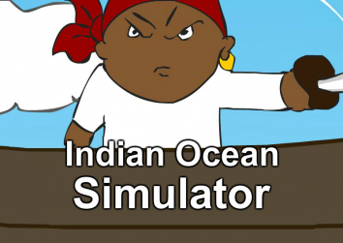

Material
Game: http://sakkee.org/fgj
Video link: https://www.youtube.com/watch?v=HXbfeRJ-7s0
FGJ: http://globalgamejam.org/2017/games/indian-ocean-simulator
Report: report_1_.pdf
Presentation: indian_ocean_simulat.pdf

