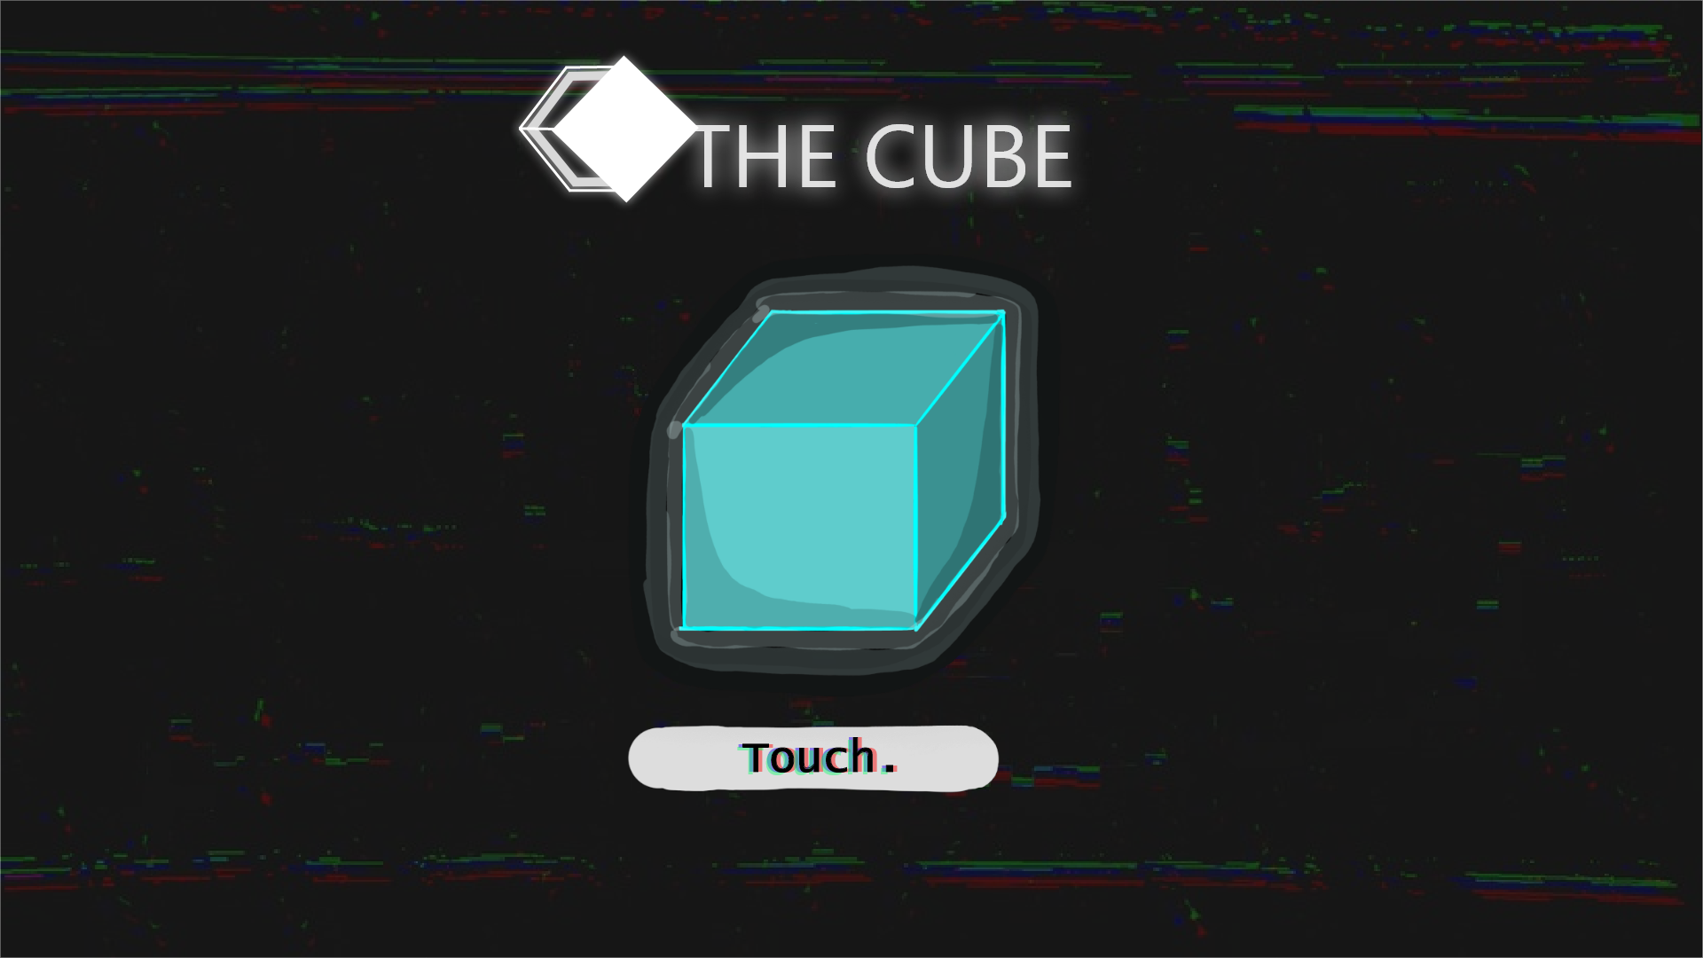

THE CUBE
THE CUBE is a game about a man who touches a cube. This cube transports him to odd - and at times even dystopian - worlds, where he must find a way to get back home. The game is in visual novel style, and includes multiple endings. Themes in this game are around dystopias, science fiction, and sustainability. Our team wanted to create a game that has themes about sustainability, celebrates the art produced for it, but also is manageable for first-time jammers to make.
- Genre: visual novel, 2D, story-rich, casual gameplay
- Platform: PC only
- Target audience: Teens and young adults with any interest in science fiction, sustainability, and/or “make-your-own-choices” type of story games.
Team members: [.pdf]
- Axel Tuomala / character art, UI, sounds, management
- Taiisia / background art, design
- Kasperi Kaukinen / programming, Unity master (not present in CodeCamp; updates the game with the team independently)
- Ultrablitz / storywriting, voice acting (not present in CodeCamp; MIA)
Development:
The game was developed on Unity. Our team was on average not very experienced. For example, our programmer had no previous experience of 2D unity games, had no previous game jam experience, and is still starting out with programming. As such, we aimed to make a game that is possible for someone of this level of experience to create with some learning within the game jam time limit. At the end we aimed to make a visual novel with a large story tree, multiple endings, voice acting, and usual basic visual novel functions. The background art and some visual designs are done by one artist, while other artists handled character portraits, UI, sound engineering, and managing the team. Knowledge of the technical details of game graphics were also learned and investigated by those making the graphics. The brancing story was created by the last member, who also loaned his voice for the voice acting for the game. The learning curve was steep for many of the participants, but the end result is a functional game after all.
Game at the end of FGJ2022:
- [GGJ page, game files]
- [GAME PRESENTATION]
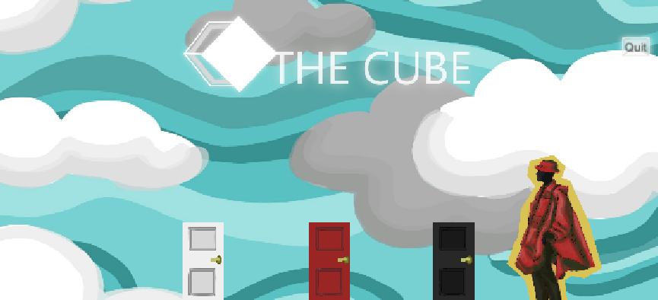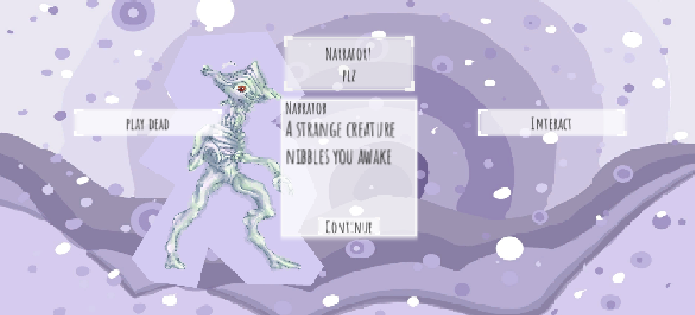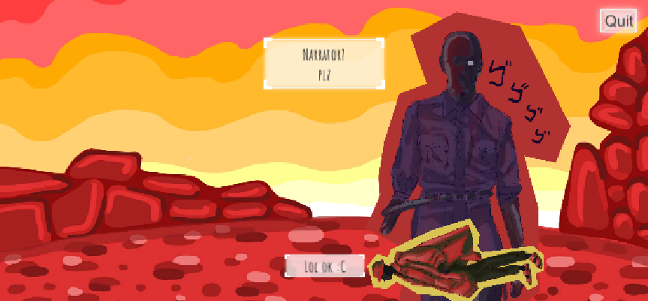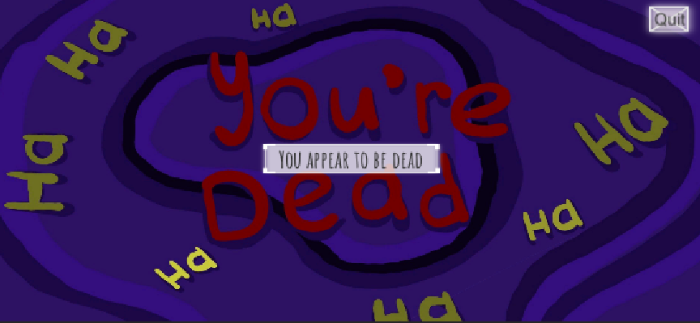

UPDATE: February 2022 / 27.02.2022
- updated_assets from Axel and Taiisia
- UPDATE REVEAL
- [UPDATE PLAN + REPORT]
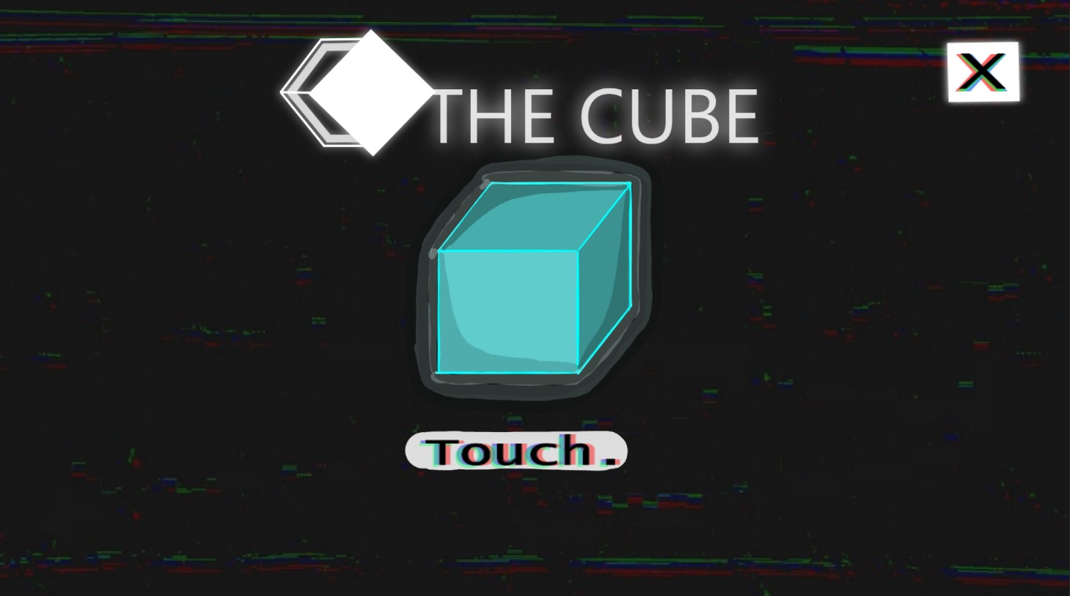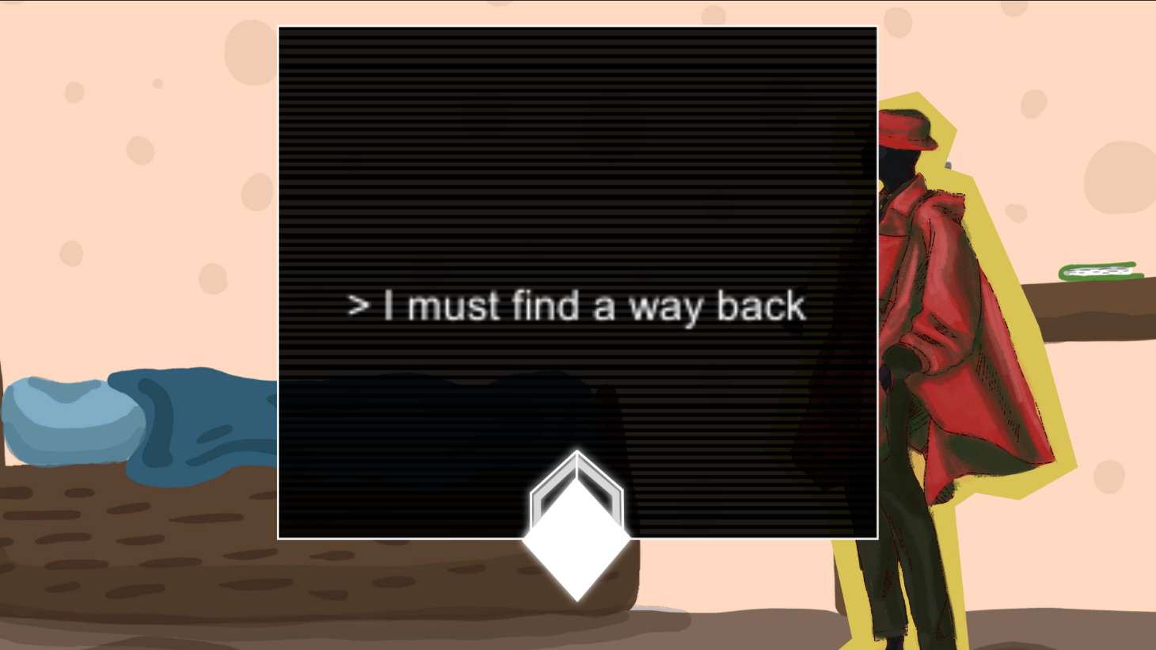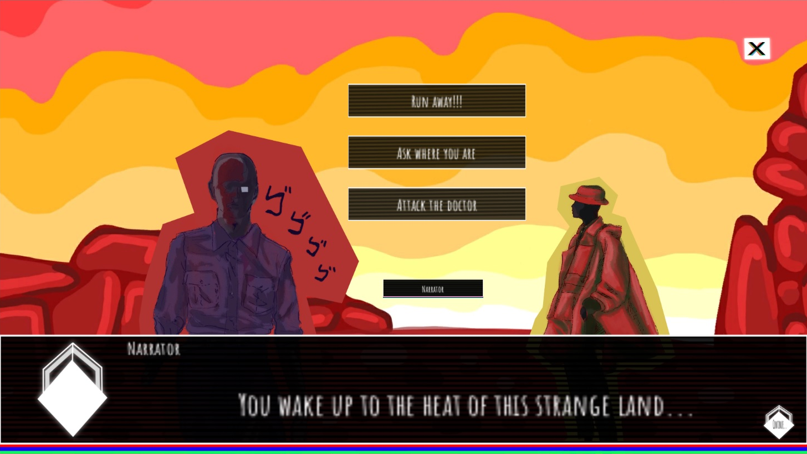
Successfully implemented updates made by 27.02.2022 can be found here. The update was mainly successful, and the game now not only has minimal functionality but now has most intended parts and functions in place. The list below will tell about the main updates. Besides the mentions in list, it should be noted that the game now has a short introduction sequence before the door selecting scene(as seen in one of the screenshots above), nd a new character added to it. More details of the updates can be found in: [UPDATE PLAN + REPORT]
See the list below for each update.
- ✅ = completed
- ❌ = unfinished
- ✅❌ = partially completed
Planned updates after game jam, planned to be done before 27.02.2022:
- * Resolution issue and UI bug fixed ✅
- * Full voice acting added ✅❌ (partial success - most are in, but some voice acting lines not recorded)
- * UI redesigned ✅
- * New art added ✅
- * File type issues resolved ✅
- * Saving and progress-tracking implemented ✅❌ (partial success - started, but not fully finished)

- Game link (itch.io)
(Bonus updates planned, if possible later on:)
- * New story added
- * New art assets for new story
- * Possibly even “marketing” materials (e.g. video, description graphics, etc) updated
- * Polishing touches
- * Reuploading the new version to itch.io

