Welcome to Group Tavata

Name | Student Number
Xhesika Ruci | 0511767
Ida Heathcote-Fumador | 0511877
Mina Rady | 0511804
Mukhammedjon Jalolov | 0511783

Idea
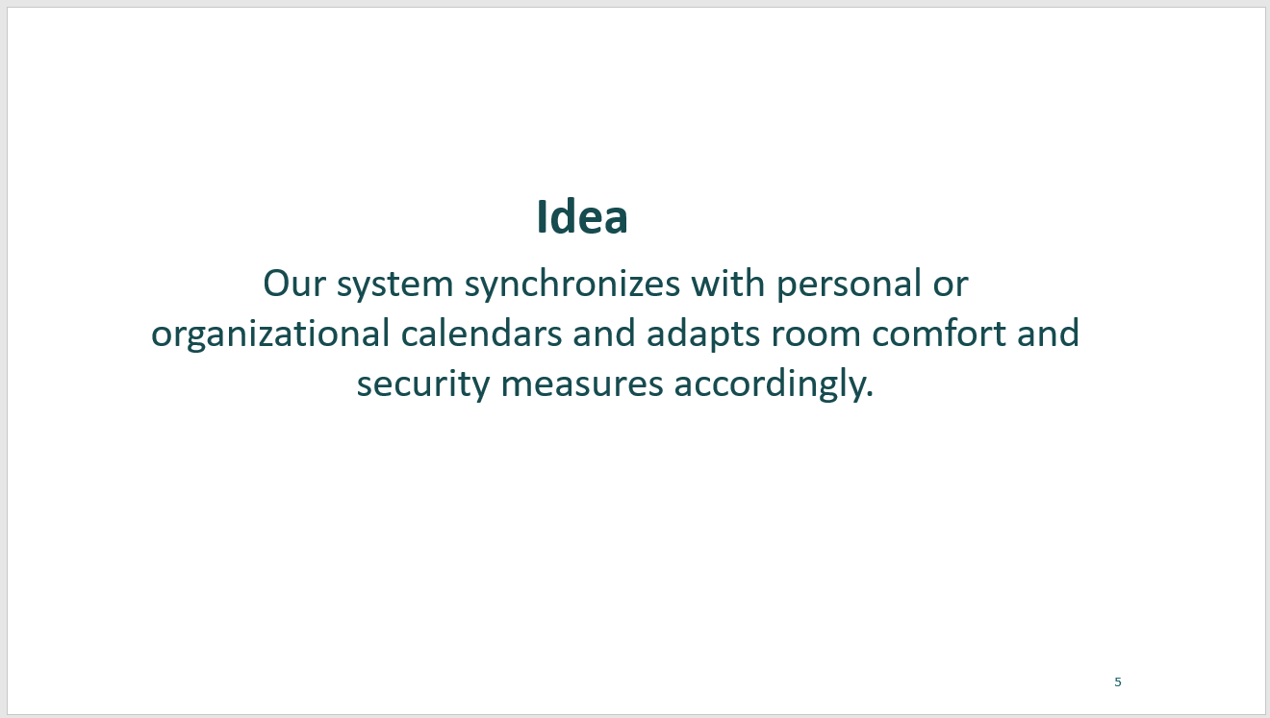
*Pre-meeting
- Turn on heating 15 minutes before meeting
*During meeting
- Automate light during projection
- Display humidex
- Display Break time notification
*After meeting__
- Check if meeting has ended then turn off all electronics
- Alert for meeting to close or extend the meeting based on the participants' decision
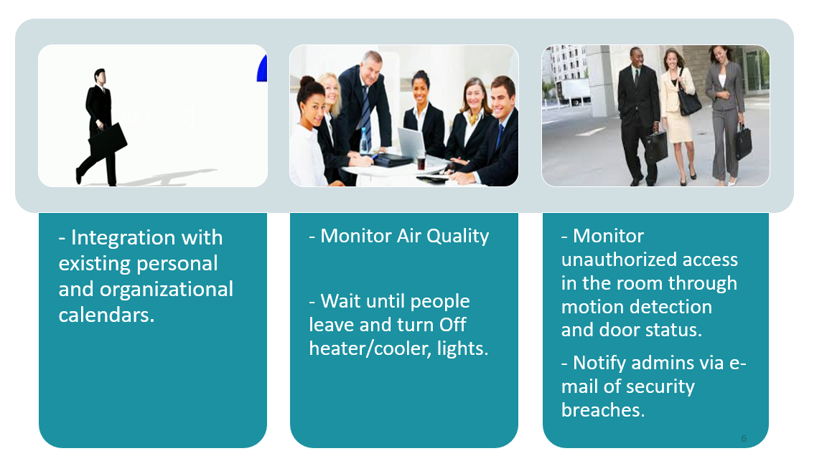

Motivation
- Comfort and Efficiency
- Control and Save Energy Consumption
- Access Control to meeting
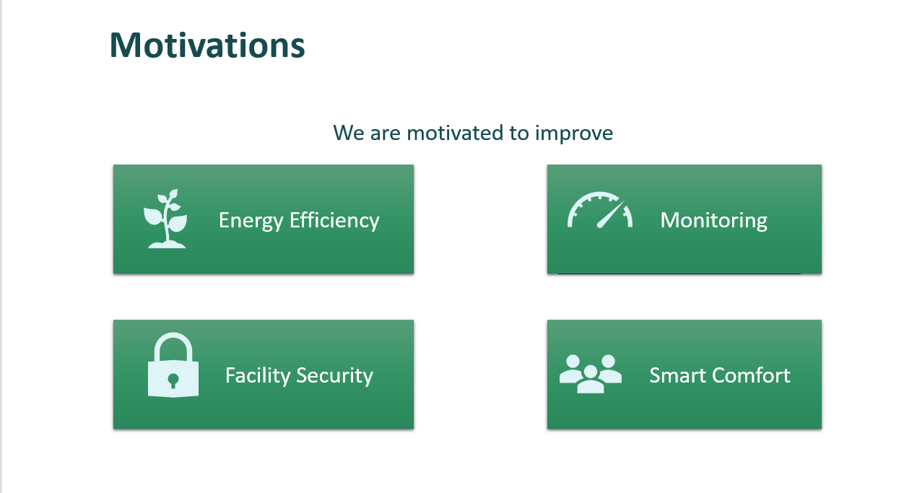
Sustainability 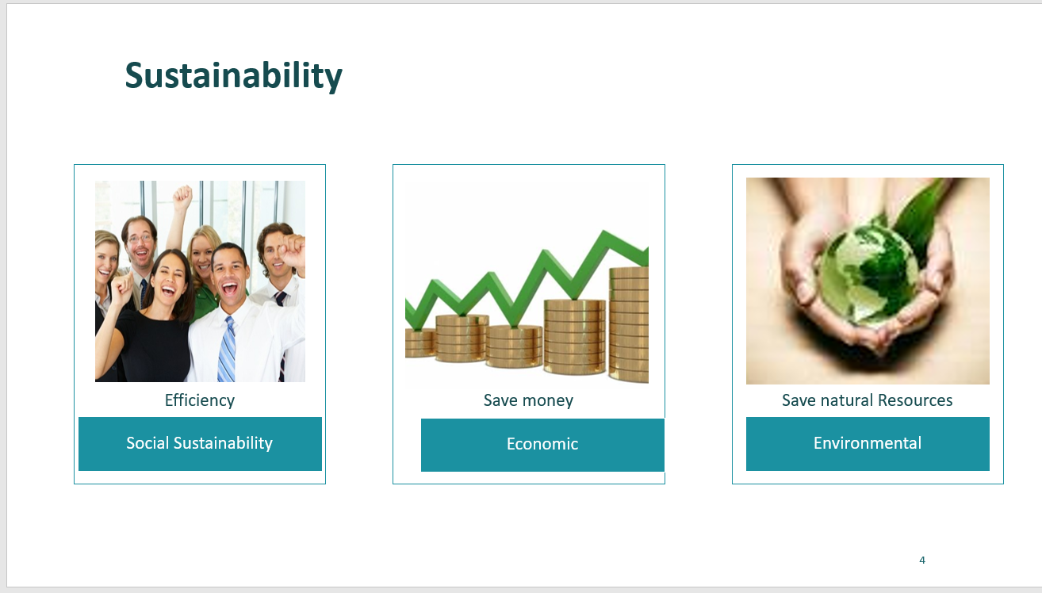

Problem
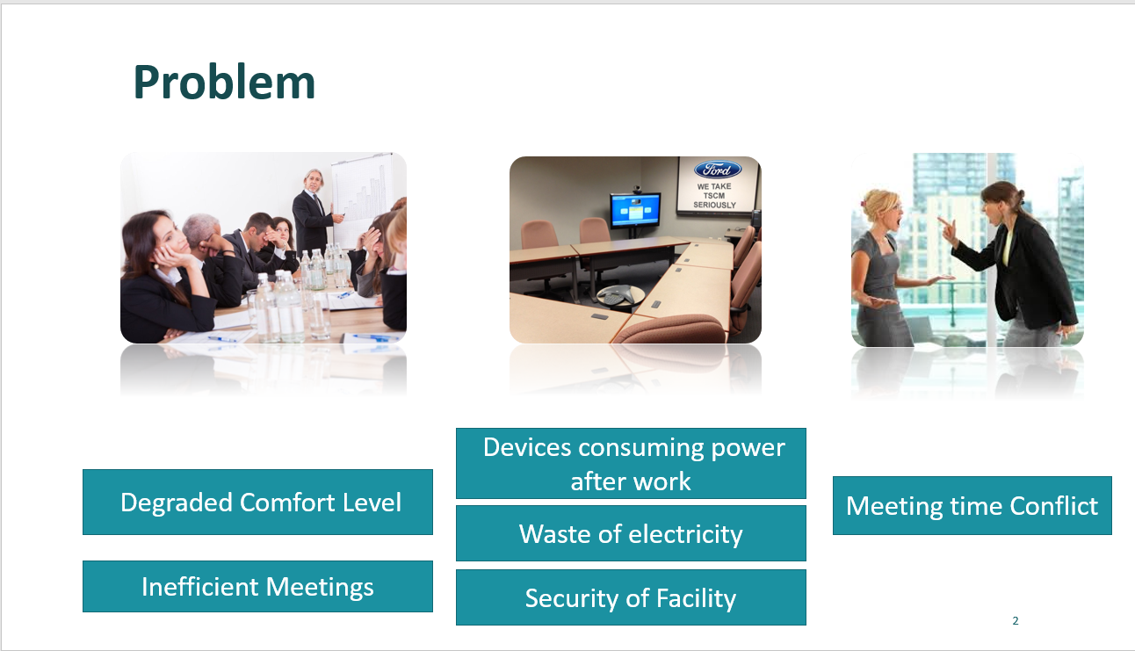

Features

Technology and platforms used
- FHEM
- FS20
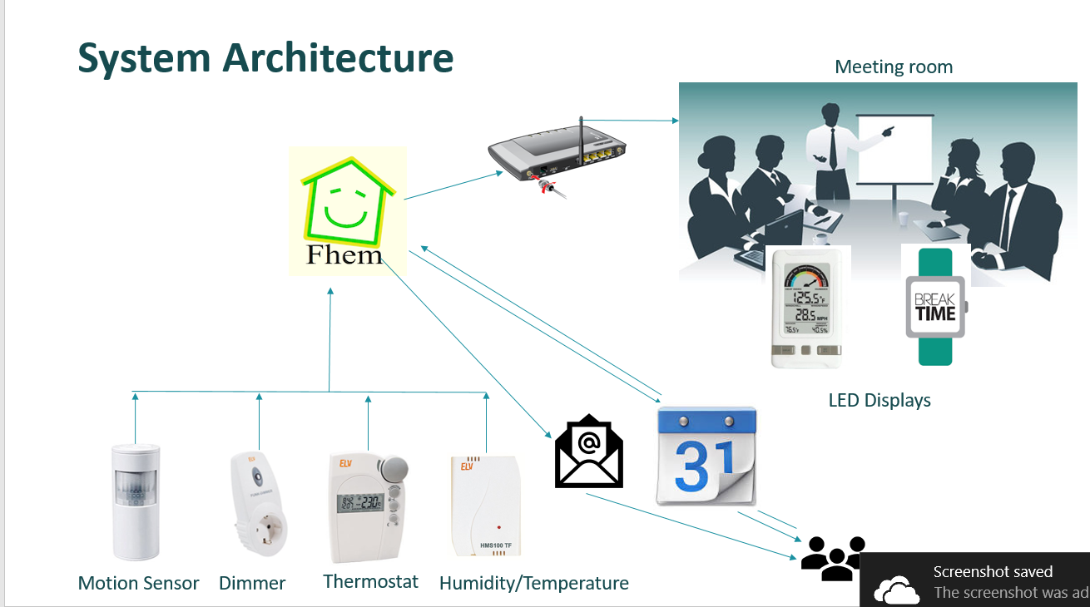

Project Plan
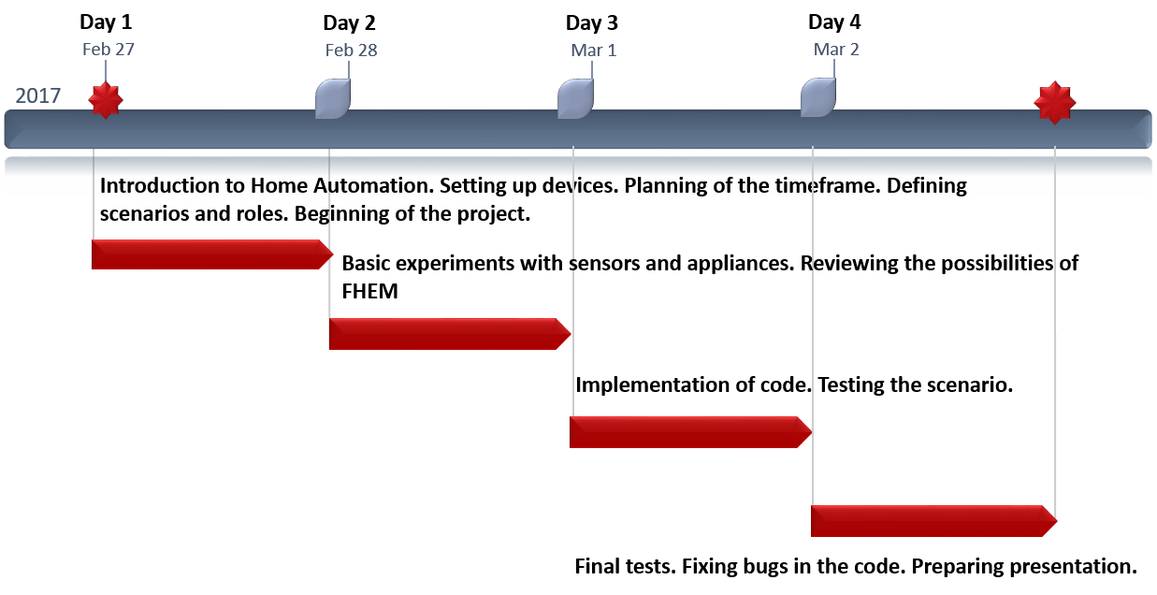

Code Package
fhem-config.zip

Goals
S/N | GOAL | Implemented
1 | Automatically Dim all light during a projector presentation | No
2 | Check Air Quality of the Room and Automatically Improve Air Quality | Yes
3 | Check when meeting has ended from parameter and the turn off all energy consuming products | Yes
4 | Increase Efficiency | Yes
5 | Integrate Google calendar | Yes

Presentation
meeting-room-automation.pptx

Z Wave explained
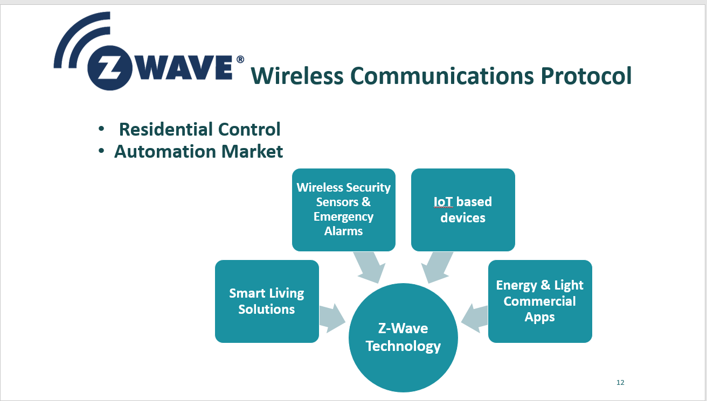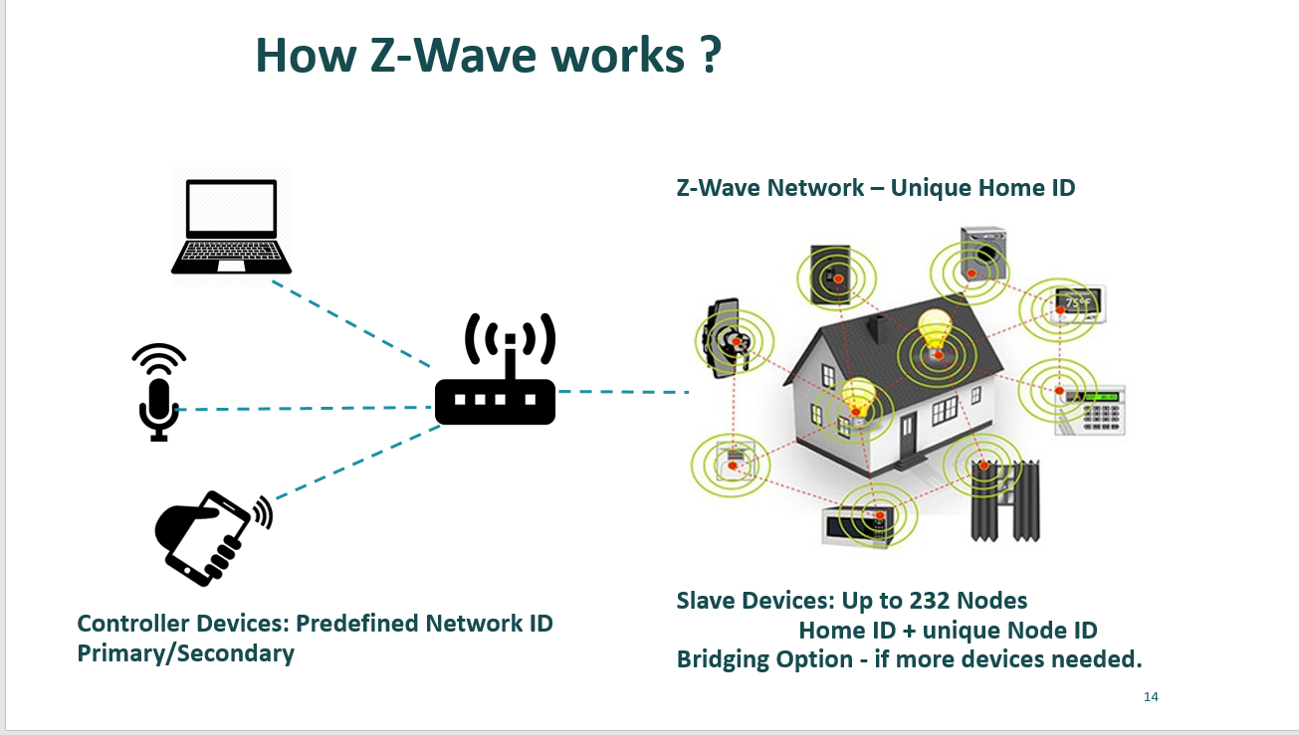

Report
home_autom_report3.pdf

Poster


