EasyLiving
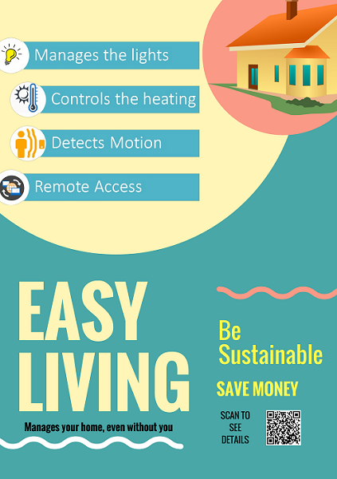

Group Members
- Ahmed Afif Monrat
- Daniyal Akhter
- Farniba Khan
- Md Tawseef Alam
- Phoebe Mutua

Problem Statement
Everyday when people wake up, they turn on the light and its in full power though there is sun light outside. The thermostat is either in low power or in full, they have to adjust it after they get up. He has to start the electronics(coffee machines, heaters etc.), which takes some of his time.
Afterwards, during the night lights and other electronics should turn off automatically, when he goes to bed. In the middle of the night we he wakes up to do something, suddenly turning on bright light can hurt his eyes.

Motivation
- Misuse of light even during daylight
- Uncomfortable temperature at room
- Wastage of time for manually turning on/off devices
- Forget to turn off electronic devices when going bed or outside
- Disturbing people at midnight with high powered light

Idea
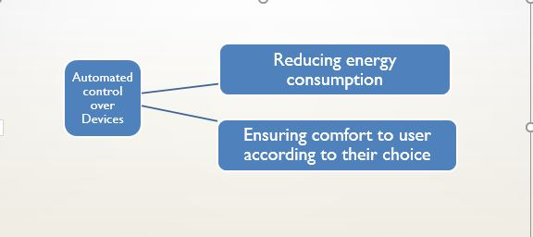

Features
Controlling electronic devices according a users habits to reduce energy consumption and comfort. The system will have two basic modes.
Day Mode
- The window drapes can automatically open at a time set by the user.
- The room heater settings will change according to the ambient temperature.
- When the person gets up from bed, the coffee machine, music system will start.
Night Mode
- At a certain time the window drapes will close.
- The lights in the house will turn on or off sensing the presence of user.
- The light will turn on at a low intensity if someone needs to go out of bed at midnight without disturbing anyone.

Devices
- Controller
- Raspberry Pi
- Actuator/Sensor
- Wireless Temperature/Humidity Sensor
- Wireless door/window sensor
- Wireless Radiator Thermostat
- Wireless Dimming Actuator
- RF Motion Detector
- Appliances/Electronics
- Lamp
- Fan
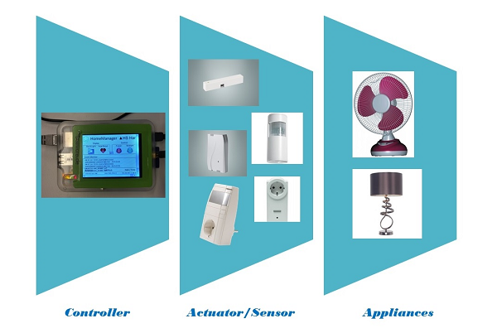

System Architecture
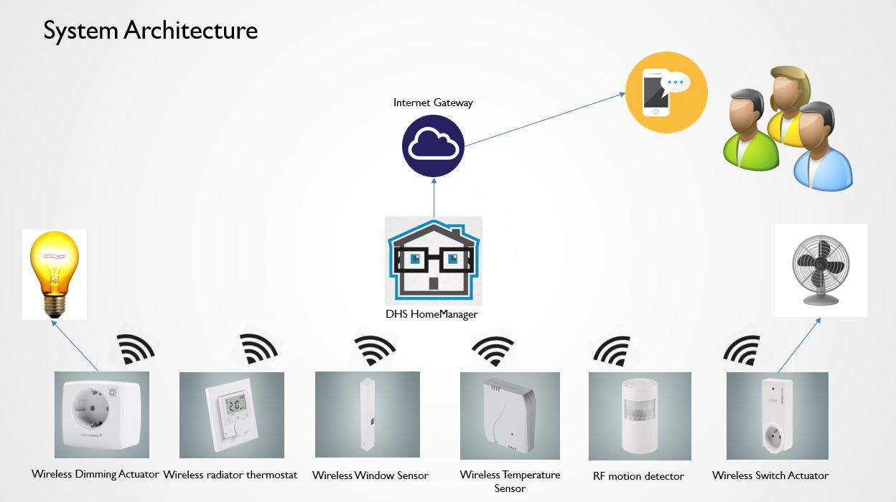

Sustainability

Review
An approach that allows us to create balance; we produce, use services (resources) and environmental affects without compromising the future.

Benefits/Breadth of Idea
- Majorly targets ‘Social Cause’.
- Also Consider energy savings/reducing CO2 footprints.
- Reflects for business idea.

Benefits Power Consumption
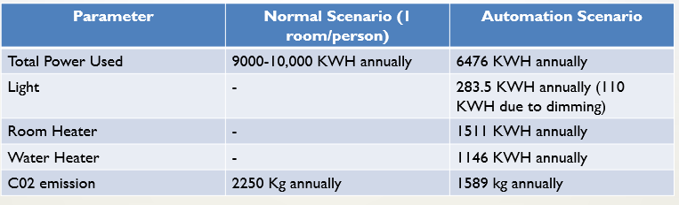

Economical Benefits
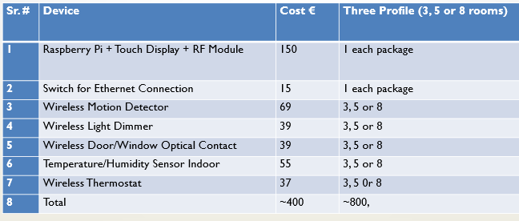

Codes in use
Code snippets for night light and air control mode:
1. define air_controller notify grp5_motion { if ($EVENT eq "motion"){fhem "set grp5_light 60 20 100"} else {fhem "set grp5_light off"} }
2. define light_controller notify grp5_window {if (($EVENT eq "closed") && (ReadingsVal("grp5_THsensor","temperature","") gt "25.0")) {fhem "set grp5_switch on"} else {fhem "set grp5_switch off"}}

Protocols to Discuss

x10 Technology
- What is x10
  - An international and open standard for communication for home automation
  - Used for communication among electronic devices
  - Developed in 1975 by Pico Electronics of Glenrothes, Scotland
  - Allows remote control of home devices and appliances
- How it works
- A signal is sent out via the X10 command interface.
- Transmitted along every internal power line within the house,
- Signal is received by all X10 modules that are plugged into a wall socket.
- Setting up each X10 module at home with a unique individual identification code.
- The identification code is broken down into two components: the house code which uses a single letter ranging from A to P, and the unit code which uses a number between 1 and 16.
- Combining the letter code and number code, gives a user 256 possible combinations, meaning that 256 individual X10 devices could be fitted and controlled within the home.
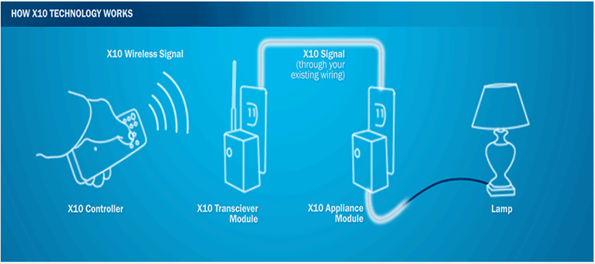
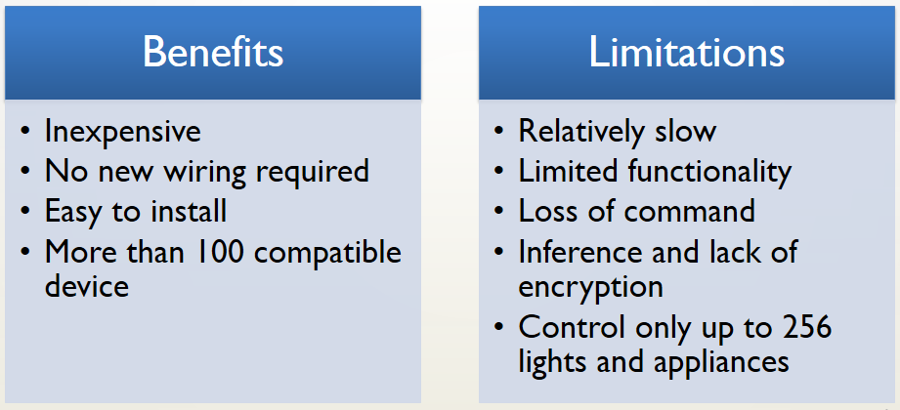

ONE-NET
- What is ONE-NET
- An open-source standard for wireless networking
- Uses a variety of off the shelf wireless transceivers and microcontrollers for implementation
- Specifically optimized for:
  - low power
  - low cost
  - high security
  - long range
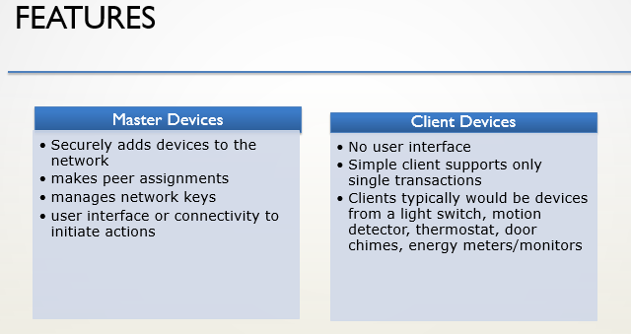
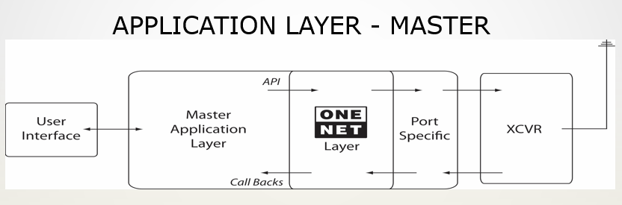
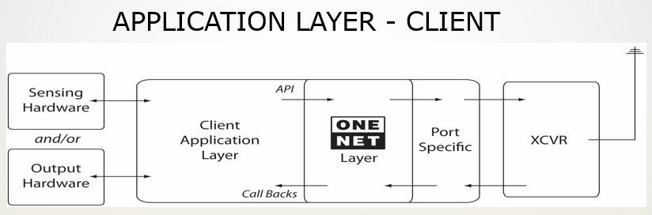
- Security
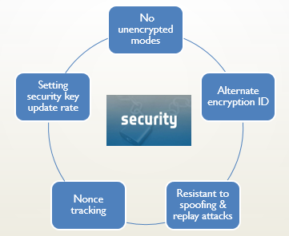

Documents and Media
- Poster homeautomation2017:group5:easyliving_poster.png
- Video Link https://drive.google.com/open?id=0B4yjf6KEwq9bWWc0X2xoa0hNTUE
- Presentation https://drive.google.com/file/d/0B4yjf6KEwq9bVkxIV1FyWWtmSFk/view?usp=sharing
- Report https://drive.google.com/file/d/0B4yjf6KEwq9bNnVHODNXZ1ZfN2s/view?usp=sharing

References
- http://fhem.de/fhem.html
- https://fhem.de/commandref.html
- http://www.one-net.info
- http://www.cleverhome.com.au/X10-home-automation.shtml
- http://www.smarthome.com/sc-what-is-x10-home-automation

