Project EReactrify
EReactrify is intuitive controlling software for smart devices at home. It keeps track of what is the status of added devices and allows user to manipulate electricity usage by device from remote. It can also calculate current electricity cost based on devices turned on and electricity price given by user. EReactrify has simple layout to illustrate where controlled devices are and for example which rooms have lights on. For convenience this solution also has masterswitch for electricity that can turn off all devices connected to this system. This is useful for example when you are going to vacation and forget to turn off your devices.

Documents and media
Repository: https://gitlab.com/C0ntrol/react-codecamp
introduction_presentation.pdf
results_presentation.pdf
Video: codecamp_video.webm

Team
Simo Partinen simo.partinen@student.lut.fi
Eetu Vierula eetu.vierula@student.lut.fi
Kimmo Flykt kimmo.flykt@student.lut.fi

Motivation
- Internet of things growing in popularity
  - Traditional household appliances getting connected to home network
- Growing demand for “smart homes”
  - Ability to control different electronic devices in home remotely

Idea and implementation
Our idea was to create a web-application that would allow user to remotely control their electronic devices.
Here are some early designs for the user interface:
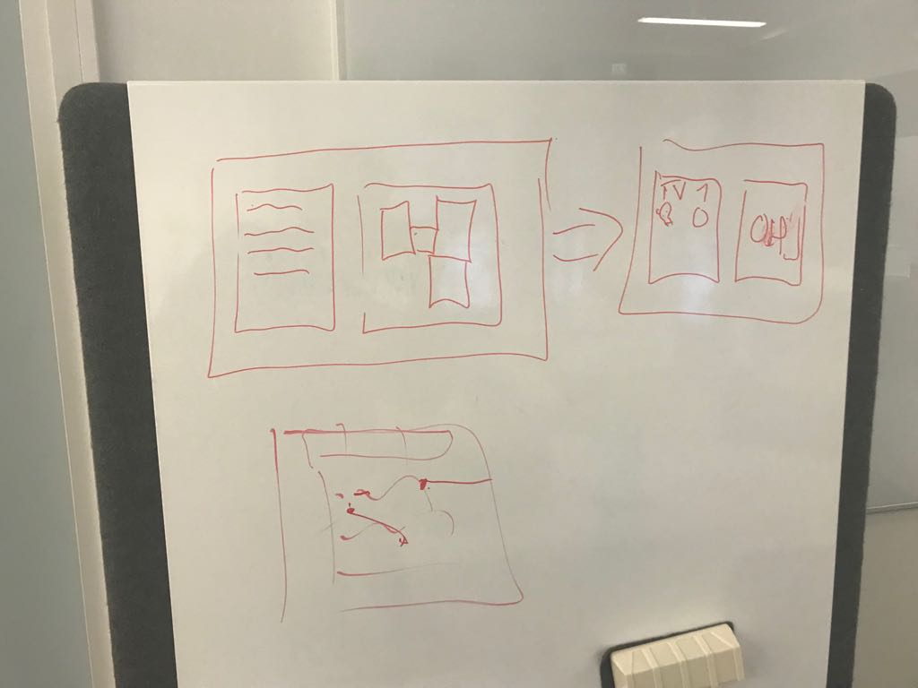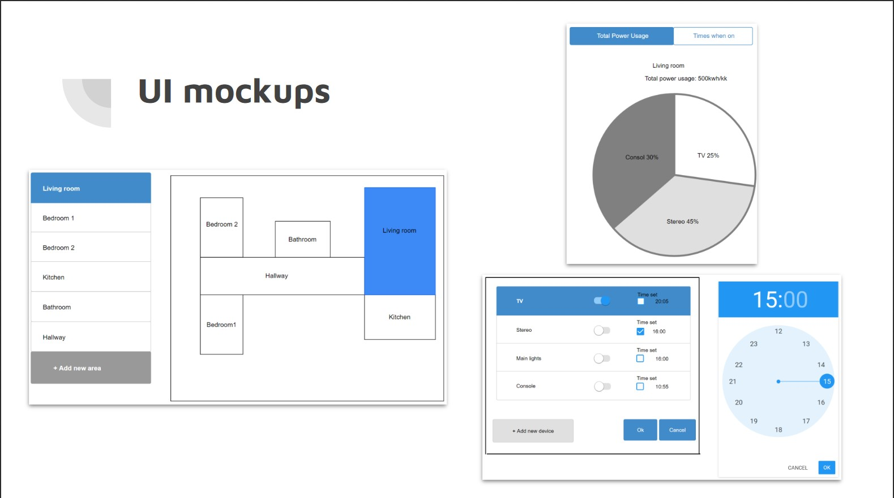
As you can see we were planning on doing one main interface, which would include the floor plan and menu for different rooms, and two interfacces that would work through modals. Modals are sort of a pop-up window that would open on top of our main interface. One of these modals would open up when clicking one of the rooms in the main interface and it would include controls for different devices in that room. The other one would display some statistics about power usage etc. However pretty soon we realized that this kind of user interface would just over complicate things and instead decided to go with much simpler solution using only one interface.
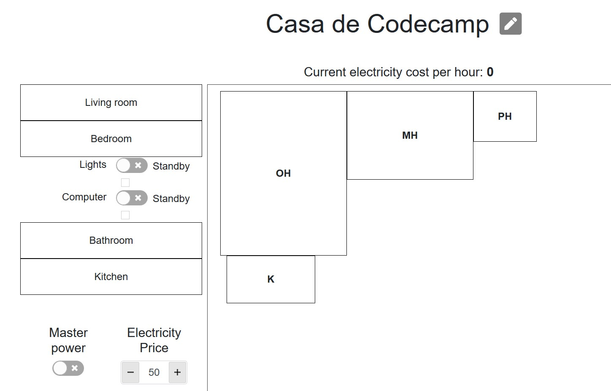
We basically combined the original main interface and the modal with device controls into single interface. Now it's easy to just click a room that you want and a dropdown menu with device list and controls will open. We had to drop the chart part of the other modal completely but instead of that some new features were added. There is now a master switch that will cut off power from the whole house, a calculator, that can calculate the cost of electricity per hour based on electricity price given by user and all the devices currently powered within the house, and standby option, which will set devices in a standby mode that barely consumes any energy.

Features
- Master power switch
- Individual power switch and standby power for different devices
- Map showing the floor plan and devices that are on
- Cost calculator
- Editable name for layout

Future development
- Improvments to UI
- Option to add new devices to rooms
- Option to create a custom floor plan
- Option to have multiple floor plans
  - Possibility to use in hotels
- Actually connecting to a smart socket for example

Readme
To make this project work, first you need to clone this project from source given earlier on this page. After cloning go to projects root with terminal and install npm to your computer. After npm is installed write “npm install” to your terminal to install all decencies that are used in this project. After install is completed write “npm start” in your terminal to start application. Then this application should automatically open to your browser. If not then write “http://localhost:3000” to your browsers address field. After this application is ready to being used.

Troubleshooting
- Cannot use any of the power switches - The apartment is not deemed reserved. When the application fetches the apartment's information from room-list.json it also get's data on it's reservation start and end dates. If current date is not between these two timestamps then the apartment's electricity - and the master switch - are automatically switched off. To change the reservation period one has to modify the room-list.json's reservation property.

