BACK TO MAIN
* Click here

Group 2: +1 Memory Game+1 MEMORY GAME

MEMBERS
- Bishal Raj Karki (raj)
- Erik Taavila (eepi)
- Petri Heinilä (hevi)
Final screenshot of working game application
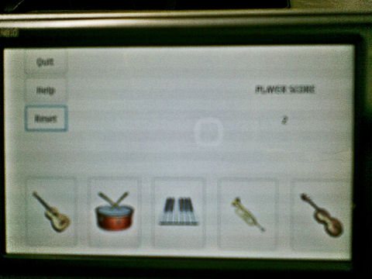Photo on the final app screen

IDEA
Two player challenge each other in memory game. Game is in N810 screen where each players has 5 sound buttons to press. First player press 1 sound button. Second player responds to it and adds one sound more to memory sequence. First player the responds to 2 sounds and adds one sound more. Second responds to 3, first to 4, second to 5 and so on. The player who make first error in correct order in sound sequence loses and other player wins.
Initial schetcing of UI layout
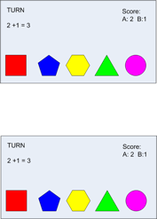Initial idea on the UI
+1 Memory Game is a musical game software where two or more users compete with each other in recognizing what musical notes the opponent played in recent turn. Also this game will be developed with an intention to teach users the various basic musical notations like guitar chords or drum notes or piano chords.

Game Logic
Lets consider 2 users playing the game.
- When the game is started both players are allowed to select and agree the theme of the game on which they compete. (for instance themes might be jazz, rock, alternative, pop, classic etc etc)
- After players agrees with the theme, both users are provides with the same user interface which shows the 5 different iconic buttons which while pressed produces different musical notes or chords respective to the themes selected.
- Player 1 starts the game with pressing any one of the 5 buttons randomly. When button is pressed both player hears the same musical note on their device and returns the turn to player 2.
- Player 2 remembers the musical note played by the player 1 and playes the same note in response.
  - If the notes doesnot match then player 1 wins.
  - If the notes match then the player 2 is allowed to add one more musical note and returns the turn back to player 1.
- Now the player 2 has to respond two correct musical notes and in order to stay in game. And if he/she does that correctly, he adds one extra musical note and passes the turn to next player.
- Each correct response is awarded 1 points.
- similarly, the game continues with adding one new musical notation in the sequence untill and unless any player fails to respond the sequence correctly and in order.
- The Player who fails ..loses the game and the other wins.

Music Classroom Logic
Here users are a Teacher and students (Multiple)
- The teacher selects the theme for musical instrument to teach (like guitar, drum, paino etc)
- The teacher plays one chord or a music note and the student in response plays the same music note or chord. In this way students get to hear and learn the different musical instrument notations.

System Requirement
- Nokia N810 Internet Tablet
- Maemo environment

Networking Technology Used
- Peer-to-Peer

Programming Language Used
- Python

Sound Files Used
- Format: wav
- Sound Samples of Drum , Guitar, Violin, Trumpet and Piano. sound_files_ready.zip

Icon Files Used
- Format: png
- Icons of Drum , Guitar, Violin, Trumpet and Piano. new_icon_file.zip

Technical problems and help
If you need to scale image then heres a sample code!
def getImageFromFile(self, fileName, width):
pixbuf = gtk.gdk.pixbuf_new_from_file(fileName)
pixbuf = pixbuf.scale_simple(width, width, gtk.gdk.INTERP_BILINEAR)
fileImage = gtk.Image()
fileImage.set_from_pixbuf(pixbuf)
return fileImage
Code for enabling and disabling buttons
disable
self.guitarButton.set_sensitive(False)
self.drumButton.set_sensitive(False)
enable
self.guitarButton.set_sensitive(True)
self.drumButton.set_sensitive(True)

Result
What did we end up with? Save codes here.
* Result from Code Camp
* Pictures&Video

Resources
* https://garage.maemo.org/plugins/scmsvn/viewcvs.php/virtual_instruments/?root=jammo
* https://garage.maemo.org/plugins/scmsvn/viewcvs.php/trunk/data/themes/?root=jammo

